UNIVERSITY OF RWANDA
COLLEGE OF SCIENCE AND TECHNOLOGY
KIGALI-RWANDA

SCHOOL OF ICT
DEPARTMENT OF COMPUTER AND SOFTWARE ENGINEERING

COMPUTER HARDWARE AND MAINTENANCE LABORATORY

YEAR 1

LECTURER: Mr. NAHIMANA Godefroid
CONTACTS: Phone number: 0788442597
E-mail: godenahimana@gmail.com

Academic year 2025-2026

COURSE OBJECTIVES:
Upon completion of this module, it is expected that the students will be able to identify components relating to a computer system. The module uses a combination of lectures, demonstrations discussions and hands-on labs as given in the following:
MOTHER BOARDS
Lab-1: Motherboard Identification
Objective
This lab will focus on identifying motherboards, removing motherboards, replacing motherboards, and using the motherboard manuals to identify a number of the system components.
Lab 2: Motherboard Installation
Objective
Upon completion of this lab, the motherboard will be placed into the case and secured.
The CPU, the heat sink, the LEDs, and the memory will also be installed.
THE DISK DRIVES AND MEMORY
Lab-3: Identify ROM and BIOS Chips
Objective
This lab will focus on the student’s ability to locate and identify the ROM chip, BIOS chip, and BIOS manufacturer on a motherboard.
Lab 4: Identifying RAM and RAM Sockets
Objective
This lab will focus on the identification of various types of Random Access Memory (RAM) and RAM sockets.
Lab 5 : Floppy Drive, Hard Drive, and CD-ROM Installation
Objective
In this lab, the student will install the floppy drive, hard drive, and CD-ROM drive. The student will also install the ribbon cables for each drive and the audio cable for the CDROM.

I/O DEVICES AND DISPLAY
Lab 6 : Identifying Computer Expansion Slots
Objective
Upon completion of this lab, the student will be able to identify safety issues, specifications, and components relating to expansion slots. The student will also be able to list the advantages and disadvantages of each expansion slot.
Lab 7: The Computer Case and Power Supply
Objective
In this lab, identify the type of computer case to be used, the form factor of the unit, and the voltage selector switch on the power supply. The inventory of all the components that will be installed in the computer case will also be discussed. Finally, motherboard standoffs will be installed to prepare the case for the installation of the motherboard.
Lab 8: Video Card Installation and System Booting
Objective
Upon completion of this lab, the student will have installed the video card. The student will also have connected the mouse, keyboard, and monitor. If everything is installed properly, the student should be able to turn on the computer at the end of this lab.
INSTALLATION, CONFIGURATION & UPGRADING OF OS AND APPLICATION
Lab 9: Hard Drive Preparation Using FDISK and FORMAT Commands
Objective
Upon completion of this lab, the student will be able to partition the hard drive. The student will also be able to install the three system files onto the hard drive to make it a bootable drive.
Lab 10: Basic DOS Commands
Objective
Upon completion of this lab, the student will be able to navigate the DOS command line. The student will also be able to perform basic file management tasks such as creating directories and files, navigating through directories, displaying content of directories, and displaying and changing file attributes.
Lab 11: Creating a DOS Boot Disk
Objective
Upon completion of this lab, the student will know which files are necessary to make a floppy disk bootable. The student will also learn the commands necessary to create a boot disk.
Lab 12: Installation Demonstration of Windows 9x
In this exercise, the student will learn how to install the Windows 9x operating system.
Lab 13: Installation Demonstration of Windows 2000
Objective
In this exercise, the student will learn how to install the Windows 2000 operating system.
Lab 14 : Installation Demonstration of Windows XP
In this exercise, the student will learn how to install the Windows XP operating system.
Lab 15: Assigning Permissions in Windows 2000 and XP
Objective
In this exercise, the student will learn how to assign NTFS permissions to folders.
Lab 16 : Creating Users Accounts in Windows 2000 and XP
Objective
Upon completion of this lab, the student will be able to create users and groups as well as assign properties to each.
Lab 17 Application installations
In this exercise student will learn how to install the application like Office 2003, PageMaker, oracle and etc….

Lab 18 : Windows 98 Startup Disk
Objective
Upon completion of this exercise, the student will be able to create a Windows 98 startup disk.
Lab 19 : Device Driver Installation (Sound, Video, Audio)
Objective
Upon completion of this lab, the student will be able to install a sound card in a computer, attach the speakers and microphone, and install the proper drivers.
Lab 20: Creating an Emergency Repair Disk Objective
In this lab, the student will learn how to create and use an emergency repair disk.
Lab 21 : Adding an Printer to Your Computer
Objective
In this lab, the student will connect a printer to a PC, install the correct printer driver, and verify computer-printer communication by printing a test page.

DIAGNOSING, TROUBLESHOOTING AND PREVENTIVE MAINTENANCE

Lab 22: Identifying POST Errors
Objective
Upon completion of this lab, the student will be able to identify common POST errors. The ability to identify POST errors is essential for troubleshooting computers.
Lab 23: Data Backup and restore.
Objective
Upon completion of this lab, the student will be able to perform data backup and restore to prevent a complete loss of data.

Lab 24: Booting into Safe Mode
Objective
Upon completion of this lab, the student will be able to boot the PC utilizing the advanced troubleshooting options of Windows XP.
Lab 25: Using the Windows 2000/XP Recovery Console
Objective
In this lab, the student will learn how to use and implement the Windows 2000/XP Recovery Console.
Lab 26 Safe Handling and Use of a Multi meter
In this lab, the student will learn how to use a digital multi-meter to measure Voltage levels of a PC power supply.
Lab 27 Data Recovery and Password recovery
Using Data recovery software’s recovering deleted and formatted data, and Cracking passwords using ERD Commander CD in Windows OS.
Lab 28 : Using the Scandisk and Defragmentation Utilities .
Objective
Upon completion of this lab, the student will be able to scan a hard drive, defragment the drive to check for errors, and defragment files using the Scandisk and Defrag utilities.

COURSE OUTLINES
UNIT 1
Chap. 1 MICROPROCESSORS
Chap.2 SEMICONDUCTOR AND SECONDARY MEMORIES
Chap. 3 SYSTEM BUSES AND BASIC CARDS
Chap.4 POWER DEVICES

UNIT 2
CHAPTER 1: HOW THE COMPUTER WORKS
CHAPTER 2: ASSEMBLING THE COMPUTER
CHAPTER 3 THE OPERATING SYSTEMS

GRADING:
- Assignment: 30%
- CAT2: 30%
- Final exam: 40%

TABLE OF CONTENT
COURSE OBJECTIVES: 2
COURSE OUTLINES 7
TABLE OF CONTENT 8
UNIT 0NE 14
CHAPTER ONE: MICROPROCESSORS 14
1.1 Computer organization 14
1.2 Microprocessor architecture 15
1.3 Microprocessor History 15
1.4 Rates & Data Transfer: 17
1.5 Cache 17
1.6 Types of Intel Pentium family of Microprocessors 17
REVIEW QUESTIONS 18
CHAPTER TWO: SEMICONDUCTOR AND SECONDARY MEMORIES 19
2.1 Definition 19
2.2 Memory basics 19
2.3 Memory characteristics 19
2.4 Semiconductor memory 22
2.4.1 Basic Memory Unit 22
2.4.2 Basic Memory Organization 23
2.4.3 Cell Organization (Memory Addressing) 25
2.4.4 Classification of Semiconductor Memory 26
2.4.5 Read Only Memory 27
2.5 Secondary memories 28
2.5.1 Magnetic Memory 28
2.5.2 Optical Memory 31
Review Questions 32
CHAPTER 3 SYSEM BUSES AND BASIC CARDS 34
3.1 System buses 34
3.1.1 Types of buses 35
3.1.2 Expansion Bus and Expansion Slots 36
3.1.3 IRQs - Interrupt Request lines 39
3.1.4 Resolving IRQ conflict 39
3.1.4 DMA Channels 40
3.1.5 I/O Addresses 40
3.1.6 Bus Mastering 41
3.2 Basic cards 41
3.2.1 IDE, EIDE and SCSI controllers 41
3.2.2 VGA 42
3.2.3 Network interface card 43
3.2.4 Setting the IP address 43
Review questions 45
CHAPTER 4 POWER DEVICES 45
4.1 SMPS: Switching Mode Power Supply 45
4.2 Constant Voltage Transformer (CVT) 46
4.3 Uninterruptible Power Supply 47
REVIEW QUESTIONS 49
UNIT TWO 50
CHAPTER 1 HOW THE COMPUTER WORKS 50
1.1 System overview 50
1.1.1 Input, process, output, and storage 50
1.2 The Boot Process 51
1.2.1 Initializing and testing the system hardware 51
1.2.2 Loading the operating system and hardware configuration 53
1.2.3 The boot sequence 54
1.3 Hardware Components 54
1.3.1 Computer cases and power supplies 54
1.3.2 The motherboard 57
1.3.3 The CPU 59
1.3.4 BIOS 60
1.3.5 Expansion slots 61
1.3.6 RAM and Cache 61
1.3.7 Monitors 64
2.3.8 Video cards 65
1.3.9 I/O ports 65
1.3.10 Floppy drives 68
1.3.11 The hard drive 68
1.3.12 CD-ROMs 70
Review questions and Labs 71
CHAPTER 2: ASSEMBLING THE COMPUTER 79
2.1 Overview of the Assembly Process and Safety Issues 79
2.2 Creating a Computer Inventory 79
2.3 The computer Case and Power Supply 80
2.3.1 Computer cases and system units 80
2.3.2 Desktops 80
2.3.3 Towers 81
2.3.4 Power supplies 81
2. 4 Preparing the Motherboard for Installation 83
2.4.1 Motherboard configuration 83
2.4.2 Motherboard Jumpers 83
2.4.3 Installing the CPU 84
2.4.4 Installing the heat sink and Fan 85
3.4.6 Installing RAM 86
2.5 Installing the Motherboard 88
2.5.1 Installing the Motherboard into the case 88
2.5.2 Connecting power supply cables to the motherboard. 89
2.6 Installing the Floppy Drive, Hard Drive, and CD-ROM 89
2.6.1 Attaching the floppy drive to the case. 89
2.6.2 Attaching the hard drive and CD-ROM to the case 90
2.6.3 Connecting the floppy drive, hard drive, and CD-ROM to the system 93
3.6.4 Connecting power cables to the floppy drive, hard drive, and CD-ROM 95
2.7 Video Card installation 96
2.7.1 Step-by-step installation of the video card 96
3.8 Final steps 98
3.8.1 Fitting the case together 98
2.8.2 Connecting the keyboard, mouse, monitor, and power cord 98
2.9 Booting the System for the First Time 99
2.9.1 What is BIOS? 99
REVIEW QUESTIONS AND LABS 100
CHAPTER 3 THE OPERATING SYSTEM 112
3.1 The Operating System 112
3.1.1 Components of an operating system 112
3.1.2 Functions of an Operating system 113
3.1.3 Operating system types 113
3.2 Disk Operating System (DOS) 114
3.2.1 What is DOS, and why learn about it? 114
3.2.2 Overview of basic DOS commands 116
3.2.3 Creating a dos boot disk 119
3.3 Hard Disk Partitioning And Formatting Procedure Using Fdisk And Format 121
3.4 Microsoft windows operating system installation 124
3.4.1 Installing Windows 98 124
3.4. 2 Installing Windows 2000 Professional 126
3.5 Creating user account in Windows XP/ 2000 139
3.6 Assigning permission in Windows XP 142
3.7 Adding a printer on windows XP 146
3.8 Using scandisk and defrag utilities 149
3.8.1 SCANDISK 149
3.8.2 Defrag utility 151
3.9 Booting windows operating system in safe mode 152
3.9.1 Booting Windows 2000 / XP/VISTA/WINDOWS 7 in safe mode 153
3.9.2 Windows 95/ 98 / ME users 153
3.10 Using windows 2000/xp recovery console 154
3.10.1 Starting the Windows Recovery Console 155
3.10.2 Using the Command Console 155
REFERENCES 156

UNIT 0NE

CHAPTER ONE: MICROPROCESSORS

1.1 Computer organization

All computer systems, no matter how small or large, have the same fundamental capabilities: processing, storage, input and output. Input unit includes devices like keyboard and mouse, which are used by the user to give some data to the computer. Processing unit is where these data are processed and turned into meaningful information. Processing unit also includes temporary storage (RAM) in which the data currently being processed are stored temporarily. To show the result of processes, to the user, output devices like monitors and printers are used. The output on a monitor is usually called softcopy and the output on a printer is usually called hardcopy. Sometimes we may want to store our data and information permanently so that we can refer to them again, later. For this purpose, interchangeable devices like floppy disk drives and CD-ROM drives, or permanently installed devices like hard disks are used as permanent storage mediums.
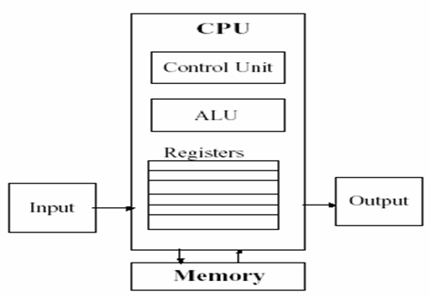

1.2 Microprocessor architecture

The microprocessor or a center processing unit CPU is a brain of any normal computer whether it is a personal computer, server or a laptop. Microprocessor within any computer might be a INTEL Pentium, AMD, Power PC, Spark or any other brand but they all do approximately the same thing in approximately the same way.

CPU contains three basic components as shown in the figure below:

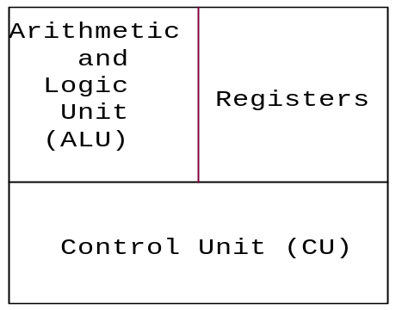
- A control unit instructs the rest of the computer system on how to follow program instructions. It directs the movement of data to and from processor / memory. The control unit temporarily holds data, instructions, and processed information in its arithmetic/logic unit. In addition, it directs control signals between the CPU and external devices such as hard disks, main memory, I/O ports, and so on.
- The Arithmetic/Logic Unit (ALU) performs both arithmetic and logical operations. Arithmetic operations are fundamental math operations like addition, subtraction, multiplication, and division. Logical operations such as the AND, OR, and XOR are used to make comparisons and decisions, and these determine how a program is executed.
- Registers are used by a processor to temporally store data being processed.

1.3 Microprocessor History

The first microprocessor was the Intel 4004, introduced in 1971. The 4004 was not very powerful and all it could do was add and subtract. The first microprocessor to make it into a home computer was the Intel 8080, introduced in 1974.
The first microprocessor to make a real splash in the market was the Intel 8088, introduced in 1979 and incorporated into the IBM PC which first appeared around 1982.
PC market moved from the 8088 to the 80286 to the 80386 to the 80486 to the Pentium to the Pentium II to the Pentium III to the Pentium 4. The Pentium 4 can execute any piece of code that ran on the original 8088, but it does it about 5,000 times faster.
Based on the way CPU fits into the computer motherboard microprocessor are of two types namely Slot types and socket type as shown in Figures below .
Socket type processor
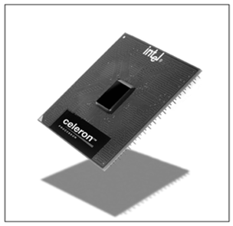
Intel Celeron processor which has pins on underside to be inserted in CPU socket

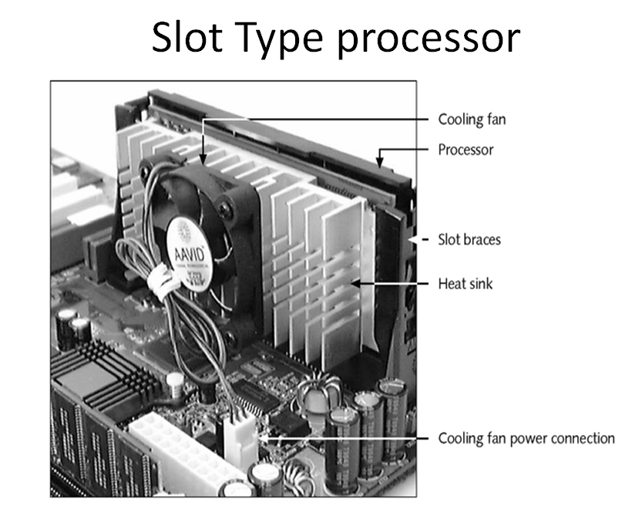

1.4 Rates & Data Transfer:
What characterizes a computer processor is its speed or rate - how fast it can execute instructions. As of now, speed is measured in gigahertz (GHz), or billions of cycles a second. Some CPU rates are 2.0 GHz, 2.40 GHz, and 3.20 GHz. Because the CPU greatly determines the overall performance of a PC, the type of processor and its speed are two of the main factors to look for when deciding to buy a computer. But keep in mind there are other important things, such as the amount of memory.
CPUs are either 32-bit or 64-bit. This means how much data that can be processed in terms of bits. Computers data is composed of 1's and 0's (e.g. 01110010). Each individual 1 or 0 is called a bit. A 32-bit CPU can process a max of 2^32 (2 raised to 32nd power) or about 4.3 billion bits per cycle. A 64-bit processor 2^64 or about 18,400,000,000,000,000,000 of data per cycle. The more data a computer can handle means improved performance. The amount of memory supported by a processor is also determined by the number of bits. Using the same math above, a 32-bit processor supports 2^32 or approximately 4 GB of memory.

1.5 Cache

In addition to CPU speed, another important processor feature that influences performance is the amount of cache (pronounced cash) it has. CPU cache is memory set aside for the most frequently used data. There's Level 1, Level 2, and Level 3 (commonly just called L1, L2, and L3). L1 uses extremely fast and expensive SRAM (Static RAM) and is the smallest in size. L2 is slightly larger in size. Both L1 and L2 are located on the processor. L3 is the largest and is usually located outside the CPU and shared by all the cores. When data is requested, the CPU first checks the L1 to see if it's there. If not it checks L2 and so on. Accessing data in the cache is far more faster and efficient than fetching it from RAM

1.6 Types of Intel Pentium family of Microprocessors
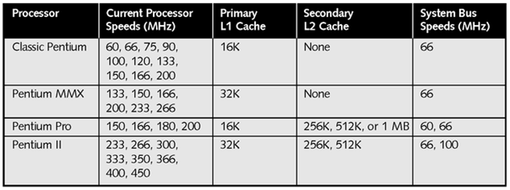
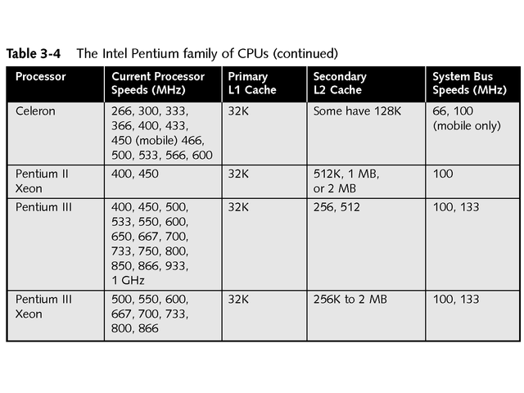

REVIEW QUESTIONS
- Give a diagram of a computer organization and explain the function of each block.
- With a help of diagram, explain the basic three components of a processor.
- How much RAM size would a 64-bits processor support?
- Explain the factors influencing the performance of the processor.
- The speed of the processor is measured in ………..while the data transfer rate is measured in ……………………

CHAPTER TWO: SEMICONDUCTOR AND SECONDARY MEMORIES

2.1 Definition
Semiconductor memory is an electronic data storage device, often used as computer memory, implemented on a semiconductor-based integrated circuit. Data is accessed by means of a binary memory address to the memory. Memories are most essential part of computer and microprocessor systems. They are used to store data and programs for the computer systems. In many general-purpose applications they are also used to store the needed control information for the applications. There are various types of memory devices to accommodate various needs of data storage.

2.2 Memory basics

The ability to remember is the most important characteristics of digital circuits. The circuits or systems designed to facilitate storage of digital information are called memory. The general information that is stored in the memory is called as Data. The circuit arrangement that holds a 1-bit information is conveniently called a storage cell or simply memory cell.

The total number of bits (or storage cells) that a memory device can store is referred to as its storage capacity. For example a device that can store 1024 bits is said to have a storage capacity of 1024 bits. In memory, data is always stored as a group of bits. In fact a single memory cell is rarely accessed; instead they are accessed in a group of fixed size. The number of bits in a group of data is called as the Word Length and each group is called as Word. For example In a memory if there are 10 data each of which are a group of 4-bits, then memory is said to have ability to store 10 words of word length 4-bits. Therefore the memory capacity would be simply 10 words × 4-bits (word length) = 40-bits.

Storage Capacity (in bits) = N o. of Words × Word Length

2.3 Memory characteristics
All kind of memory devices (semiconductor, magnetic, and optical memory), used to build the memory system have some functional characteristics in common. One or more of these characteristics may be used to describe the performance of the memory devices. Following are the important functional characteristics that must be considered for any description of memory:
1. Storage Capacity: It is defined as the total number of bits (or words) that a memory device can store. In general storage capacity is specified in Kilobytes (KB), Megabytes (MB), or Gigabytes (GB). Kilobit is represented as Kb. In binary the kilo means 1024 (not 103) and Mega means 1024 K (not 1011). If storage capacity of device is 1KB it means it has 1024 storage locations and at each location a word of length 1 byte (i.e. 8-bits) can be stored. So the total capacity in bits would be 1024 × 8=8192 bits or 8 Kb.

2. Cost: The cost of the memory can be defined as the cost per bit. It is expected that the cost/bit should be as low as possible. If S is the storage capacity, C is the total cost of memory then the cost per bit Cp /b can be defined as

Cp /b = [total cost (C)/Storage capacity (S)]

3. Memory Access Time. The performance of a memory device is primarily determined by the rate at which the information can be read or write into the memory. The average time required to read a fixed amount of information from the selected memory location is termed as Read Access Time or Access Tim e and is denoted as ‘tA’. In precise words, it is average time delay after memory address is issued till the data appears at output. The access time should be kept as low as possible. Similarly the average time required to store a fixed amount of information at the selected memory location is termed as Write Access Time.

Read Access Tim e> Write Access Tim e

The average rate at which memory can be accessed is defined as the Access Rate ‘bA’ of a memory and is measured in words/sec.

Access Rate (bA) = 1/tA

4. Memory Accessing Modes: It is defined as the way or sequence in which the Information is accessed in the memory. The two types of access modes are

- Random Access Mode
- Serial Access Mode
If the memory cells can be accessed in any order, then the access time is independent of the position of cell. This type of access mode is referred as random access mode, and the memories having such access mode are called Random Access Memory (RAM). In such memories any storage cell (or location) can be reached in a fixed amount of time and each storage cell can be accessed independently of the positions of other cells. Obviously this type of memories is faster. Semiconductor memories are of this type.
If the memory cells can be accessed one after another or only in certain predetermined sequences, the access time is dependent of position of cell. Thus the access time will be different for different cell locations. This is called serial access mode and the memories having such access mode are called Serial Access Memory. Magnetic memories are of this type.
5. Memory Cycle Time and Bandwidth. The minimum time that must elapse between the initiation of two consecutive memory accesses is defined as the Memory Cycle Time t_{C}. The cycle time t_{C} can be greater than the access time t_{A}. This is because after completion of one memory access some memory devices need a small amount of time, t_{D E L AY} to make them ready for next access. In general,

t_{C} = t_{A} + t_{D E L AY}

Where t_{D E L AY} is additional delay due to the physical characteristics of memory; which may not be present in all type of memories.

Maximum amount of information that can be transferred to or from memory every second is referred to as the maximum Data Transfer Rate in words/sec or the Bandwidth ‘b_{C}’, d e f i n e d a s Bandwidth (b_{C}) = 1/t_{C}

6. Non Destructive Read Out (NDRO).It is required that the read process should create a copy (i.e. sense) of the data stored and must not disturb the data. Such a reading is called Non Destructive Read Out (NDRO) and is expected from all kind of memory. In some memories the reading may destroy the data stored at a location. Such a reading is called Destructive Read Out (DRO). In such cases the read operation must be followed by a write operation to restore the original state of memory. Obviously such memories would be slower ones.

7. Permanence of Storage. It is concerned with how long stored information can be retained when:
- Power is switched off: If the stored information does not vanish with power off, the memory is referred as NON VOLATILE memory. But if the stored information vanishes completely at power off the memory is called as VOLATILE memory.

- Power is N OT Switched off: If the data can be retained indefinitely the memory is called as STATIC memory. If it can be retained for some definite small amount of time, the memory is called as DYNAMIC memory. In the later case the data must be rewritten periodically, this is called refreshing.
8. Memory Alterability: Alterability is concerned to the capability of memory devices with which the stored data can be changed or updated when they are in use (i.e. online). Memories, which can be altered online, are referred as Read-Write
Memories. Memories, which cannot be altered online (if at all they can be altered offline) are called erasable read only memory devices. However some memory devices cannot be altered even when they are off line and are called nonerasable read only memory devices.

2.4 Semiconductor memory
Numerous developments in semiconductor technology have emerged into a variation of memory devices, called memory chips. A semiconductor memory is organized as a rectangular array of storage cells that are integrated on a silicon wafer. Due to this organization any memory cell can be accessed randomly, thus all the semiconductor memories are called Random Access Memory (RAM). The basic memory cell may be a charge storing element like capacitor that is said to hold logic 1 when charged and logic 0 when discharged.

2.4.1 Basic Memory Unit
A simple block diagram of a memory unit can be drawn as shown in Figure below. It contains data bus, address bus and control signals. A bus is a group of parallel conductors whose job is to carry binary information. Each of the conductors carries 1-bit information. The number of bits that a memory data bus carries simultaneously is called memory bus width. Usually, but not necessarily, the memory word length and memory bus widths are same.

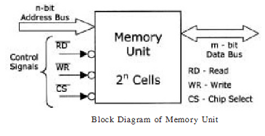
The m-bit data bus is used to transfer data to and from the memory. The n-bit address bus carries the address of memory locations. An n-bit address bus can access up to 2n storage cells i.e. storage capacity is 2n bits as each cell can store 1-bit. The Read (RD) & Write (WR) signals specify the operation to be performed. As shown the two signals are active low i.e. they are activated when logic ‘0’. At any time either of the two signals can be activated. In some memory chips read & write controls are available at one signal line. Chip select signal (CS) (sometimes labeled as enable EN also) is used to enable/disable the chip in multiple memory system. It is also a logic low signal. There may be multiple enable signals in a single chip that must be activated simultaneously to enable the chip.

2.4.2 Basic Memory Organization
Basic organization of semiconductor memory is shown in Figure below. It consists of a storage cell array, Read/Write control circuit along with control signals, an address decoder feeded by a register called memory address register, and a buffer register through which data transfer is carried out. In a semiconductor memory storage cells are organized as a rectangular array. The address bus is connected to internal address decoder through the address register. The RD and WR control line specifies the type of access: If RD= 0 and WR= 1 then read operation.
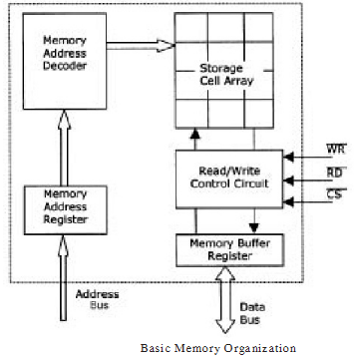
If RD= 1 and WR= 0 then write operation. To access memory, address of the required cell is issued to the memory address register through the address bus. The address decoder selects the particular location in memory array. If read operation is requested then the content of selected location is copied to the memory buffer register which transfer it to the data bus. If write operation is requested then content of data bus is brought to buffer register and then transferred to the selected memory location. Memory buffer register contains bilateral three state buffers, one for each bit of data bus. By combining two three state buffers a 1-bit bi-directional input output line is formed. This is shown in Figure below.
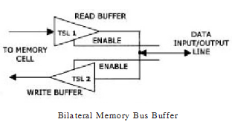
The enable or disable signals for the bilateral buffers can be generated through the realization shown in Figure below.

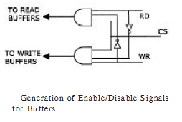
These signals are given to all the bilateral buffers of buffer register. Note that if both RD & WR are activated, or CS inactivated, arrangement in Figure above will generate disable signals for both the buffers i.e. both TSL1 & TSL2 are disabled and data bus enters into high impedance state.

2.4.3 Cell Organization (Memory Addressing)
Memory addressing is concerned with the selection of one particular memory cell from storage cell array. To facilitate selection, the memory cells are organized as rectangular array of m-rows and n-columns as shown in Figure (a) below.
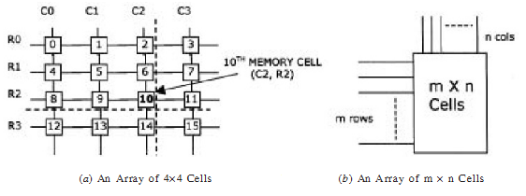
Figure (a) above shows simplified diagram of memory cells array that have 4-rows and 4- columns, thus containing a total of 16 memory cells. The control circuitry associated with memory allows only one row and one column to be activated at a time. In order to select a particular cell we need to specify the appropriate row and column number. Let us consider the selection of 10th cell. It requires column C2 and row R2 to be activated and the cell at the intersection of C2 and R2 is selected which is 10th cell. Dashed lines in Figure (a) show this. So the 10th cell can be designated as the cell C2, R2 (or 2, 2 or 22). This designation is defined as the address of the 10th cell. Collectively the lines corresponding to rows and columns are called address lines. In a memory array each cell will have a similar type of unique address.
Hence any cell can be accessed, just by specifying the row and column number (or address) associated with it. Since any cell can be accessed randomly, it is named Random Access Memory. If in Figure (b) m = 4 and n = 4 then it represents the array shown in Figure (a).

2.4.4 Classification of Semiconductor Memory
The semiconductor memory Classification of Semiconductor Memory devices can be categorized in several ways according to their functional and architectural characteristics. Fig. 11.10 shows the most general classification. As shown they fall in two general categories.
• Read Write Memory or Random Access Memory (RAM)
• Read Only Memory (ROM)
Read Write Memories or RAMs are those memories, which allow both read & write operation online. They are used in applications where data has to change continuously. They are also used for temporary storage of data. Since each cell is a capacitor a power off means loss of data. Thus the RAMs are Volatile Storage Devices.
ROMs are those memory devices, which allows only read operation online and there is no write mode. ROMs are needed in applications where data does not change. Since the data is permanently stored in ROM, power failure does not result in loss of data. Hence ROMs are Non Volatile Storage Devices.
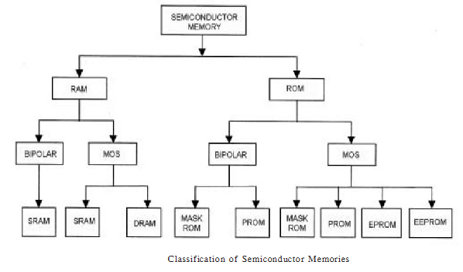
Both the RAM & ROM are further divided into other subcategories, as shown by figure above.
Static RAM (SRAM): SRAM holds the stored data indefinitely if power is on, hence the name static. SRAMs are very high speed but costly memories. A Non Volatile RAM (NVRAM) is formed by using battery backed up SRAM.

Dynamic RAM (DRAM) is a read write memory that uses a capacitor in conjunction with a MOS transistor to store 1-bit. Since the capacitors are leaky, they cannot hold the charges permanently. So they must be recharged periodically to hold the stored data, hence the name dynamic. They are slower than SRAMs but their storage capacity is greater.

The ROMs are categorized according to the data storing process. The mechanism that stores the data into ROM is called as programming mechanism.
A simple ROM is programmed during the manufacturing process according to the data specified by the user. Such a ROM is referred as Mask ROM or Mask Program m able ROM.
A PROM (Programmable ROM) is a type of ROM that can be programmed by the users in the field. They are also referred as Field Programmable ROM. But once programmed they cannot be altered.
An EPROM (Erasable Programmable ROM) is another type of field programmable ROM that can be reprogrammed by the users after erasing the stored data. The erase operation is performed optically which erases all the data stored in EPROM. Selective erase i.e. erasing just a segment of data is not possible with EPROMs.
An EEPROM (Electrically Erasable Programmable ROM) is another type of field programmable ROM that can be programmed by the users as often as required but after erasing the stored data. The erase operation is performed electrically which allows selective erase.

2.4.5 Read Only Memory
A read only memory (ROM) is a semiconductor storage device that allows only read operation to be performed on it. It is used to store the information permanently. It is an essential part computer system that stores boot up information required at the time of switch on by the operating systems. It has become an important part of many digital systems because of its high speed, large storage at low cost, and non-volatility. ROMs are mainly classified by the method that is used to store the information. The mechanism that stores the data into ROM is called as programming mechanism. ROMs do not contain write signal. The actual consideration here would be the type of cells that a ROM device must use.
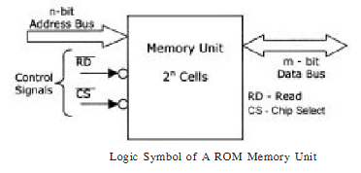

2.5 Secondary memories
The devices used to store high volumes of data are referred as mass storage devices or secondary memories. The magnetic memories and Optical memories (CD-ROMs) are such memory devices. The magnetic memories are used for very large data storage for long time, but due to their lower speed they are not connected directly to the CPU.
Due to this they are generally called secondary memory or backup storage device. Optical memories (CD-ROMs) are another type of mass storage device. The optical disks are popular due to large storage capacity, transportability and reliability.

2.5.1 Magnetic Memory
In magnetic memory devices some sort of magnetic coating (usually ferric oxide) runs throughout the base. On this coating direction of magnetic flux or direction of magnetization can be used to store 1 or 0.
These devices are called Serial Access Memory (SAM) devices, because we cannot reach the data directly and to reach a data stored we must go one after another.
Hard disks and floppy disk are common type of magnetic memories used in computers. The storage media of magnetic disks are made up of aluminum or plastic base with a thin coating magnetic on its surface where the data are actually stored.
Floppy disk
In a Floppy Disk, as shown in Figure below, the whole media is divided into a number of concentric circles, called track.
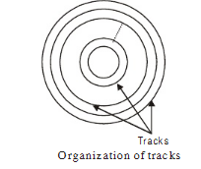
Each track is further divided into a number of sectors. In these sectors bytes of data block are stored. To reach to a stored data first a particularly track is selected, and then particular sector is reached on this track, of course starting from the very first sector on this track. To reach to required sector an external rotating mechanism is employed, thus time delay to reach particular sector is called rotational delay or latency time.
The time delay to select a particular track is called Seek time. Now-a-day the 3.5-inch floppy disk of storage capacity 1.44-MB is popular. It contains a total of 40 tracks where innermost track is numbered as Track ‘0’ and outermost track is numbered Track ‘39’. For each of the data access search starts from 1st sector of Track ‘0’. The main advantage of using floppy disk is portability, but its use is restricted by its small storage capacity.
Hard disk
A Hard Disk can be supposed to have collection of such circular disk surfaces kept in a cylinder on a common shaft, called spindle for rotation. A simple organization of hard disk storage unit is shown in Figure below.

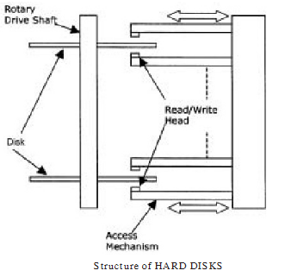
The spindle rotates the disk the disk surfaces at higher speeds, making data access faster than the floppy disks. On each disk surface there are several hundreds of tracks arranged in concentric circle as shown in Figure above. Each of the tracks is further divided into a number of sectors where data actually resides. Each of the disk surfaces is provided with the separate Read/Write head that may be connected to form a Read/write arm.
During the access operations the disks are rotated continuously by the spindle, at a constant speed.
The Read/Write arm the moves in a fixed linear path to select a particular set of tracks and the sectors on these tracks. The disk monitoring system determines which disk surface has to be accessed to find the target data.
In both the magnetic disks the digital information can be stored on disk surface by applying a current pulse to magnetization coil present in Read/Write head. This causes a change in magnetization in the area under the read/write head. The direction of magnetization will be parallel to the direction of applied field. To read the magnetically stored information on the disk the Read/Write head has to sense the state of magnetization resulting from the area under the head. Movement of magnetic disk causes change in magnetic field, which induces a voltage in the coil of head. The polarity of induced voltage is monitored to obtain the Magnetization State, which in turns gives the stored binary bit.
The principal disadvantage of magnetic disk memory is relatively slower slow speed that is attributed to slow rotational mechanism, seek and latency time and the fact that data transfer through such devices are serial. Also presence of mechanically moving parts makes magnetic memory unreliable.
But their advantage lies in two great facts that it offers very large-scale data storage for long time at very low cost per bit. There are other kind of magnetic memory devices also, namely ferrite core memory, magnetic tape memory, magnetic bubble memories etc.

2.5.2 Optical Memory
Optical memories usually take the form of optical disks which resembles magnetic disks in that they store binary information in concentric tracks on a mechanically rotated disks. The read & write operations are done with the help of Lasers, capable of producing a light spot of the order of 1 micron.
Optical discs are available in many formats: CD-ROM (compact disk-read only memory), CD-R (compact disk-recordable), and CD-RW (compact disk-rewritable). Newer high capacity version of optical disks is DVDs, the Digital Versatile Disk. Similar to the CDs, the DVDs also have different formats as DVD-ROM, DVD-R, and DVD-RW. Most of the CDs can store upto 650 MB where as the simple single layered DVD can store 4.7 GB of data.
The CD-ROM is manufactured using carefully prepared glass master. The master is pressed into injection molded polycarbonate plastic forming the CD-ROM. The resulting CD- ROM contains several small pits and lands (no pits) on the various tracks that can be processed optically. When a computer system want to read the disk, a Laser beam is aimed on the disk from the bottom and the reflection from the pits & lands are interpreted by the photo detector as logic 0s and 1s.
For the purpose of permanent storage (archival storage) the CD-Rs are very popular, and many a times known as WORM (write once read m any) storage devices. The information can be recorded on CD-R (commonly known as CD burning) by using CD-writers. During the burning process a laser heats gold reflective layer, and a dye layer in the CD-R causing it to have a dull appearance. When read by the CD-R drive the dark burnt areas (like pits) reflect less light. The CD-R reader interprets the shiny areas (lands) and the dull areas (burned) as logic 0s & 1s.
The CD-ROM and DVD-ROM both are manufactured by using the same technology and read data from a spiral track of pits and lands. However the DVD-ROM has a greater storage capacity. It is because the pits and lands on the DVD-ROM are much smaller and more closely packed, thus allowing more information per track. The tracks also are closely spaced allowing more tracks per disk. The DVD-ROMs can store 4.7 GB (single sided layer), 9.4 GB (double sided layer), or 17 GB (double sided double layered), where as the CD-ROMs can store only up to 650 MB.
The data transfer rate of a CD-ROM drive is indicated as 1x, 2x, 4x, 16x, 32x etc. A CD- ROM drive with a designation of 1x would have a max data transfer rate of 150 Kbytes/sec. Therefore a 4x drive would have a data transfer speed of 150 Kbytes/sec × 4= 1100 Kbytes/ sec. These data transfer rates are theoretical and the actual data transfer rates are usually lesser. The DVD-ROMs can provide data transfer rates of 1.38 Mbytes/sec, which is approximately same as the speed of 9x CD-ROM.
The advantages of Optical disks are huge amount of data storage, low cost, easily transferable, a few mechanical parts results in reliability, and high speed. The main disadvantage could be the complexity of Read/Write head.

Review Questions
1. What is meant by primary memory, secondary memory and mass storage devices?
2. Define the terms storage capacity, memory word, storage location, and word length.
4. Define the following terms
(i) Access Time
(ii) Cycle time
(iii) Bandwidth
(iv)Volatile
(v) Dynamic
(vi)Static
5. Explain organization of tracks in magnetic memories with the help of figure.
6. What are optical memories?
7. Explain basic semiconductor memory organization with the help of figure.
8. With the help of figure explain the memory cell addressing.
9. Explain the memory cell organization. How a particular cell can be selected in this case?
10. Explain the sequence of operation to be performed to write a data into memory?
11. A memory has access time of 50 n sec. It has an additional delay called precharge time of 20 n sec. Find out the access rate and bandwidth of this unit?
12. What is Dynamic RAM? Why they are most widely used?
12. What is Static RAM? Why they are most widely used?
13. Explain how a hard disk reads information it stores.
14. Provide advantages and disadvantages of a hard disk as a storage media
15. Explain how the CD-ROM stores data.
16. Provide advantages and disadvantages of a CD-ROM as a storage media
17. What is the difference between the CD-ROM and a DVD?

CHAPTER 3 SYSEM BUSES AND BASIC CARDS

3.1 System buses

All the basic components of the computer are connected together by communication paths that are referred to as buses. The system bus is a parallel collection of conductors that carry data and control signals from one component to the other. Recall that the conductors in modern computers are actually metallic traces on the circuit board.
The system bus combines the functions of a data bus to carry information, an address bus to determine where it should be sent, and a control bus to determine its operation as shown in the figure below.
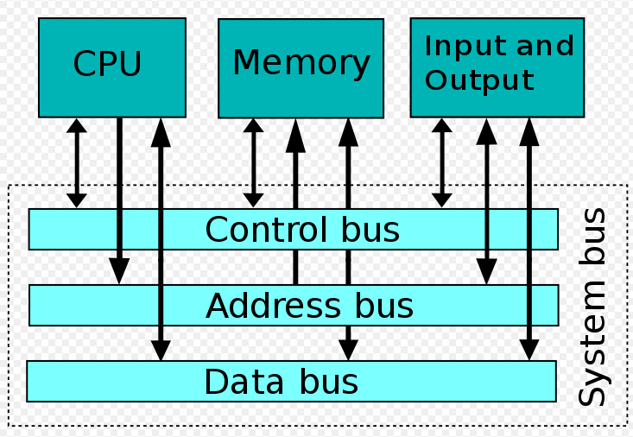

- The address bus is a uni-directional pathway, which means that information can only flow one way. Its function is to carry addresses generated by the CPU to the memory and I/O elements of the computer. The number of conductors in the bus determines the size of the address bus; this, in turn, determines the number of memory locations and I/O elements that the microprocessor can address.

- The data bus, unlike the address bus, is a bi-directional pathway for data flow, which means that information can flow in two directions. Data can flow along the data bus from the CPU to memory during a write operation, and data can move from the computer memory to the CPU during a read operation. The data bus size, measured in bits, represents the computer word size. Generally, the larger the bus size, the faster the computer system. Common data bus sizes are 8-bits or 16-bits (older systems) and 32 bits (new systems). 64-bit data bus systems are currently being developed.
- The control bus carries the control and timing signals needed to coordinate the activities of the entire computer. Control bus signals, unlike information carried by the data and address buses, are not necessarily related to each other. Some are output signals from the CPU, and others are input signals to the CPU from I/O elements of the system. The most common control signals in use today are:

  - System Clock (SYSCLK)
  - Memory Read (MEMR)
  - Memory Write (MEMW)
  - Read/Write Line (R/W Line)
  - I/O Read (IOR)
  - I/O Write (IOW)

3.1.1 Types of buses
The CPU has to be able to send various data values, instructions, and information to all the devices and components inside a computer as well as the different peripherals and devices attached. A look at the bottom of a motherboard provides a whole network of lines or electronic pathways called buses that join the different components together.
A computer's bus can be divided into two different types:
- Internal buses or system bus
- External buses.
The Internal Bus connects the different components inside the case such as the CPU, system memory, and all other components on the motherboard. It's also referred to as the System Bus.
The External Bus connects the different external devices, peripherals, expansion slots, I/O ports and drive connections to the rest of the computer. In other words, the External Bus allows various devices to be added to the computer.
The external bus allows for the expansion of the computer's capabilities. It is generally slower than the system bus. Another name for the External Bus is the Expansion Bus.

3.1.2 Expansion Bus and Expansion Slots
Expansion Slot (connector): Expansion bus, or external bus, is made up of the electronic pathways that connect the different external devices to the rest of your computer.
These external devices such as monitor, telephone line and printer connect to ports on the back of the computer. Those ports are actually part of a small circuit board or 'card' that fits into a connector on your motherboard inside the case. These connectors are called an expansion slots.
Based on the speed, capability and performance, Expansion slots are of various types including:
- ISA (Industry standard architecture slots)
- EISA(Enhanced Industry standard architecture slots)
- PCI (Peripheral Component Interconnect slots)\
- AGP (Accelerated Graphic Port slot)
All these expansion slots may or may not be found on the computer motherboard depending on the type of system board, but An ISA card fits into an ISA slot, a PCI adapter card must be installed into a PCI expansion slot.
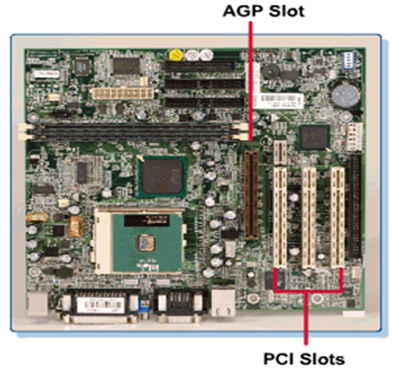
ISA BUS
The Industry Standard Architecture (ISA) is a 16-bit expansion slot developed by IBM. It transfers data with the motherboard at 8 MHz. ISA slots are becoming obsolete and are being replaced by PCI slots in new systems. ISA slots are found on old AT (Advanced Technology) motherboards. However, many motherboard manufacturers may still include one or two for backward compatibility with older expansion cards.

Extended ISA Bus (EISA)
As a result of the advanced architecture, IBM introduced the 32-bit, Extended ISA (EISA) bus, which accommodates the Pentium chip.
EISA has a 32-bit data path and is capable of using multiple bus mastering devices. The EISA bus has no need for interrupts or DMA channels and is configured with software, using a configuration utility and a device specific program. It still only has an 8 MHz bus speed.
The socket itself is taller than the 16-bit ISA. The EISA expansion cards have two horizontal rows of metal contacts on their edge connector making ISA cards to do not fit in EISA sockets.
PCI BUS
The Peripheral Component Interconnect (PCI) is a 32-bit local bus slot developed by Intel. Since they talk to the motherboard at 33 MHz, the PCI bus slots offer a significant improvement over ISA or EISA expansion slots. With the PCI bus, each add-on card contains information that the processor uses to automatically configure the card. The PCI bus is one of the three components necessary for plug-and-play. The main purpose of the PCI bus is to allow direct access to the CPU for devices such as memory and video. PCI expansion slots are the most commonly used type in ATX motherboards today.
AGP SLOTS
The Accelerated Graphics Port (AGP) was developed by Intel, AGP is a dedicated high-speed bus that is used to support the high demands of graphical software. This slot is reserved for video adapters. This is the standard graphics port in all new systems. On AGP-equipped motherboards, a single AGP slot holds the display adapter, and the PCI slot can be used for another device. Slightly shorter than the white PCI slot, the AGP slot is usually a different color and is located about an inch beyond the PCI slot. The latest version of the accelerated graphics port, AGP-4, came out in 1992. It offers a 1 gigabyte (GB) transfer rate.
IEE RS 232 BUS
In telecommunications, RS-232 (Recommended Standard 232) is the traditional name for a series of standards for serial binary single-ended data and control signals connecting between a DTE (Data Terminal Equipment) and a DCE (Data Circuit-terminating Equipment). It is commonly used in computer serial ports. The standard defines the electrical characteristics and timing of signals, the meaning of signals, and the physical size and pin out of connectors.
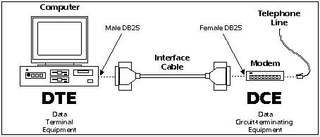
Figure below: DB 9 RS 232 Pinout
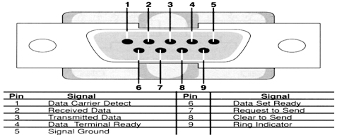
Universal Serial Bus (USB)
The Universal Serial Bus (USB) is an external port, Figure above, that allows the user to connect up to 127 external PC peripherals, including USB keyboards, mice, printers, modems, scanners, and external disk drives. It offers a data transfer rate of up to 12 Mbps. The latest version, USB 2.0 is much faster and transfers data at a rate of 450 Mbps. Seven USB devices can typically be connected directly to the computer using the standard USB four-pin connector. USB devices can be hot-plugged (hot-swapped). This means that they can be attached while the computer is already powered up and running. USB devices are also plug-and-play.
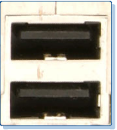

3.1.3 IRQs - Interrupt Request lines
Interrupt Request lines are special pathways directly to the processor that a device uses to get the attention of the CPU when it needs to communicate to it. Actually, the lines go through an interrupt controller which is usually part of the chipset on your motherboard (South Bridge) that checks the information and its source before passing it on to the CPU. Each line has a specific number and the CPU associates that number with a certain device. Each device is also assigned a priority level. When an interrupt request is received, the processor will put aside what its doing and handle the request. When it's finished, it will return to the task it was at originally. However, if an IRQ is received and the task being performed has a higher priority, then it will finish the task before the interrupt is handled.
IRQ stands for Interrupt ReQuest, and refers to special numbered channels that are used by devices to get the processors attention. For example, when you press a key on your keyboard it sends a signal to the processor via an IRQ channel (usually IRQ 1) to let it know that it needs to process some data.

3.1.4 Resolving IRQ conflict

IRQ conflicts can occur when new hardware is installed or reconfigured. For example, it can cause problems if you have your mouse on COM 1 (IRQ4) and a modem on COM 3 (IRQ4), below is a list of the default assignments for IRQ channels in Windows XP.
Viewing your current IRQ assignments
To view your current IRQ assignments you can open Device Manager.
- Click on START, click on CONTROL PANEL.
- Click on Performance and Maintenance.
- Click on System.
- Click on the Hardware tab.
- Click the DEVICE MANAGER Button.

Once you have Device Manager open, select VIEW from the toolbar menu, and then click Resources by Type. Double click on Interrupt Request (IRQ):
The list that appears on your machine will vary depending on the hardware you have. If you are experiencing problems with a newly installed/configured piece of hardware and the drivers are installed correctly, then check to see if it has its own IRQ channel.

Changing IRQ Settings
Warning: Changing system resources such as IRQ channels can result in your computer not functioning correctly, always make a note of the settings before you change anything so you can restore them back if required.
If you do have a conflict and need to change an IRQ setting:
- Right click on the device in the list (see above), and then select properties.
- Click the Resources tab.
- Remove the tick from the Use automatic settings option.
- Select a non-conflicting configuration from the pull down box.
- Click OK
You may find you cannot manually change your IRQ settings (the Use automatic settings will be greyed out).
To resolve conflicts with PCI or ISA cards, try manually setting them in your motherboard's BIOS, or try a different slot for the newly installed device. You will usually find that by changing the slot you will change the IRQ channel as well.

3.1.4 DMA Channels
DMA stands for Direct Memory Access. These are channels which allow specific devices such as hard drives, CD ROMS, tape drives and sound cards to access memory directly, without having to pass through the CPU. This allows for faster data transfers. Once again, each device requires its own channel. If two devices are assigned the same DMA channel, neither will write to memory properly, and a resource conflict could freeze up your system.

3.1.5 I/O Addresses
Each device on a computer is assigned and allocated a specific area in memory to exchange data and information with the rest of the computer. The size of the memory area, or segment, allocated for exchange may differ between devices. The I/O address (or Input/ Output address) is the starting address for the area in memory assigned to a particular device, and is given in hexadecimal notation. As you know, an IRQ is a line directly to the CPU to get its attention, well; an I/O address is kind of like a reverse IRQ. It allows access back to that device.
If a CPU wants a particular device to do something, it sends a signal or instructions to the device's I/O address. The device then carries out the instructions and responds via the data bus or DMA channels.

3.1.6 Bus Mastering
Originally, to write from one device to another, the CPU had to acknowledge the interrupt from the one device, receive the data, then access the other device via the I/O address, and transmit the information. The transfer between devices was controlled by the CPU.
Newer expansion bus types included a bus controller. This circuitry, included with the circuitry on a particular device, could allow the device to control its own transfer of data to another device, freeing up the CPU for other tasks. A device with these capabilities is called a Bus Mastering device.

3.2 Basic cards

3.2.1 IDE, EIDE and SCSI controllers

IDE and SCSI Controllers

The hard drive along with other devices can use one of two types of interface controllers in order to communicate with the computer. These include the Integrated Drive Electronics (IDE), and Small Computer System Interface (SCSI) connections

IDE Drive Interface Controllers
Integrated Drive Electronics (IDE) is a type of hardware interface widely used to connect hard disks, CD-ROMs, and tape drives to a PC. IDE is very popular because it is an economical way to connect peripherals. Starting out with 40 MB capacities years ago, 20 GB IDE hard disks have become entry level, costing less than half a cent per megabyte.
The IDE interface is officially known as the AT Attachment (ATA) specification. ATA Packet Interface (ATAPI) defines the IDE standard for CD-ROMs and tape drives. ATA-2 (Fast ATA) defined the faster transfer rates used in Enhanced IDE. ATA-3 added interface improvements, including the ability to report potential problems.
With IDE, the controller electronics are built into the drive itself, requiring a simple circuit in the PC for connection. IDE drives were attached to earlier PCs using an IDE host adapter card. Today, two Enhanced IDE (EIDE) sockets are built onto the motherboard, and each socket connects to two devices via a 40-pin ribbon cable. Starting with ATA-66 drives, the cable uses 80 wires and 39 pins. It plugs into the same socket with one pin removed.
Enhanced IDE (EIDE)

Enhanced IDE (EIDE) or ATA-2 disk drives is the "new and improved" IDE. Not confined to IDE's 528 MB of data, the EIDE interface can handle up to 8.4 GB or more. While IDE can support only two drives, EIDE can support up to four devices using two IDE cables that have 40-pins and a maximum length of 18-inches. Additionally, EIDE supports non-disk peripherals that follow the ATAPI protocol. The EIDE interface is often described as an ATAPI (AT Attachment Packet Interface), or a Fast ATA (Fast AT Attachment) interface. ATAPI is the protocol used by enhanced IDE devices such as IDE CD-ROM drives, IDE external tape backup drives, and so on.

SCSI Interface Controller

The Small Computer Systems Interface (SCSI) controller was developed in 1979 at Shugart Associates Standard Interface (SASI). Like EIDE, SCSI devices have the controlling electronics on each of the drives. However, SCSI is a much more advanced interface controller than EIDE. It is ideal for high-end computers, including network servers.

3.2.2 VGA
A video card, video adapter, graphics accelerator card, display adapter, or graphics card is an expansion card which generates output images to a display. Most video cards offer added functions, such as accelerated rendering of 3D scenes and 2D graphics and TV-tuner adapter. Other modern high performance video cards are used for more graphically demanding purposes, such as PC games. The figure below shows the video card.

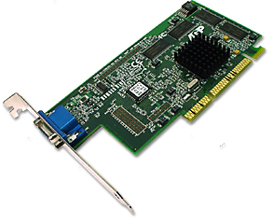

3.2.3 Network interface card
A network interface card (NIC) is a device that plugs into a motherboard and provides ports for the network media connections. It is the component of the computer that interfaces with the local-area network (LAN). When network interface cards are installed in a computer, the IRQ, I/O address, and memory space for the operating system drivers will be set automatically in order to perform their function. However, with older NICs these settings would have needed to be set manually.
The following information is important to consider when selecting a NIC to use on a network:
- The type of network – NICs are designed for Ethernet LANs, Token Ring, Fiber Distributed Data Interface (FDDI), and others. A NIC designed for Ethernet LANs will not work for Token Ring networks and vice versa.
- The type of media – The type of port or connector on a NIC that provides network connection is media specific. The media types include twisted-pair, coaxial, fiber-optic, and wireless.
- The type of system bus – The Protocol Control Information (PCI) slots are faster than Industry-Standard Architecture (ISA). It is recommended that PCI be used with FDDI cards since an ISA bus will not be able to handle the speed required

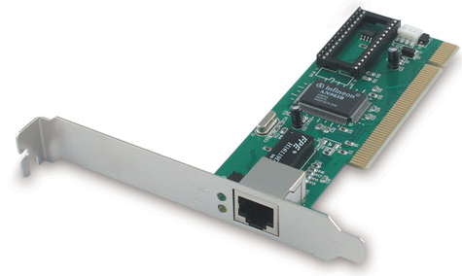

3.2.4 Setting the IP address

In a TCP/IP-based LAN, PCs use Internet Protocol (IP) addresses to identify and locate each other. An IP address is a 32-bit binary number. This binary number is divided into 4 groups of 8 bits known as octets, each of which is represented by a decimal number in the range of 0 to 255. The octets are separated by decimal points. An example of an IP address is 190.100.5.54. This type of address is described as a dotted decimal representation. Each device on the network that has an IP address is known as a host or node.
A secondary dotted decimal number, known as the subnet mask, always accompanies an IP address. A subnet mask is a tool used by a system administrator to segment the network address that has been assigned to the network the technique of subnetting allows the entire network to be represented to the Internet by one address. An example of a subnet mask is 255.255.0.0. The subnet mask is also used to determine whether a particular host IP address is local (on the same network segment) or remote (on another segment).
There are several options for assigning IP addresses for hosts on a LAN:
- Static – Assigned by the network administrator manually
- Dynamic – Assigned by a Dynamic Host Configuration Protocol (DHCP) server (DHCP servers are discussed in the next section.)
- Automatic – Private IP addressing
If there are more than a few computers, manually configuring TCP/IP addresses for every host on the network can be a time consuming process. This also requires that the network administrator assigning the addresses understands IP addressing and knows how to choose a valid address for the particular network. An IP address is unique for each host. The IP address is stored in the Network Settings of the Operating System Software. It is commonly referred to as the logical address. TCP/IP addressing will be taught later in this course.
In the Windows operating system, the IP address is manually entered into the TCP/IP properties dialog box. Figure below shows the TCP/IP configuration box, which is used to set the address settings, or configurations that are entered, which include the following:
- An IP address
- A subnet mask
- Default gateway address
- Optional values including a Domain Name System (DNS) server address and Windows Internet Naming Service (WINS)
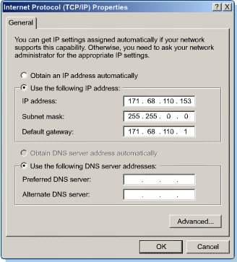

Review questions

1. Define a computer system bus.
2. Explain the types of system buses based on the type of information they carry.
3. What is the difference between internal and external buses?
4. What do you understand by expansion bus?
5. With a block diagram explain the system bus related to computer operation.
6. Explain various expansion slots available on a computer motherboard.
7. Give the difference between ISA and EISA expansion slots.
8. Differentiate ISA from PCI expansion slots.
9. What do you understand by interrupt request lines in a computer?
10. Explain the function of DMA channels and I/O addresses.
11. Explain the term “Bus Mastering”.
11. Differentiate IDE from EIDE controller.
12. Explain the factors you would base on while selecting a network interface card to
Purchase.

CHAPTER 4 POWER DEVICES

4.1 SMPS: Switching Mode Power Supply

The electric power normally is not used in the form in which it was produced or distributed. Practically all of electronic systems require some form of power conversion. A device that transfers electric energy from the source to the load using electronic circuits is referred to as Power Supply, although "power converter" would be a more accurate term for such a device.
A typical application of a power supply is to convert utility AC voltage into regulated DC voltages required for electronic equipment. Nowadays in most power supplies providing more than a few watts the energy flow is controlled with power semiconductors that are continuously switching on and off with high frequency. Such devices are referred to as switch mode power supplies or SMPS. In general, SMPS can be classified into four types according to the form of input and output voltages: AC to DC (off-line power supply or a rectifier); DC to DC (voltage converter); AC to AC (frequency changer or cycloconverter); DC to AC (inverter).
The field of engineering that deals with the design and analysis of power conversion circuits and devices is called power electronics. This site is the power electronics information guide. Here you will find tutorials, tools, links and resources on all aspects of switching power supply design, information on other energy conversion devices, as well as basic electrical engineering and electronics reference.

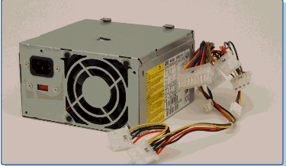

4.2 Constant Voltage Transformer (CVT)

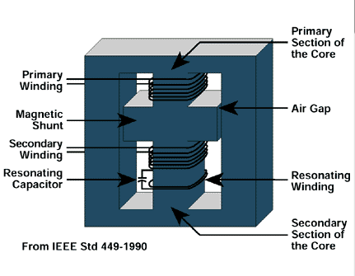
The very best power protection comes from a special type of transformer known as a Constant Voltage Transformer (CVT). Providing unparalleled reliability and conditioning performance, spikes and electrical noise are neutralised with attenuation as high as 75dB.
In addition the input (or primary) and output (or secondary) transformer windings are physically separated. Known as Galvanic isolation this separation ensures that there is no direct connection between the mains supply and load.
A CVT therefore provides an impenetrable barrier to spikes and high frequency electrical noise. This barrier also works in reverse mode to prevent a 'noisy' load from polluting the mains supply itself.

4.3 Uninterruptible Power Supply

An Uninterruptible Power Supply (UPS), also known as an Uninterruptible Power Source, Uninterruptible Power System, Continuous Power Supply (CPS) or a battery backup is a device which maintains a continuous supply of electric power to connected equipment by supplying power from a separate source when utility power is not available. There are two distinct types of UPS: off-line and line-interactive (also called on-line).
An off-line UPS remains idle until a power failure occurs, and then switches from utility power to its own power source, almost instantaneously. An on-line UPS continuously powers the protected load from its reserves (usually lead-acid batteries or stored kinetic energy), while simultaneously replenishing the reserves from the AC power.
The on-line type of UPS, in addition to providing protection against complete failure of the utility supply, provides protection against all common power problems, and for this reason it is also known as a power conditioner and a line conditioner.
While not limited to safeguarding any particular type of equipment, a UPS is typically used to protect computers, telecommunication equipment or other electrical equipment where an unexpected power disruption could cause injuries, fatalities, serious business disruption or data loss. UPS units come in sizes ranging from units which will back up a single computer without monitor (around 200 VA) to units which will power entire data centers or buildings (several megawatts). Larger UPS units typically work in conjunction with generators.
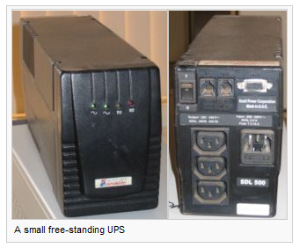
Historically, UPSs were expensive and were most likely to be used on expensive computer systems and in areas where the power supply is interrupted frequently. As prices have fallen, UPS units have become an essential piece of equipment for data centers and business computers, and are also used for personal computers, entertainment systems and more.
In certain countries, where the electrical grid is under strain, providers struggle to ensure supply during peak demand (such as summer, when air-conditioning usage increases). To prevent unplanned blackouts, electrical utilities will sometimes use a process called rolling blackouts or load shedding, which involves cutting the power to large groups of customers for short periods of time. Several major blackouts occurred in 2003, most notably the 2003 North America blackout in the north-eastern US and eastern Canada and the 2003 Italy blackout, both of which affected over 50 million people, and brought attention to the need for UPS power backup units.
A UPS should not be confused with a standby generator, which does not provide protection from a momentary power interruption and may result in an interruption when it is switched into service, whether manually or automatically. Such generators are typically placed upstream of the UPS to provide cover for lengthy outages. Integrated systems that have UPS and standby-generator components are often referred to as emergency power systems.

REVIEW QUESTIONS

1. Give different DC voltage level produced by ATX power supply with their use.
Specify also the colors of the power supply wires with their voltages.
2. Give different DC voltage level produced by AT power supply with their use.
Specify also the colors of the power supply wires with their voltages.
3. What is the main difference between AT and ATX power supplies?
4. What is an off-line UPS?
5. What is an Online UPS?
6. What is the difference between online and offline UPS?

..

UNIT TWO

CHAPTER 1 HOW THE COMPUTER WORKS

1.1 System overview

1.1.1 Input, process, output, and storage

The operating system is the software that controls functionality and provides lower-level routines for application programs. Most operating systems provide functions to read and write data to files. An operating system translates requests for operations on files into operations that the disk controller can carry out. The operating system helps the computer perform four basic operations, which include input-process-output-storage:

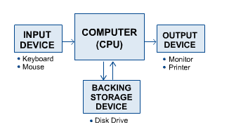
- The input operation recognizes input from the keyboard or mouse.
- The processing operation manipulates data according to the user’s instructions.
- The output operation sends output to the video screen or printer.
- The storage operation keeps track of files for use later. Examples of storage devices include floppy disks and hard drives.
The most common way to input data into a computer is from the keyboard. Opening a web page, an e-mail file, or a file that came from a network server are also ways to input data. After the data has been input, the computer can process or crunch the data. While a file is open and the text is being reformatted, the computer is processing data.
Processing data usually results in some kind of output, such as a word processor file or a spreadsheet. The most common way to output data is to send it to the computer monitor, or to a printer. Today, most computers have a connection to the Internet, making it common to output the data to the Internet via e-mail or as a web page.
Data storage is probably the most important of the four basic computer functions. The most common way to store a file is to save it to a hard drive. Hard drives can be thought of as very large file cabinets. An operating system will find a place on the hard drive, save the file, and remember its location.

1.2 The Boot Process

1.2.1 Initializing and testing the system hardware
For an operating system to run, it must be loaded into the computer random access memory (RAM). When a computer is first turned on, it launches a small program called the bootstrap loader that resides in the Basic Input Output System (BIOS) chip or firmware. The term bootstrap comes from the phrase “picking yourself up by the bootstraps”, hence the term booting the computer. The primary functions of the bootstrap loader are to test the computer hardware and to locate and load the operating system into RAM. Because the bootstrap program is built into the BIOS chip, it is also referred to as BIOS control. During the execution of the BIOS firmware routines, three major sets of operations are performed:
- Power-On Self-Tests (POST) are run.
- Initialization is done.
- BIOS moves the starting address and mode information into the DMA controller then loads the Master Boot Record (MBR)
Power-on Self-Test (POST)
To test the computer hardware, the bootstrap program runs a program called power-on self-test or POST. In this test, the computer central processing unit (CPU) checks itself first and then checks the computer system timer. The POST checks the RAM by writing data to each RAM chip and then reading that data. Any difference indicates a problem.
If the POST finds errors, it sends a message to the computer monitor. If the POST finds errors that cannot be displayed on the monitor, it sends errors in the form of beeps. If the POST does not find errors, the POST sends one beep and the screen begins to display OS loading messages. The meaning of any beep code depends on the manufacturer of the BIOS. There are three major manufacturers of BIOS chips. They are AMIBIOS (American Megatrends, Inc.), Phoenix BIOS (Phoenix Technologies Ltd.), and Award BIOS (Award Software, Inc.). These manufacturers all have very different beep codes, even between versions of their BIOS. It is normal to hear a single beep during the boot process, as long as the boot process does not stop. This is a code to signify that the computer is starting normally.

POST errors
Every time the computer is turned on, it runs through a Power-On Self-Test (POST). The POST is a series of self-diagnostic tests that the computer runs through to test the major hardware. It is the first task run by the computer BIOS. The POST performs basic test routines on the motherboard and major hardware devices. It does not perform in-depth testing on the computer system. It can only detect major failures that will prohibit the boot up process.
The POST is stored in the computer ROM BIOS. As the computer is turned on, the POST function is passed to the first bank of RAM. For example, the computer checks for a properly functioning system timer, CPU, video card, memory, and keyboard during the POST. If an error occurs, the BIOS has predefined error codes that will be reported to the users. These errors can be reported visually or through a series of beep codes.
The beep code error messages are useful troubleshooting aides. If the BIOS encounters any hardware errors while running the POST routine, it will issue a series of beeps. These beep codes indicate or confirm that there is a problem with the computer hardware. Beep codes are produced with a combination of short and long beeps. Beep codes for a computer with AMI BIOS are described in table below.
Beeps | Error Message | Description
1 short | DRAM refresh failure | The programmable interrupt timer or programmable interrupt controller has probably failed
2 short | Memory parity error | A memory parity error has occurred in the first 64K of RAM. The RAM IC is probably bad
3 short | Base 64K memory failure | A memory failure has occurred in the first 64K of RAM. The RAM IC is probably bad
4 short | System timer failure | The system clock/timer IC has failed or there is a memory error in the first bank of memory
5 short | Processor error | The system CPU has failed
6 short | Gate A20 failure | The keyboard controller IC has failed, which is not allowing Gate A20 to switch the processor to protected mode. Replace the keyboard controller
7 short | Virtual mode processor exception error | The CPU has generated an exception error because of a fault in the CPU or motherboard circuitry
8 short | Display memory read/write error | The system video adapter is missing or defective
9 short | ROM checksum error | The contents of the system BIOS ROM does not match the expected checksum value. The BIOS ROM is probably defective and should be replaced
10 short | CMOS shutdown register read/write error | The shutdown for the CMOS has failed
11 short | Cache error | The L2 cache is faulty
1 long, 2 short | Failure in video system | An error was encountered in the video BIOS ROM, or a horizontal retrace failure has been encountered
1 long, 3 short | Memory test failure | A fault has been detected in memory above 64KB
1 long, 8 short | Display test failure | The video adapter is either missing or defective
2 short | POST Failure | One of the hardware testa have failed
1 long | POST has passed all tests
Note: The error reports generated by the POST will vary slightly depending on the BIOS that is installed on the computer.

1.2.2 Loading the operating system and hardware configuration
The next step for the bootstrap program is to locate the OS and copy it to the computer RAM. The bootstrap loader first looks to see if the OS boot file (or boot record) is located on a floppy drive. If not, it looks for it on the hard disk. In some cases, if the operating system is not found on either the floppy drive or the hard disk, the bootstrap loader will look for the OS on the built-in CD-ROM.
However, the most common means of storing the OS is on the computer hard drive. The order in which the bootstrap program searches the OS boot up file can be changed in the system BIOS setup.

The most common order of search is as follows:
- floppy drive
- hard drive
- CD-ROM
When the bootstrap finds the OS boot record, it is copied to the computer RAM and the bootstrap program turns over the control of the boot process to the boot record. The boot record looks for files on the hard disk that help the hard disk find and locate the rest of the OS. As files are located and loaded into RAM, the boot record is no longer needed. The OS that was stored on the hard disk is now in control of the boot process.
The last step of the boot process is for the OS to find hardware configuration files that are specific to the computer. If the computer has a modem or a sound card, the OS finds their configuration files (hardware drivers) and loads them.

1.2.3 The boot sequence
The PC boot sequence defines the set of actions as well as the sequence of the actions that take place when the computer is started from a power-off status or when the PC is restarted with the power already on. The number of events that happen in the boot process depends on the version of Windows and whether it is a cold boot or a warm boot.
- A warm boot is performed whenever the PC is restarted or reset with the power still on. The warm boot is accomplished in one of the following ways:
  - By choosing Start > Shutdown > Restart
  - By pressing the computer's reset button
  - By pressing Ctrl + Alt + Del twice.
- A cold boot begins whenever the PC power switch is turned on. A cold boot involves many more events and bootstrap (BIOS) activities than a warm boot. A cold boot causes the BIOS to guide the computer’s boot sequence through a series of steps that verify the system’s integrity.

1.3 Hardware Components

1.3.1 Computer cases and power supplies
The computer case and the power supply are two very important parts that help determine the performance of the system. The type of motherboard used is usually determined by the type of case and power supply. The power supply is usually included in the computer case.

Computer Cases
The type of case is the first decision when building a computer. The case is made up of the metal chassis (or frame), and a cover, usually constructed of metal or hard plastic. The case is the housing unit for the internal components and protects against dust and damage. The case usually comes with the power supply needed to power the computer and the installed components. Computer cases are either desktop as shown below,

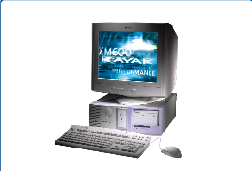

or a tower case model as illustrated here below.

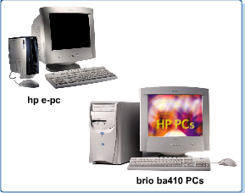
- The desktop model sits on a desk horizontally. The monitor can be set on top. This choice can be a space saver.
- The tower model stands upright in a vertical position that allows easy placement on the floor.
The choice of a desktop case or tower is a matter of personal preference. However, it is important to consider the workspace before choosing a case.
Hardware components are installed in the bays of the case. The bays are placeholders for the drives so they are neatly organized. Devices may be easily interchanged from bay to bay if necessary.
Drive bays are 5.25 inches or 3.5 inches wide and some are normally left unfilled in a new computer. This allows the machine to be upgraded with a ZIP drive, tape back up, or a CD-ROM burner.
Power Supplies
A power supply provides the needed voltage to power the various electronic circuits that make up the PC. It receives the external AC power.

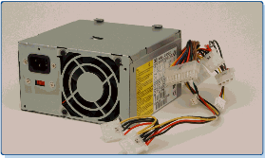
The power supply is contained in a metal box. Within this box, a transformer converts the voltage that is supplied from standard outlets into voltages that the computer parts need to operate.
Tip: Power supplies are rated in watts. A typical computer has a 250-300 watt power supply.
A fan installed in the power supply prevents the computer and its components from overheating by maintaining an air flow. It is critical that these components be kept at a consistent operating temperature to ensure their best performance. The fan is built into the power supply with openings on the backside of the case. Never block or cover the fan inlet port.
There are several different types of power supplies, varying in size and design. The more common types are known as the AT and ATX power supply form factors. AT type supplies are no longer used in new systems, and are generally found on computers built prior to the mid-1990s. ATX is the more common power supply. Probably the easiest way to distinguish the AT and ATX is from the nature of their connectors.
The devices that attach to the power supply use +5v, +12v, and +3.3v DC power. Older devices (PC/XT and early AT) also use –5v and –12v DC power.

1.3.2 The motherboard

Knowledge of the motherboard, also called the system board or main board, is crucial because it is the nerve center of the computer system. Everything else in the system plugs into it, is controlled by it, or depends on it to communicate with other devices on the system. The system board is the largest of the printed circuit boards and every system has one.
It generally houses the CPU, the controller circuitry, the bus, RAM, expansion slots for additional boards, and ports for external devices. In addition, it contains the Complementary Metal-Oxide Semiconductor (CMOS) (pronounced C moss), other Read Only memory (ROM), BIOS chips, and support chips providing varied functionality. All components relating to the system unit connect directly to the system board. External devices such as the mouse, keyboard, or monitor would not be able to communicate with the system unit without the system board.
Figure below shows the components of an ATX motherboard and how they fit together.

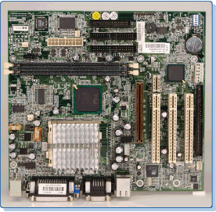
Motherboard Form Factors
Motherboards or system boards or main boards are described by their form factors, which describe their physical dimensions. The two most common form factors in use today are the Baby AT motherboard and the ATX motherboard. The ATX motherboard is similar to the Baby AT motherboard, except for a number of important enhancements. Most new systems come with the ATX motherboard form factor.

ATX motherboard distinguishing features include the following:
- The expansion slots are parallel to the short side of the board, which allows more space for other components.
- The CPU and RAM are located next to the power supply. These components consume a lot of power, so they need a lot of cooling by the fan of the power supply.
- ATX motherboards contain an integrated I/O port and PS/2 mouse connectors.
- ATX motherboard supports 3.3 volts operation from an ATX power supply.
Motherboard Chipset: The chipset is a crucial component of the motherboard. The motherboard chipset literally determines the motherboard compatibility with several other vital system components. Based on Intel Pentium-class microprocessors, the term chipset often refers to a specific pair of chips on the motherboard: the northbridge and the southbridge. The northbridge links the CPU to very high-speed devices, especially main memory and graphics controllers, and the southbridge connects to lower-speed peripheral buses (such as PCI or ISA). In many modern chipsets, the southbridge actually contains some on-chip integrated peripherals, such as Ethernet, USB, and audio devices.

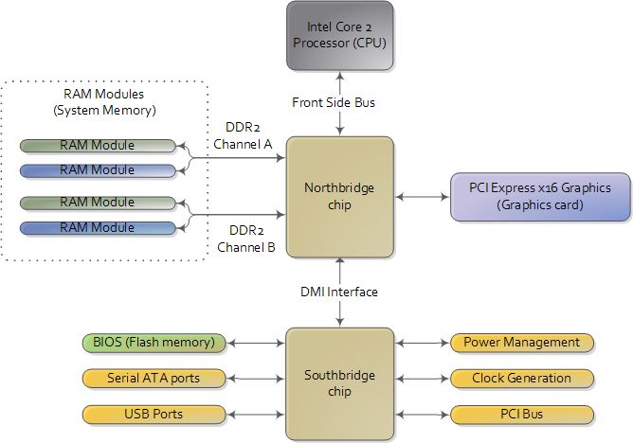

The chipset determines:
- How much RAM a motherboard can use
- The type of RAM chip
- Cache size and speed
- Processor types and speed
- Types of expansion slots the motherboard can accommodate
There are many manufacturers of chipsets. Intel currently produces some of the fastest chipsets.

1.3.3 The CPU

The CPU is one of the most important elements of the personal computer. On the motherboard, the CPU is contained on a single integrated circuit called the microprocessor. The computer will not run without a CPU. Often referred to as the brains of a computer, the The processor handles most of the operations that are required of the computer by processing instructions and sending signals out, checking for connectivity, and ensuring that operations and hardware are functioning properly. It acts as a messenger to major components such as RAM, the monitor, and disk drives. The microprocessor is connected to the rest of the computer system through three buses, including the data bus, address bus, and control bus. There are many different companies that produce CPUs, including Intel, Advanced Micro Devices (AMD), and Cyrix.
Pentium Processors
The current family of the Intel Pentium microprocessors includes the Pentium II, III, IV and Xeon. The Pentium class is the current standard for processor chips. These processors represent the Intel processor second and third generations. By combining memory cache with microprocessor circuitry, the Pentium supports processor speeds of 1,000 MHz and more. The combined chips cover less than 2 square inches (6 sq cm) and comprise over a million transistors.
The Pentium processors have made several improvements over their predecessor, which evolved from the Intel 80486. For instance, the Pentium data bus is 64 bits wide and can take in data 64 bits at a time, compared to 32 bits with the Intel 486. The Pentium has multiple caches of storage totaling as much as 2 MB compared to the 8 kilobytes of the Intel 486.
Processor Speed Rating
CPU descriptions as Pentium 133, Pentium 166, or Pentium 200 are well known. These numbers are specifications that indicate the maximum (reliable) operating speed at which the CPU can execute instructions.
The CPU speed is not controlled by the microprocessor itself, but by an external clock located on the motherboard. The speed of the processor is determined by the frequency of the clock signal.
It is typically expressed in megahertz (MHz), and the higher the number, the faster the processor. Processor speeds are getting faster all the time. Currently, there are processors with speeds of up to 2.3 gigahertz (2,300 MHz). The CPU speed and the frequency of the clock signal are not always at a one-to-one ratio. This is because the CPU can run at a much higher MHz than the other chips on the motherboard. A variable-frequency synthesizer circuit built into the motherboard circuit multiplies the clock signal so that the motherboard can support several speeds of CPUs. Generally, three factors determine how much information can be processed at any given time. These include:
- The size of the internal bus
- The size of the address bus
- The processor's speed ratings

1.3.4 BIOS
The instructions and data in the ROM chip that control the boot process and the computer hardware are known as the basic input/output system (BIOS), sometimes called firmware. The ROM chip that contains the firmware is called the ROM BIOS chip. It is also referred to as ROM BIOS, or simply BIOS, and is usually marked “BIOS” on the motherboard. The system BIOS is a very critical part of the computer. In fact, if the CPU is considered the brains of the computer, the system BIOS is considered the heart of the system. It determines what hard drive the user has installed, whether there is a 3.5-inch floppy drive, what kind of memory is installed, and many other important parts of the system hardware at startup. The responsibility of the BIOS is to serve as a liaison between the computer operating software and the various hardware components that support it. These responsibilities include:
- Hosting the setup program for the hardware
- Testing the system in a process known as POST
- Controlling all the aspects of the boot process
- Producing audio and video error codes, when there is a problem during the POST
- Providing the computer with basic instructions to control devices in the system
- Locating any BIOS codes on expansion cards and executing them
- Locating a volume or boot sector from any drives to start the operating system
- Ensuring hardware and system compatibility
The BIOS is easy to locate because it is larger than most other chips, and it often has a shiny plastic label containing the manufacturer name, the serial number of the chip, and the date the chip was manufactured. This information is vital when the time comes to select the correct upgrade for the chip.

1.3.5 Expansion slots

Expansion slots, also known as sockets, are receptacles on the computer motherboard that accept printed circuit boards. All computers have expansion slots that allow additional devices to be added. Video cards, I/O cards, and sound cards are examples of components that are located in expansion slots.
There are several types of expansion slots on a motherboard. The number and type of expansion slots in the computer determines future expansion possibilities. The common expansion slots that are likely to be encountered include the following:

1.3.6 RAM and Cache

Random access memory (RAM) is the place in a computer where the OS, application programs, and data in current use are kept so that they can be quickly reached by the processor. The cache (pronounced CASH) is a place to store something temporarily. For example, the files automatically requested by looking at a web page are stored on the hard disk in a cache subdirectory under the directory for the browser.
Random Access Memory (RAM)
RAM is considered temporary or volatile memory. The contents of RAM are lost when the computer power is turned off. RAM chips on the computer motherboard hold the data and programs that the microprocessor is processing. In other words, RAM is memory that stores frequently used data for rapid retrieval by the processor. The more RAM a computer has the more capacity the computer has to hold and process large programs and files. The amount and type of memory in the system can make a big difference in the system performance. Some programs have more memory requirements than others. Typically a computer running Windows 95, 98, or ME would have 64 MB installed. It is common to find systems with 128 MB or 256 MB of RAM, especially if they are running newer operating systems such as Windows 2000 or other network operating systems.
There are two classes of RAM that are commonly used today. These are Static RAM (SRAM) and Dynamic RAM (DRAM).
- SRAM is relatively more expensive, but it is fast and holds data when the power is turned off for a brief period of time. This is useful in such circumstances as an unexpected loss of power. SRAM is used for cache memory.
- DRAM is inexpensive and somewhat slow, and requires an uninterrupted power supply to maintain the data. DRAM stores data in tiny capacitor that must be refreshed to maintain the data. Once the power is turned off, the data is lost.
RAM can be installed on the motherboard, either as a permanent fixture, or in the form of small chips, referred to as Single Inline Memory Modules (SIMMs) or Dual Inline Memory Modules (DIMMs). SIMMs and DIMMs, as shown in Figures below, are removable cards that can be replaced with larger or smaller increments of memory. Although having more memory installed on the computer is a good thing, most system boards have limitations on the amount and type of RAM that can be added or supported. Some systems may require that only SIMMs be used, while others may require that SIMMs be installed in matched sets of 2 or 4 modules at a time.

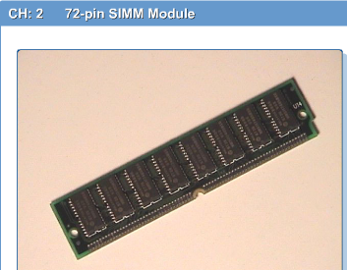

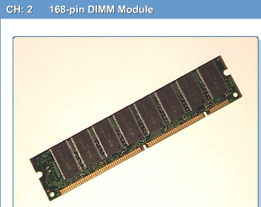

Identifying SIMMs and DIMMs
A SIMM plugs into the motherboard with a 72-pin or 30-pin connector. The pins connect to the system bus, creating an electronic path through which memory data can flow to and from other system components. Two 72-pin SIMMs can be installed in a computer that supports 64-bit data flow. With a SIMM board, the pins on opposite sides of the module board are connected to each other forming a single row of contacts.
A DIMM plugs into the system memory bank using a 168-pin connector. The pins establish a connection with the system bus, creating an electronic path through which data can flow between the memory chip and other system components. A single 168-pin DIMM supports 64-bit (non-parity) and 72-bit (parity) data flow. This configuration is now being used in the latest generation of 64-bit systems. Recall that parity refers to error checking capability built into the RAM chip to ensure data integrity. An important feature is that the pins on a DIMM board are not connected side to side (as with SIMMs) forming two sets of contacts.
Note: SIMMs are available in 30-pin and 72-pin versions, while DIMMs take the form of larger, 168-pin circuit boards.
With most technologies, newer or more specialized forms of RAM are put out into the market all the time. Here are some examples that are of particular interest:
- Random access memory Digital to Analog Converter (RAMDAC) is another specialized form of memory designed to convert digitally encoded images into analog signals for display. It is made of a SRAM component (for storing the color map) and three DACs, one each for the RGB (red, green, and blue) electron guns.

- Video RAM (VRAM) and Windows RAM (WRAM) are currently the best kinds of memory for video. Both VRAM and WRAM are optimized for video cards and are designed to be dual-ported. This means that the chipset processor and RAMDAC chip can access the memory at the same time. Simultaneous access greatly increases video throughput. The newest types of video cards also support the newest system RAM types, such as Synchronous DRAM (SDRAM).
Cache Memory
Cache is a specialized form of computer chip or firmware that is designed to enhance memory performance. Cache memory stores frequently used information and transfers it to the processor much faster than RAM. Most computers have two separate memory cache levels:
- L1 cache is located on the CPU
- L2 cache is located between the CPU and DRAM
L1 cache is faster than L2 because it is located within the CPU and runs at same speed as the CPU. It is the first place the CPU looks for its data. If data is not found in L1 cache, the search will then continue with L2 cache, and then on to main memory (or RAM).
L1 and L2 cache is made of SRAM chips.

1.3.7 Monitors
Computers are usually connected to a display, also called a monitor . Monitors are available in different types, sizes, and characteristics. When purchasing a new computer, the monitor may have to be purchased separately.
Understanding the characteristics of a good monitor will help determine which is best suited for a specific system. The following terms relate to monitors.
- Pixels are picture elements. The screen image is made of pixels (tiny dots), which are arranged in rows across the screen. Each pixel consists of three colors: red, green, and blue (RGB). Examine the screen closely to see them.
- Dot pitch is a measurement of how close together the phosphor dots are on the screen. The finer the dot pitch, the better the image quality. Look for the smaller number. Most monitors today have a 0.25 mm dot pitch. Some have a 0.22 mm dot pitch, which gives a very fine resolution.
- The refresh rate is the rate the screen image is refreshed. Refresh rates are measured in hertz (Hz), which means times per second. The higher the refresh rate, the more steady the screen image will be. It may look like a steady picture, but actually it flickers every time the electron beam hits the phosphor-coated dots. Refresh rate is also called vertical frequency or vertical refresh rate.
- Color depth refers to the number of different colors each pixel can display. This is measured in bits. The higher the depth, the more colors that can be produced.
- Resolution varies based on the number of pixels. The more pixels in the screen, the better the resolution. Better resolution means a sharper image. The lowest screen resolution on modern PCs is 640 x 480 pixels, which is called Video Graphics Array (VGA). There are now Super Video Graphics Array (SVGA) and Extended Graphics Array (XGA) with resolutions all the way up to 1600 x 1200.
- Monitor screen sizes are measured in inches, just like televisions. The most common sizes are 14", 15", 17", 19", and 21" screens, measured diagonally. Note that the visible size is actually smaller than the measurement size. Have this in mind when shopping for a monitor for the computer.
- Most PCs display many colors on the screen. The colors are created by varying the light intensity of the three basic colors (red, green, and blue). 24- and 32- bit colors are the usual choice for graphic artists and professional photographers. For most other applications, a 16-bit color will be sufficient. The following is a summary of the most commonly used color depths:
- 256 colors (8-bit color)
- 65,536 colors (16-bit color, also called 65K or HiColor)
- 16 million colors (24-bit color, also called True Color)
- 4 billion colors (32-bit color, also called True Color)

2.3.8 Video cards
The video card or video adapter, as shown in Figure below, is the interface between the computer and monitor. The video card tells the monitor which pixels to light up, what color the pixels should be, and the intensity of the color. The video card is either an expansion card (installed into one of the motherboard expansion slots) or it can be built into the motherboard. The display capabilities of a computer depend on both the video adapter and the monitor. A monochrome monitor (black and white), for example, cannot display colors no matter how powerful the video adapter.

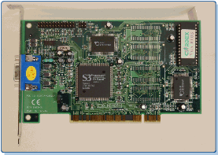

1.3.9 I/O ports
All peripheral devices that connect to the computer such as printers, scanners, and so on, use connectors on the back of the computer known as I/O ports. An I/O port is a pathway into and out of the computer. There are different types of ports on the computer that serve different purposes. This section explores the various types of ports and the types of devices that use them to interface with the computer.
Serial Ports
A serial port can be used to connect devices that use a serial interface such as a modem, scanner, mouse, etc. Generally, a PC can identify up to four serial ports, but the typical computer contains only two, referred to as COM1 and COM2. Serial ports are sometimes called the RS-232 ports because they use the RS-232C standard as defined by the Electronics Industry Association (EIA). A serial port transmits data bits one after the other (serially) over a single line. USB 2.0, the most recent version, will run at a speed of 450 megabit per second (Mbps).
Figure below shows a DB-9 (9-pin) male connector used on most new computers for the serial ports.
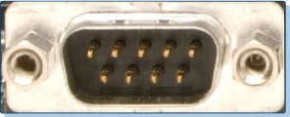
Older printers use a larger, 25-pin connector for the serial port interface as shown in Figure below.

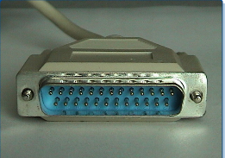

The mouse is sometimes used in serial port 1, called COM1, which is a 9-pin male connector. The modem is typically used in serial port 2, called COM2, which is also a 9-pin male connector. Both serial ports are located in the back of the computer system.
Parallel Ports
A parallel port is a socket on the computer that is used to connect newer printers or other peripheral device such as a portable hard disk, tape backup, scanner, or a CD-ROM. The parallel port contains eight lines for transmitting an entire byte (8 bits) across the eight data lines simultaneously. The parallel port interface offers 8-bit parallel data words and nine I/O control lines at a DB-25 socket (25-pin female connector). DB-25 socket can be found on the back of the computer unit. Figure below shows a female DB-25 parallel port.

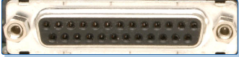

Figure below shows the 36-pin female port typically found on the printer. Parallel ports can be configured as LPT1, LPT2, or LPT3.
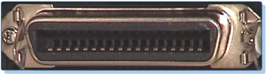
Parallel ports were originally used for printers, but today they can be used for both data input and output devices. This type of parallel port is called bi-directional and is often used for the rapid transmission of data over short distances. The newer, enhanced parallel ports can be converted from uni-directional to bi-directional through the CMOS setup screen.
PS/2 Ports/6-pin Mini Din, 5-Pin DIN
PS/2 keyboard or PS/2 mouse ports are used to connect the PC to its keyboard and mouse. Though both ports look identical, the mouse and keyboard ports are not interchangeable. Usually both ports are color coded or labeled to avoid any confusion as shown in Figure below.

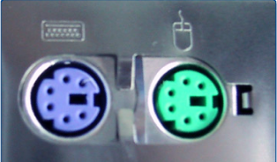
The cable that connects the PS/2 keyboard or mouse uses a PS/2 type connector, also known as a 6-pin mini DIN connector. The PS/2 (or 6-pin mini-DIN) has become very popular since its introduction by IBM in 1987 with the IBM PS/2.
However, the 5-pin DIN XT/AT connector type ports and serial mice are still quite common. The 5-pin DIN AT connectors are typically used to connect the AT keyboard directly to the motherboard.

Universal Serial Bus (USB)
The Universal Serial Bus (USB) is an external port, Figure above, that allows the user to connect up to 127 external PC peripherals, including USB keyboards, mice, printers, modems, scanners, and external disk drives.

1.3.10 Floppy drives
A floppy disk drive (FDD) magnetically reads and writes information onto floppy diskettes, which are a form of removable storage media. Introduced in 1987, the 3.5" floppy diskettes used today have a hard plastic exterior shell that protects the thin, flexible disk inside.
An FDD is mounted inside the system unit and only removed for repairs or upgrades. The floppy diskette can be removed at the end of a computer working session. The main drawback to the floppy diskette is that it only holds 1.44 MB of information, although most PCs still have a floppy drive. Although 1.44 MB is plenty of space for most text documents such as MS Word and Excel files, for a file containing rich graphical content, a floppy disk capacity may be insufficient. The main parts of a typical floppy diskette include the floppy protective case, the thin magnetic flexible disk, a sliding door, and sliding door spring.

1.3.11 The hard drive
A hard disk drive shares many physical and operational characteristics with the floppy disk drive. It has a more complex design and provides a greater speed of access. The HDD has a much larger storage capacity than the floppy for long-term storage. It stores programs and files, as well as the operating system. Typically, the HDD is an internal drive that cannot be removed from the computer.
The HDD contains aluminum that is relatively inflexible, glass platters, or disks. This inflexibility led to the name hard disk drive. The hard drive is typically not removable, which is why IBM has referred to hard drives as fixed disk drives. In short, a hard disk drive is a high-volume disk storage device with fixed, high density, rigid media.
Hard Drive Components
Figure below shows the components shared by all hard disk drives. These components include disk platters, read/write heads, head actuator assembly, spindle motor, logic/circuit board, bezel/faceplate, configuration jumpers, and interface connectors.
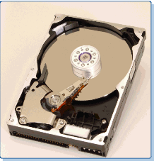
A hard disk drive typically has two to ten platters. They are usually either 2 ½” or 3 ½” in diameter and are typically constructed of aluminum or a glass-ceramic composite material. They are coated with a thin-film media that is magnetically sensitive. The platters are double-sided, with the magnetically sensitive media on each side. Platters are stacked with spaces between them on a hub that holds them in position, separate from one another. The hub is also called the spindle.
Note: Users should never open a disk drive to attempt to repair it because the hard disk lives in an extremely clean environment. The disks are sealed in a protective housing and should never be opened to the atmosphere. Repairs are performed in special facilities called ultra-clean rooms. (Even particles such as smoke, dust, and hair have been removed from the air.)
How the Drive Functions
The hard disk drive functions in much the same way as a floppy disk drive. The disk platters spin at a high speed while the drive heads access the media to conduct read or write operations. Understanding how the heads read and write the data structures on the platter media is critical to knowing how the drive functions.
The media on the drive platters is a layer of magnetically sensitive material. In general, modern hard disk drives use a thin-film of a cobalt metal alloy laid down in several micro-thin layers. The magnetic particles in this media are randomly aligned when the disk is empty of data. However, as the read/write head writes to an area, it causes the particles on that track to align in a specific direction. This is done according to the direction of electric current flow in the heads. This local magnetic direction in the media is referred to as a flux. The current in the head can be reversed, causing a flux reversal (opposite magnetic orientation in the media). As the platter spins, the head will lay down a flux pattern along the length of a track. This pattern of flux transitions on the track represents the recorded data.

1.3.12 CD-ROMs

The impact of CD-ROM (Compact Disk-Read Only Memory) on modern computing makes it an important technological development. This section discusses CD-ROM drives and media. The technology behind the CD-ROM is not new. It dates back to 1978, with the introduction of the audio compact disc (CD) by the Sony and Phillips Corporations. Presently, the size of the actual media and the basic design of the CD-ROM has not changed. Virtually every system unit assembled today includes a CD-ROM drive. It consists of a spindle, a laser that flashes onto the disc's uneven surface, a prism that deflects the laser beam, and a light-sensitive diode that reads the flashing light.
A CD-ROM drive is a secondary storage device that reads information stored on a compact disc. While floppy and hard disks are magnetic media, the CD-ROM is an optical media. The life span of optic media is counted in tens of years, which makes CD-ROM a very useful tool. CD-ROM drives can be housed inside the computer case (internal), or connected to the computer by a cable (external). CD-ROMs are useful for installing programs, running applications that install some of the files to the hard drive, and executing the program by transferring the data from the CD-ROM to memory while the program is running.
How the CD-ROM Works: Data is stored in the form of indentations and bumps on the reflective surface of every CD-ROM disk. The indentations are called pits, and the bumps are called lands. When data is being read, light from the laser is bounced off the pits and the lands located on the underside of the disk. Because the pits reflect less light, they are read by the CD-ROM drive as 0s. Because lands reflect more light, they are read as 1s. Together these 1s and 0s make up the binary language understood by computers.
Speed, Access Time, and Transfer Rate
One specification for a CD-ROM drive is its speed, or how fast the disc will spin. The faster the disc spins, the faster the data can be transferred to the computer memory. The CD-ROM speed is indicated by a number with an "x" after it. For example, a 12-speed CD-ROM is labeled as a 12x. The larger the number, the faster the disc can spin . Two other important specifications to consider are the access time and data transfer rate.
- Access time is how quickly the data the user is looking for can be located and the laser positioned.
- Data transfer rate is how fast the computer can transfer the information into memory.

Review questions and Labs

1. Explain the steps performed during the computer system power on self test (POST).
2. How can you identify an ATX motherboard?
3. Give the different types of expansion slots available on the Computer Motherboard.
4 Give different DC voltage level produced by ATX power supply with their use. Specify also the colors of the power supply wires with their voltages.
4. Discuss why you would choose to build your own PC rather than buy a ready-made PC. You should list at least seven reasons to build your own PC and three reasons to buy a ready-made PC.
5. Give and explain three components of any operating system.
6. Give the difference between low level and high level formatting.

Lab 1: Motherboard Identification

Objective

This lab will focus on identifying motherboards, removing motherboards, replacing motherboards, and using the motherboard manuals to identify a number of the system components.

Equipment

The following equipment is required for this exercise:

- A system board (either mounted in a case or not)
- Motherboard manuals if available
Scenario

You have just been hired by a PC repair center and have begun your training. PC technicians need to be able to remove and replace motherboards either in an upgrade situation or due to a motherboard failure.

Procedures: If the system board has been diagnosed as needing replacement, there are a few guidelines that must be followed. Verify that the system’s power cord is not attached. All necessary safety precautions need to be followed carefully concerning power supplies.
Step 1: Gain access to the motherboard. If the motherboard is installed in a case, remove the
case cover.

Step 2: If needed, remove components and/or cabling to gain access to the motherboard manufacturer's name and ID number. Be sure to carefully record these connections so they can be properly replaced.

Note: These numbers may be difficult to find and hard to read, so look carefully. As you become familiar with different manufacturers, it will become easier. Due to variations in motherboards, not all of the following information may be available. On others, additional information may be available. Check with the instructor about your system.

Step 3: Record the following information from the computer’s motherboard.

S/N | Components | Available?  (Y/N) | Name/ Type (if applicable)
1 | Motherboard Manufacturer
2 | Motherboard Model Number
3 | Form Factor (physical size and layout)
4 | Type of CPU Installed
5 | Types of CPUs Supported (socket or slot)
6 | Chipset
7 | BIOS Manufacturer
8 | BIOS Battery
9 | ISA (number and type)
10 | PCI (number and type)
11 | AGP (number and type)

Reflection

The ability to properly identify all the components of a motherboard will prove to be very useful when troubleshooting in the field. Where is the first place to look to determine the manufacturer of a motherboard?
Lab 2 Identify ROM BIOS Chips

Objective

This lab will focus on the student’s ability to locate and identify the ROM chip, BIOS chip, and BIOS manufacturer on a motherboard.

Equipment

The following equipment is required for this exercise:
• A complete motherboard
• Motherboard manuals

Procedures

BIOS – The Basic Input-Output System is a ROM chip that has built-in commands, which allow the system to power-up and perform a self-test of its hardware before turning over control to the operating system. ROM – Read-Only Memory, as its name implies, can be read, but not changed. It is used to store basic information the computer needs to operate (for example, the BIOS). Determine the manufacturer and version number of the BIOS. Also, examine the physical ROM chip to help answer the questions below.

Step 1

Describe the physical appearance of the ROM chip and its location on the board:
__________________________________________________________________
__________________________________________________________________
__________________________________________________________________

Step 2

What type of BIOS is used?
- Manufacturer:
- Version/Type:
- Battery Type:

Step 3

If an Internet connection is available, visit the manufacture’s website and list the version number and any new features that are supported.
__________________________________________________________________
__________________________________________________________________
__________________________________________________________________

Reflection

1. How many BIOS manufacturer’s can you list?
__________________________________________________________________
__________________________________________________________________
2. Why is the BIOS needed?
__________________________________________________________________
__________________________________________________________________

3. The BIOS serves as the interface between the ___________________ and the
________________________.
4. The detailed instructions needed for system start-up are stored in
______________________________________________________________ .
5. What does BIOS stand for?
_______________________________________________________________
6. What does ROM stand for?
_______________________________________________________________

7. What differentiates RAM from ROM?
_______________________________________________________________
_______________________________________________________________
_______________________________________________________________

Lab 3: Identifying Computer Expansion Slots

Objective

Upon completion of this lab, the student will be able to identify safety issues, specifications, and components relating to expansion slots. The student will also be able to list the advantages and disadvantages of each expansion slot.

Equipment

The following equipment is required for this exercise:
• Motherboard & motherboard manuals
• Expansion cards (not required, but additive)

Scenario

Bob has purchased a used computer and is trying to determine what type of video card and other expansion cards can be installed. Help Bob figure out what is currently installed so that he can make an educated decision when he is ready to buy new expansion cards.

Procedures

An expansion slot is a long, thin, socket connection, located on a motherboard or riser board, which allows various cards to be added to a computer. These cards may include devices such as modems, sound cards, and network interface cards (NICs). Expansion slots allow the life of a computer to be extended, since new technology can be added as it becomes available. Verify that the power cord is disconnected and Remove the computer’s system case.

Step 1

Locate the expansion slots on the motherboard (or riser card) and list them:

1 | 4
2 | 5
3 | 6

Step 2

Using the available resources, identify any expansion cards that are installed:

1 | 4
2 | 5
3 | 6

Troubleshooting

Occasionally when a PC is shipped from one location to another, an expansion card may become unseated. Verify that all expansion cards are properly seated as well as all connectors properly plugged in before turning the unit on.

Reflection

What type of expansion cards would be installed in a PCI slot?
__________________________________________________________________
__________________________________________________________________
What is the speed difference between PCI and ISA expansion slots?
__________________________________________________________________
__________________________________________________________________

Questions

1. What are expansion slots?

2. Expansion bus is also referred to as a (an)? _________________or
____________________
3. An expansion bus is used to add _________________to existing systems.
4. List four different types of expansion slots:
a. _____________________________________________________________
b. _____________________________________________________________
c. _____________________________________________________________
d. _____________________________________________________________

5. Define the term “Plug and Play”.
_______________________________________________________________
_______________________________________________________________
6. Name the three bus types:
a. _____________________________________________________________
b. _____________________________________________________________
c. _____________________________________________________________
7. An ISA bus was developed with both _________ bit bus speeds.
9. What does PCI stand for? ___________________________________________

Lab 4: Identifying RAM and RAM Sockets

Objective

This lab will focus on the identification of various types of Random Access Memory (RAM) and RAM sockets.

Equipment

The following equipment is required for this exercise:
- A functioning computer system with two DIMMS installed and screw driver.
- Manual for the motherboard used in the computer if available.

Scenario

Fred would like to upgrade the amount of RAM in his PC, but he is not sure how to locate it or how to determine how much RAM is installed. Help him determine how much RAM he has so he can figure out how much more to buy.

Procedure

Random Access Memory is memory used by the CPU to store open files and active applications temporarily. RAM is volatile, meaning that any information stored in it is lost when the system is powered-down. RAM comes in small expansion board forms with varying numbers of edge connectors. The RAM boards (also called sticks) are made in 30, 72, 168, or 184 pin configurations. They are referred to as SIMMs or DIMMs, depending on the chip density.
Many times, the only information to be gained visually is the manufacturer’s name. This is why a quality RAM tester is a critical piece of diagnostic equipment for PC repair shops.

Step 1: Boot the system and record the POST amount of RAM. ___________________

Step 2: Shut down the system and follow all the safety steps in removing the computer’s cover.

Step 3: After gaining access to the motherboard, note the position of the RAM slots and whether they are in use, making notes in the journal.

- SLOT TYPE:
- TOTAL NUMBER OF SLOTS:
- NUMBER OF SLOTS OPEN:
- TOTAL RAM CAPACITY:

Step 4: Record the information about the installed RAM sticks in the table below.

- MANUFACTURER:
- TYPE:
- CAPACITY: (each)
- SPEED:
- TOTAL CAPACITY INSTALLED:

Step 5: Refer to the motherboard manual or search the Internet for the type and range of RAM chips that can be installed on this computer.

Step 6: If there are two sticks of RAM installed, remove one of the RAM sticks, noting the location and orientation of the stick.

Step 7: Put the cover of the computer back on the computer and plug in the power cords. Restart the computer system. Note the POST-test RAM amount. ________________

Step 8: Shut down the system and follow all the safety steps in removing the computer cover.

Step 9: Reinstall the RAM stick that was removed in Step 6.

Step 10: Put the cover of the computer back on the computer and plug in the power cords. Restart the computer system. Note the POST-test RAM amount. ________________

Step 11: Reflect in the journal about any special considerations to be aware of as the RAM
Memory is installed.

Troubleshooting

Take extreme caution when working with RAM.

Reflection

1. Was an antistatic wrist strap use while working with RAM modules?
__________________________________________________________________

2. What other types of RAM are there besides the type installed in the PC worked on?
__________________________________________________________________

2. Memory chips in a computer system are referred to as _________________
3. RAM is the industry standard abbreviation for ________________________
4. Define volatile as it applies to RAM:
______________________________________________________________
______________________________________________________________
______________________________________________________________

5. Name the two basic types of RAM: ________________, ________________

6. Which type of RAM needs to be re-energized constantly in order to retain its
contents? _________________________________

7. Define RAM parity: ________________________________________________
______________________________________________________________

8. _______________________ refers to the process by which the computer rewrites
Data to RAM.

9. Describe the physical difference between a SIMM and DIMM chip:
_______________________________________________________________
_______________________________________________________________

10. Define memory caching:

CHAPTER 2: ASSEMBLING THE COMPUTER

2.1 Overview of the Assembly Process and Safety Issues

Assembling a computer helps demystify the inner workings of a computer and is considered a milestone by IT professionals. In fact, it helps create the confidence needed to advance in the IT profession. Before beginning any assembly process, it is a good idea to review safety procedures. The following items should be taken into account when working with computers:
- Keep the work area clean.
- Keep food and drinks out of the work area.
- A computer monitor may store up to 25,000 volts, so avoid opening one unless trained to do so.
- Remove all jewelry and watches.
- Make sure the power is off and the power plug has been removed when working inside the computer.
- Never look into a laser beam. Lasers are found in computer related equipment.
- Cover sharp edges with tape when working inside the computer case.

2.2 Creating a Computer Inventory

Importance of an inventory
When building a computer from scratch, it is important to document all components and the parts purchased. Once the computer is built and operational, it may be difficult to recall the brand of each of the components used as not all expansion cards or computer parts are clearly labeled with manufacturer information. This list will come in handy after the packaging has been thrown away or the manual or instruction sheet for a particular part cannot be found. With these details, and using the Internet, the required device drivers or other information may be found and downloaded. It is a good idea to make a note about specific warranty information for each different part bought. Make sure the specifics about installation and maintenance requirements are saved, so that warranties will be valid. Use a small secure box to hold all of the manuals and disks used in the assembly of the computer. Label the box with a name that identifies the computer to which it is associated, and store it in a secure location. If any information is needed in the future, all the documentation will be easily available.

2.3 The computer Case and Power Supply

2.3.1 Computer cases and system units

Issues and concerns that affect the purchasing or gathering of parts to assemble a first computer will now be focused on. Whether buying a tower or desktop (to be discussed in the following sections), it is recommended that it conforms to the ATX standard and has at least a 250-watt power supply (300 watts is ideal). Make sure to purchase a case that comes with a tray that allows easy access to the internal components. If frequent upgrades are intended, then make sure that the choice of a case provides enough room for expansion. Look for spare drive bays, ample room to work inside the case, easily removable motherboard mounting plates and drive racks. Additionally, verify the sturdiness of the case because some of the cheaper ones can be quite flimsy. A system unit is typically a metal and plastic case that contains the basic parts of the computer system. There are three basic system unit styles: desktops, towers, and portables. Each design offers characteristics that adapt the system for different environments. These characteristics include mounting methods for the printed circuit boards, ventilation characteristics, total drive capacity, footprint (the amount of desk space they take up), and portability.

2.3.2 Desktops

Most of Desktop units are designed to sit horizontally on the desktop. Note that the first IBM computers, the original IBM-PC, XT, and AT designs, use this case style. Most desktop cases today come in two sizes: the slim-line and regular sizes.
The two important considerations in choosing a desktop case style for a computer are:
- Available desktop space – Generally the computer would have to share the desktop with the monitor and other peripherals, so space must be allowed. Avoid buying the slim-line because these are generally small and designed for business environments. They have little room for expansion.
- Form factor – Cases come in different form factors. The form factor simply describes the general layout of the computer case, the positioning of the slots in the case, and the type of motherboard the case will accommodate. The baby AT form factor, which accommodates the baby AT motherboard, has been the most popular for the past few years. However, the newest form factor, and the one most often encountered, is the ATX. It accommodates the ATX motherboard, which has integrated I/O ports and is designed for easier access to the common components as well as better airflow. If selecting a desktop case, choose the ATX form factor.

2.3.3 Towers
Tower cases are usually designed to sit vertically on the floor beneath a desk. Some users in the past resorted to standing the desktop cases on their sides under the desk to provide more usable workspace on the desktop. This has prompted computer makers today to develop cases that would naturally fit under the desk. In general, tower cases typically have enough bays to hold floppy drives, CD-ROM drives, tape drives, DVD drives as well as just about anything else that might be installed. The internal design of a tower system resembles that of the desktop unit.

Many easy-access schemes have been built in to allow quick or convenient access to the inside of the system case. Some towers, for example, use removable trays that allow the motherboard and I/O cards to be plugged in before being slid into the unit.
Other tower cases use hinged doors on the side of the case, allowing the system and I/O boards to swing away from the chassis. Either of these features will facilitate the process of assembling the computer.

2.3.4 Power supplies

The power supply is one of the most important parts of the computer that needs to be understood. The power supply unit provides electrical power for every component inside the system unit. In the past, it also supplied alternating current (AC) to the display monitor. Some power supply units that can supply AC power can still be found. These units are identified by the existence of two power plugs at the rear. As mentioned in the previous chapter, the computer power supply performs the critical role of converting commercial electrical power received from a 120 volts AC, 60 Hz (or 220 volts AC, 50 Hz outside the U.S.) outlet into other levels required by the components of the computer. The power supply unit also provides the system’s ground.
Tip: The power supply converts AC to DC.
There are two basic types of power supplies:
- AT power supplies are designed to support AT-compatible motherboards.
- ATX power supplies are designed according to newer ATX design specifications to support the ATX motherboard.
Figure below an ATX power supply.
There are two major distinctions between the legacy AT and the new ATX power supplies. The AT power supply has two 6-pin motherboard power connectors (P8/P9), while ATX power supply uses a single 20-pin power connector (P1). In the ATX-compatible power supply, the cooling fan pulls air through the case from the front and exhausts it out the rear of the power supply unit. Conversely, the AT design pulls air in through the rear of the power supply unit and blows it directly on the AT motherboard.
Levels of DC Voltage from the Power Supply
The power supply produces four (five in the ATX) different levels of well-regulated DC voltage for use by the system components. These are +5V, -5V, +12V, and -12V. In ATX power supplies, the +3.3V level is also produced and is used by the second-generation Intel Pentium processors. The IC devices on the motherboard and adapter cards use the +5V level.
Tip: The power supply voltage is tested with a multi meter.
The power supply delivers power to the motherboard and its expansion slots through the motherboard power connectors. The ATX motherboard connector is a 20-pin (P1) keyed connector while AT motherboard connector is a two 6-pins connector.
DC voltage produced by the power supply.
Voltage | Wire color | Use | AT | ATX | ATX v12
+12V | Yellow | Disk drives fans, cooling devices and the system slots | YES | YES | YES
-12V | Blue | Some types of serial ports circuits and earlier programmable Read only memory. | YES | YES | YES
+5V | Red | Mother boards Baby AT earlier CPUs and many motherboard components. | YES | YES | YES
-5V | White | ISA bus cards and early PROM | YES | YES | YES
+3.3V | Orange | Most newer CPUs, some types of memories and AGP video card | NON | YES | YES
0V | Black | Ground: Used to complete circuit with the other voltage | YES | YES | YES

2. 4 Preparing the Motherboard for Installation

2.4.1 Motherboard configuration
Configuring the motherboard is one of the most important tasks to accomplish when preparing the motherboard for installation of the various components. This process is also known as setting the system hardware. Configuring the motherboard typically means the following:
- Installing the CPU
- Installing the heat sink and fan
- Installing RAM
- Connecting the power supply cables to the motherboard power connectors and connecting miscellaneous connectors to the correct switches and status lights on the front case panel

2.4.2 Motherboard Jumpers
A jumper is a pair of prongs that are electrical contact points set into the computer motherboard or an adapter card. When setting a jumper, place a plug on the prongs that completes or closes the contact. Closing or opening the circuits establishes logic levels to select functions for the operation of the board. Some motherboard jumpers are given below.
- BIOS recovery – This jumper is for recovering BIOS data from a diskette in the event of a catastrophic failure. Leave this to the default (normal operation) values. Check the technical product specifications for details.
- Password clear – Use this jumper, if provided, to clear the password if the password is forgotten. The default setting is "password enabled".
- BIOS setup access – This jumper enables or disables access to the Setup program. The default setting is "access enabled".
- Processor voltage – This jumper , when provided, sets the output of the onboard voltage regulator. The two choices are usually standard voltage and Voltage Regulator Enhanced (VRE).
Caution: When installing a processor in the motherboard for the first time or upgrading to a new processor, check the processor documentation for the correct voltage setting. Operating the processor at the wrong voltage can cause unreliable performance or damage to the system components.
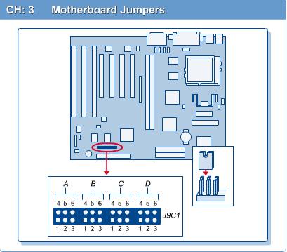

2.4.3 Installing the CPU

Microprocessor installation is not a complicated process. Most problems occur when the chip is hastily installed or installed backwards causing the chip pins to break. It is important to handle the microprocessor with extreme care. There are two main types of CPU interfaces. These are the socket type and the slot. Slot type interfaces use a slot similar to an expansion card. Slot 1 is the Single Edge Contact (SEC) interface used only by the Intel Pentium II processor family. SEC is a cartridge containing the CPU and L2 cache chips. Therefore, the installation of the CPU will differ depending on the processor being used and the interface type.
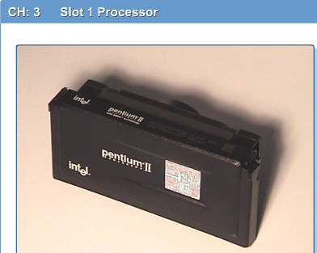

The Step-by-Step Installation of the CPU
Almost all socket systems make use of the zero-insertion force socket, commonly referred to as "ZIF". To install a socket or similar chip, follow this general procedure:
Step 1 First, turn over the chip and inspect the pins to make sure none are bent or broken. All pins should stick straight out.

Step 2 Now, orient the chip by locating pin 1 on both the chip and the socket. Notice that the chip is always marked at pin 1 otherwise it might be a notched corner with a missing pin as in figure below.

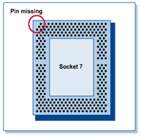

Step 3 After correctly orienting the chip, open the ZIF socket. Shift the lever slightly away from the socket, from its default closed level position and raise it to the open, vertical position.

Step 4 With the socket open, Aligning pin 1 according to the orientation that was determined in step2. Insert the processor chip into the socket so that all of the pins slide into the matching holes. Avoid forcing the processor into the socket as the pins can be damaged.

Step 5 Double-check to make sure that there is no gap between the bottom of the CPU chip and the socket. If there is none, then the processor chip is properly inserted.

Step 6 Finally, to secure the installed chip, simply push the lever gently back down to the closed, level position. A little resistance may be felt, but the lever and ZIF socket should close fairly easy.

2.4.4 Installing the heat sink and Fan
Most microprocessors will produce a lot of heat, which if not efficiently dissipated, can cause the system to operate intermittently or fail completely. One way to dissipate heat from processors is to use the heat sink and cooling fan. Proper installation is crucial to this unit performing its role effectively. Although the heat sink can be mounted before installing the processor chip on the motherboard, there is a risk of causing damage to the pins on the chip. Only on Pentium II processors is the fan attached before the CPU installation.

Use the following steps when installing a heat sink and fan to socket type processors:
Step 1 If the CPU fan did not come with the heat sink already attached to it, use the screws that came with the fan to attach it to the heat sink.

Step 2 Apply the heat sink compound to the surface of the chip. Some setups use heat sink compound or thermal grease.

Step 3 Now attach the heat sink. Proceed with care at this point. Place the heat sink squarely on top of the processor, and press it down gently. Most of the newer heat sinks actually use a set of clips on each side to hold them down.

Step 4 At this point, double-check to make sure the heat sink maintains a good contact with the processor chip surface.

Step 5 Some heat sink compound or thermal grease may have oozed out the sides of the contact surfaces when pressed down the heat sink. Wipe up the excess compound.

Step 6 Plug the power cord from the fan to the fan power pins provided on the motherboard. Make sure to observe the proper orientation.

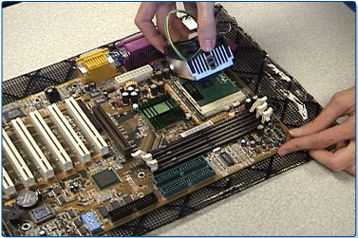

3.4.6 Installing RAM
There are two types of memory modules used on most PCs. These are 168-pin dual inline memory module (DIMM) cards and 72-pin single inline memory module (SIMM) cards. Figure below shows both a 168-pin DIMM and a 72-pin SIMM.

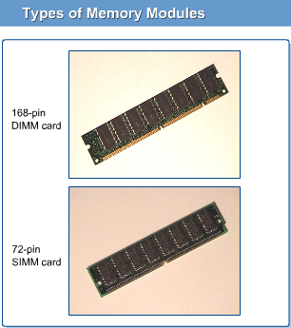

DIMMS and SIMMS both share common edge connectors and fit into slots on the motherboard called RAM sockets. RAM sockets used for DIMM cards are often called DIMM sockets, while those used for SIMM cards are called SIMM sockets. When the DIMM card or SIMM card is inserted into the slot, each edge connector makes contact with a corresponding gold trace on the motherboard. Each gold line represents an individual data path. Just as the gold lines leading to the CPU make up the processor bus, all these gold lines make up the memory bus. The memory bus data "highway" is used to transfer data between the RAM and the CPU.

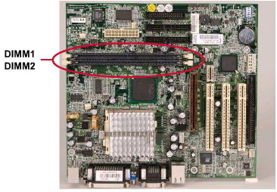
Step-by-Step Installation of RAM
Step 1 First, decide on which slots to use and then orient the SIMM or DIMM chip over it. Both SIMMs and DIMMs are keyed, so they can go in only one way.

Step 2 Insert the DIMM module straight into the slot. The SIMM module is inserted at an angle of about 45 degrees.

Step 3 Now, the memory module must be locked into place. With a SIMM, rotate it from the angled position to the vertical position. Some resistance is normal. Do not force it. If difficulty is encountered, the chip might be backwards. Rotate it and try again.

When the SIMM is vertical, the little metal or plastic clip should snap in place, securing the SIMM vertically in the memory slot. With a DIMM, simply close the levers on either side of it. Usually, if the levers do not close, it is because the DIMM is not inserted all the way into the slot or it is installed backwards. In most cases, if the DIMM is inserted properly, the levers will snap in place without further action.

Step 4 Repeat Steps 1 to 3 for the rest of the memory modules. When finished, check the work to be sure that each module is well seated in the slot on both ends.

2.5 Installing the Motherboard

2.5.1 Installing the Motherboard into the case
It is important to make sure that the board is handled by the edges. When physically manipulating the board, take care not to bang it or any of its components.

The following steps summarize the motherboard installation process:
Step 1 Position the case in such a way that gives easy access. Then, locate the holes on the motherboard and the corresponding holes on the case. Holding the board just above the case will allow the holes on the case and motherboard that need to be seen for alignment purposes to be shown. The expansion card slots give a good indication of how the board should be oriented.

Step 2 Insert the spacers that came with the motherboard securely into the holes on the case
(or mounting plate).

Step 3 Install plastic standoffs into the holes on the motherboard that line up with an eyelet
(a hole that is very long and key shaped so that users can slide things into it). Some cases do not have an eyelet and instead use only the metal spacer screws to hold the motherboard in place.

Step 4 At this point, carefully slide the board into the case, making sure that it sits on the spacers and that all the spacers line up with an available hole on the motherboard.

Step 5 Inspect the screws to be used. It is a good practice to insert plastic washers on each screw before they are installed. This will prevent the metallic screws from overlapping and possibly destroying or shorting any part of the circuitry near the holes.

Step 6 Now tighten the board to the case, first by hand, and then finish with a screwdriver. Make sure the screws are not tightened too much. The screws only need to be tight enough to prevent the board from moving around in the case.

Step 7 Check the work to make sure everything is right. Verify the following:
- The back of the motherboard is not touching any part of the case.
- All the slots and connectors line up properly with the holes on the back of case.
- The board is securely held in place.
- When pressed at any point, the board does not bend.
The steps outlined above are very general. Some cases have additional features.
After becoming familiar with assembling PCs, some of the steps can be combined or bypassed altogether.

2.5.2 Connecting power supply cables to the motherboard.
After successfully installing the motherboard in the computer case, proceed with attaching the appropriate power supply connector(s) to it. This process is easy with an ATX (boards and power supply) because there is only one connector that is also keyed to fit only one way. Take more care with the older AT systems because there are two separate, but physically identical connectors that must be plugged in a specific way.
The following are the steps for connecting the power supply cables to the motherboard:
Step 1 On an AT system, first locate the two large wire leads from the power supply labeled P8 and P9

Step 2 Locate the large 12-pin power connector on the motherboard. It is usually found right behind the keyboard connector.

Step 3 Plug the P8 and P9 wire lead connectors in the 12-pin power connector.
Caution: Make sure the black wires are in the middle, right next to each other. If this configuration is reversed, the motherboard is likely to be damaged when the power is turned on. Pressure might have to be applied to insert the connectors. On an ATX system, there is one large 20-pin (P1) connector. It is keyed for easy installation.

2.6 Installing the Floppy Drive, Hard Drive, and CD-ROM

2.6.1 Attaching the floppy drive to the case.
Make sure the floppy cables and power cables are long enough to reach the drive before starting. Verify the drive is mounted right side up or it will not work.
Step 1 First, select which drive bay will be used for the floppy drive. Remove the faceplate of that bay. Save the faceplate for future use. The two bays to be chosen from are a 3.5” and a 5.25” bay. Be sure to choose the correct bay for the floppy drive that is being attached.
To mount a 3.5” drive into a 5.25” bay, a special bracket may be needed that usually comes with the new floppy drive.

Step 2 Without connecting anything yet, insert the drive into the chosen bay, making sure it fits properly.

Step 3 Select the right size screws (preferably those that came with the drive). If using brackets to hold the drive in place, secure them now, or simply use the screws to attach the drive to the bay. First, tighten the screws by hand, and then use a screwdriver to secure the screws. Make sure they are not too tight, and take care not to cross thread or strip the screws.

Step 4 Attach the power and ribbon cable to the drive. If other drives are to be installed, this step can be skipped. This provides more maneuvering room in the case, especially if there are no removable drive bays. The drive cable and power cord can then be connected after all of the drives have been installed.

Step 5 Check the work.

Test Tip: Know what makes a floppy drive A or B and how to set up the drives to function as either master or slave.

2.6.2 Attaching the hard drive and CD-ROM to the case

Attaching the hard drive and CD-ROM are basically similar. This section shows how to attach both to the case processes.
Before proceeding, make sure that the interface cable will reach the drive in its intended location. With IDE/ATA drives, the length of the cable is limited to 18" and less, in some cases. Also, make sure the power cable will reach the drive from the power supply. Do not mount the drive upside down or backwards. Verify the label of the drive is up and the circuit board is down.
The first step is setting the jumpers.
Master/Slave Jumper Settings
The designation of a hard drive or CD-ROM drive as either master or slave is generally determined by the jumper configuration, not by the order in which the drive is daisy-chained to the other drive. The only exception is if the drive is jumpered (or set to) “cable select” and both the system and ribbon cable support cable select. In this case, master and slave are determined by the position on the data ribbon cable. Depending on how the system controls the cable, the select line on the ribbon cable determines where the master and slave need to be attached. Refer to the system manual for more information on this. This description applies only to a situation where both drives are attached to the same IDE channel (that is, where the CD-ROM is set to slave).
For better performance, always attach the drives to separate channels. That is, the hard drive to the primary IDE channel as primary master and the CD-ROM to the second IDE channel as secondary master.
It is much easier to configure these drives before installing them in the computer case. Installing them first may leave little room to set the jumpers. Before setting the jumpers, determine the types and number of drives to install.
It is assumed here that there are two IDE drives, one hard drive, and one CD-ROM. The jumper settings are often printed on top of the drive itself. If not, consult the manual. In either case, use needle-nosed pliers or tweezers to set the jumpers. Always save spare jumpers for future use by hanging them on one pin.
Hanging the jumper on one pin means the same as not jumpered, that is, no circuit configuration has been selected. This is also known as “parking” a jumper. Figure below illustrates some typical jumper settings on an IDE drive.
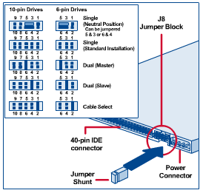
In a basic system that only has one hard drive, set the jumper to “master”. Some drives have another setting called “single”. This setting essentially tells the drive that it is alone on that IDE channel and works the same as the master. It is recommended to use this setting, if available, on a one hard drive system. The CD-ROM is similarly easy to configure. However, jumpers may be located in different places on each drive and may even be labeled differently. Set the CD-ROM to “master” if it is the only drive connected to the second IDE channel.

Attaching the Hard Drive
Technically, the hard drive can be inserted in any free bay in a computer case. However, there are some things that should be considered:
- Hard drives, especially the newer 7200- and 10,000- rpm drives (there are even 15,000-rpm drives available) can generate a lot of heat. Therefore, keep these drives as far away from other hardware as possible.
- If it is necessary to install a drive cooler, make sure there is enough room.
- Install a hard drive away from the power supply. Poorly designed cases may give room under the power supply to install the hard drive. This is not a good place for a hard drive. Power supplies act like magnets and can damage data.
- Finally, try to keep the hard drive near the front of the case. It will benefit from the cooling effect of the air current drawn into the case through the front by the system cooling fans.
With the above considerations in mind, here are the general steps for mounting a hard drive:
Step 1Set the hard drive jumper to master, as previously explained.

Step 2Slide the drive into the selected drive rail of the case. Recall that the faceplate in this area does not need to be removed. Modern (ATX) cases usually provide a hard drive bay without a faceplate. If the drive is smaller than the bay, add rails or a mounting bracket to make it fit.

Step 3Select the right size screws (preferably those packaged with the drive). Screw the drive into place, making sure not to force anything. Hand tighten the screws first and then tighten them with a screwdriver.

Step 4 Now, attach the ribbon cable and the power cord to the hard drive, the same way as with the floppy drive. Normally, the ribbon cable goes from the primary controller of the motherboard to the drive.
Attaching the CD-ROM
Installing the CD-ROM is not very different than installing the hard drive. Remove the drive bay cover first. Then set the CD-ROM jumper to master since it will be connected to the secondary IDE channel. Now slide the drive into the bay from the front, making sure that it is flush with the front panel, and screw it in place.
Note: Do not tighten the screws until the cables have been connected to the drive.
In some computer cases, particularly the mini towers, it can be quite challenging to work behind the CD-ROM because of its length and also because it is obstructed by the power supply.
Role of Drive Rails
As with the hard drive, the physical installation of the CD-ROM depends on the case design or type. Some cases come with drive rails to help install hardware. Simply screw a drive rail in the correct direction to each side of the CD-ROM. Then slide the CD-ROM into the computer case from the front, using the rails as a guide until it snaps into place. Drive rails make hardware installations relatively easy.

2.6.3 Connecting the floppy drive, hard drive, and CD-ROM to the system

The floppy drive, hard drive, and CD-ROM communicate with the rest of the system using ribbon cables. This section discusses the types of ribbon cables used as well as how to connect them to the various drives.
Characterizing Ribbon Cables
Ribbon cables are widely used to connect peripherals such as floppy drives and hard drives internally. They are rarely used outside of the system case. They are thin, flat, multiconductor cables that must be connected correctly or the component will not work.
Floppy Drive Cable
The floppy drive exchanges data with the motherboard devices, including the microprocessor, via a 34-pin flat ribbon (data) cable. The ribbon cable typically connects from a 34-pin male connector at the rear of the floppy drive to a 34-pin male connector on the motherboard. The cable plugs, drive connector, and floppy controller interface are all keyed, beginning at pin 1, for proper alignment. Usually, a red stripe on the edge of the cable identifies pin 1.
Lining the red-stripe edge with pin 1 of the drive connector or drive controller interface assures correct alignment.
Caution: Pin 1 on most floppy data connectors is usually on the near side to the power connector. However, floppy drives (normally 3.5 inch) from different manufacturers may have their data connectors reversed so that pin 1 (and the red wire on the ribbon cable) points away from the power connector. Also, some floppy disk drives are not clearly marked as to which is pin 1 on the data connector. In these cases, an incorrectly oriented cable becomes immediately apparent on power up by the fact that the floppy drive LED light comes on immediately and stays on.

HDD and CD-ROM cables
The hard drive and CD-ROM, just like the floppy drive, exchange data signals with the controller on the motherboard by means of a flat ribbon cable. The ribbon cable pin-outs and cable width are dependent on the type of interface. In this course, the IDE interface will be used. The ribbon cable used in this case looks physically similar to the floppy cable mentioned above but it is wider. Pin 1 is also identified by a red edge.
However, an IDE cable typically has 40 pins and can also have two devices attached to it (like the floppy cable). In this case though, one device must be set as the master and the other as a slave using jumpers. A second cable is called IDE 2, and it can have a master and a slave. The cable connectors and plugs, just like the floppy cable, are keyed for proper alignment.
After becoming familiar with ribbon cables, the floppy drive, hard drive, and CD-ROM, these components can now be connected to the system board.
Connecting the Floppy Drive
The following steps detail how to connect the floppy drive to the motherboard.
Step 1 Identify the appropriate ribbon cable that goes with the floppy drive. It has a seven-wire twist towards one end and is smaller in width (34 pins) compared to the 40-pin IDE ribbon cable.

Step 2 Identify pin 1, the red edge of the cable, and align this with pin 1 on the rear of the floppy drive. Gently push on the cable connector until it is fully inserted. In most cases, the connectors are keyed. If any resistance is experienced as the cable is attached, then recheck the pin 1 alignment. Since this drive is being installed as drive A, be sure to use the connector past the twist in the cable.

Step 3 Now identify the floppy controller on the system board. Consult the motherboard manual to determine this. Attach the connector on the far end of the ribbon cable to the floppy controller on the board, making sure pin 1 is properly aligned for the cable and controller interface connectors.

Step 4Check work at this point, making sure that no pin is bent or displaced.
If pin 1 has accidentally been reversed (not damaged), the drive will not work and the drive light will stay on all the time until it is corrected.

Connecting the Hard Drive and CD-ROM
The following steps detail how to connect the hard drive and CD-ROM to the motherboard.
Step 1 Identify the two 40-pin IDE ribbon cables that go with the hard drive and CD-ROM. These are wider than the floppy cable and have no twist at one end.

Step 2 Attach one end of one cable connector to the rear of the hard drive connector and one end of the second cable to the rear of the CD-ROM. The CD-ROM may have to be slid out a few inches to have enough access at the rear. Both cable connectors are keyed. Make sure that pin 1 is properly aligned for the cable and drive connectors. The end of the cable with the longer span is usually connected to the motherboard.

Step 3 Now, attach the free end of the hard drive cable to IDE controller #1, the primary IDE, on the motherboard. Attach the free end of the CD-ROM cable to IDE controller #2, the secondary IDE, on the motherboard. Make sure pin 1 on each cable is aligned with pin 1 of the corresponding controller interface. Installing the hard drive and CD-ROM on separate IDE channels may improve performance.
Note: Pin 1 on both the hard drive and CD-ROM drive is usually located on the side closest to the power connector. Pin 1 might be labeled on the back of the hard drive.
Conversely, pin 1 on the motherboard might not be properly labeled, so consult your manual to make this determination. The CD-ROM drive audio cable can remain disconnected until a sound card is installed.
Step 4 Check the work, making sure all cable connectors are properly seated, no pins displaced, and all pin 1s are aligned.
If the hard drive cable is placed backwards, there may be some strange errors that make the new drive appear as if it has “died” already. If this happens, remove the hard drive cable and reinstall.

3.6.4 Connecting power cables to the floppy drive, hard drive, and CD-ROM
Small cable drive connectors from the power supply provide power to the floppy, hard drive, and the CD-ROM. The cable connectors have a female 4-pin plug that connects to a male 4-pin connector at the rear of each drive. The pin-outs or wire scheme are color-coded in order to identify the proper voltages of the wires.

Power Voltage Requirements
Two different power voltages are required for the proper functioning of these drives. The circuit board and the logic chips that each drive uses are designed to use the +5v power. The drive motors use the +12v power (see table below).
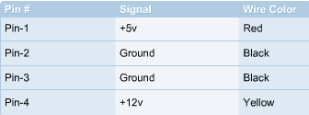

Connecting the Drives
Attaching the power cables to the floppy drive, the hard drive, and the CD-ROM is simple since all the connectors are keyed and therefore can only be inserted one way. The connectors should go on easily and should not need to be forced. Verify the proper connector is going to the appropriate drive, as described below:
- Floppy drive – Identify the proper connector that goes with the 3.5” drive. These connectors are usually the smallest plugs coming out of the power supply. Push the plugs in gently. Do not rock them back and forth to secure a connection.
- Hard drive and CD-ROM – Identify the proper power connectors for these drives. They are larger than those for the floppy, and sometimes the labels will be P1, P2, P3, and so on, on these power plugs. They are harder to push in so rock them gently back and forth if needed until they snap into place.

2.7 Video Card installation

2.7.1 Step-by-step installation of the video card
The video card as shown in Figure below, is the only expansion card that needs to be installed before booting the PC for the first time. It is critical in displaying vital information needed to configure the BIOS during the initial boot process. All the other cards can be installed once the computer is up and running.
Installation of the video card is a four-step process:
Step 1 Locate an expansion slot type that matches the video card. AGP is used for newer (ATX) motherboards while ISA and PCI are used for older boards.

Step 2 Take out the slot insert that corresponds to the slot on the motherboard. Some cases have punch out inserts while others have inserts that are screwed in.

Step 3 Insert the video card into the slot by aligning the pins and gently applying pressure alternately to the front and back of the board until all the pins are in place. Older ISA cards may be more challenging to insert because of their length. When pushing the card into the slot, try not to let the motherboard bend. Sometimes it might be necessary to put a hand underneath to push the board up if it bends. Make sure to be properly grounded to the case.

Step 4 Once the card is in place, secure it to the case with a screw. Do not forget to check all work.
These general steps can be used to install other expansion cards such as modem card and sound card.
Caution: Some motherboards have built-in video. If this is the case, it must be disabled in the CMOS in order to install an external video card. Built-in video that is not disabled will cause a system conflict that will need to be resolved before the new external video card will be recognized.
If the video card is plug-and-play, the system will detect the new hardware and install the proper driver. If the proper driver is not detected, the driver that came with the video card should be used. Current drivers can also be downloaded from the video card manufacturer website.
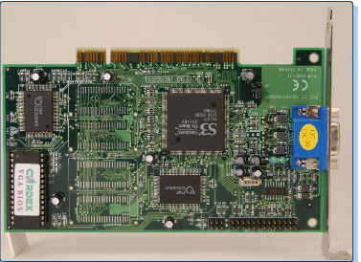

3.8 Final steps

3.8.1 Fitting the case together
Once all the components and parts have been installed in the case, it is time to complete the PC assembly process. First, check the cable connectors. Check to make sure that all of the pin 1 indicators on the cables match up with all of the pin 1 indicators on the sockets. Next, make sure all of the connections are snug.
If a connection does not look correct, push on it gently to seat it. Do not force any connection because the pins and circuit boards bend and break easily. No connection should be too difficult to attach. If it is, there is probably something wrong. After all the cables are secured, check to make sure that all of the screws are properly tightened. These screws should be secured, but not overly tight. Finally, when securing the case, make sure no cables or wires are sticking out or are caught between the parts of the case.
Please make sure that everything included in the list is complete and properly done:
- All expansion cards are fully inserted in appropriate slots
- CPU fan is attached to power
- The 110/220 volt switch is configured properly
- Drives are properly connected to power
- Ribbon cables are attached correctly
- No wires are protruding into fans
- CPU voltage settings are correctly configured
- Power switch is off and power supply connectors are connected properly to the motherboard
- All connections are sufficiently tight
- Pins are properly aligned
Close the newly assembled computer before testing it to avoid any accidental contact with the internal parts while the machine is running since there is no grounding at this point. This can be hazardous for both the installer and the computer as discussed earlier in this chapter.

2.8.2 Connecting the keyboard, mouse, monitor, and power cord

The very last step before turning on the power is to connect the basic input and output (I/O) devices that the computer needs to start. These devices can be connected in any order. The following list includes instructions for connecting these devices:
- Connect the keyboard to the back of the case – Older model motherboards use a 5-pin connector, but most computers use a 6-pin PS/2 port. Sometimes the keyboard connector and port are color-coded (violet) to distinguish them from the mouse.
- Connect the mouse to the back of the computer – The mouse is the next device to connect, usually right next to the keyboard connection if it is a PS/2 mouse. Follow any color codes (green) where applicable.
If it is a serial mouse, plug it in the serial port. Some motherboards number the ports, and since it is the first serial device in the system, plug it in serial port number one.
- Connect the monitor – If the motherboard has video capabilities, the connection point will be near the mouse and keyboard connections. If the motherboard has a video adapter card, plug the monitor into the connector located on that card. Since the connector is quite large, it normally has two screws to help hold it in place. Twist the tops of the screws until the connection is secure.
- Main Power Supply – Finally, plug the AC power cord into the back of the power supply, the other end into the wall socket. If there is a switch on the power supply, turn it on as well. This usually will not power the computer. It is just the master power switch for the power supply.
The computer is normally started with the power switch on the front of the case. The computer can now be turned on.

2.9 Booting the System for the First Time

2.9.1 What is BIOS?

BIOS stand for Basic Input Output System. It contains the program code required to control all the basic operating components of the computer system. In other words, the BIOS contains the software required to test hardware at boot up, load the operating system, and support the transfer of data between hardware components. To enter BIOS setup during the boot up process, follow the screen instructions. Pressing F2, F10 or DEL key for example, will access BIOS for some versions of BIOS. BIOS setup allows the customization of a computer to function optimally based on the hardware and software profiles.
Three companies have come to dominate the BIOS market:
- Phoenix Technologies, Ltd. (Phoenix)
- American Megatrends, Inc. (AMI)
- Award Software, Inc. (Award)

REVIEW QUESTIONS AND LABS

Lab 1: Identifying computer case and power supply.

Objective

In this lab, identify the type of computer case to be used, the form factor of the unit, and
the voltage selector switch on the power supply. The inventory of all the components that
will be installed in the computer case will also be discussed. Finally, motherboard
Standoffs will be installed to prepare the case for the installation of the motherboard.

Equipment

The following equipment is required for this exercise:
• Tool kit and screws
• Computer case with power supply
• Motherboard standoffs and screws
• Motherboard & manual
• Devices that will not be installed yet, but are referenced:
CD-ROM, Sound Card, Modem, NIC, RAM, Hard Drive with IDE Cable,
Floppy Drive with Cable, Mouse, Keyboard, Monitor

Scenario
The student is assembling a personal computer for a friend, and is ready to prepare the
case for the installation of the motherboard.

Procedures

Be sure to wear the antistatic wrist strap during the entire installation process. One end
Should be looped snugly around the wrist, with the other end attached to an unpainted
Metallic part of the computer case. This will prevent electrostatic discharge, which can be
Extremely hazardous to computer devices.

Step 1

The first step in the assembly process is to create an inventory of all computer components that will be installed into the computer. Lay out the computer components that will be used in this chapter’s labs. Gather all the information necessary to fill out the inventory sheet below.

Computer Identification
Name: ______________________
Number: _____________________

Case Number of 3.5” bays _____5.25” bays _____
Manufacturer: __________________

Motherboard Manufacturer: __________________
Model: ________________________
Form Factor _______AT _______ATX
Chipset Manufacturer:_____________ Model: _______________
BIOS Manufacturer:_______________ Version: _______________
Does the CPU use a socket or a slot? ________
How many CPU socket/slots are there? _______
How many ISA slots are there? ________
How many PCI slots are there? ________
How many floppy connectors are there? _______
How many serial ports are there? _____
How many parallel ports are there? _____
Is there an AGP slot? ________
How many USB ports are there? ______
How many other ports or slots are there? _______
What kind(s) are they? _______
CPU Manufacturer: ______________
Model: ___________________
Speed ________________ MHz
Memory ______ 30-pin SIMMs ______ 72-pin SIMMs
______ 168-pin DIMMs _____ 160 pin RIMMs
______ 184-pin RIMMs ______ Others: ___________

How many memory slots are there? _________
What is the fastest type of memory supported? ______
What is the maximum memory supported? _______

Hard Drive Manufacturer: __________________
Model: _________________
Size _______ Cylinders _________ Heads _________ SPT _______
Interface Type ________ IDE ________ SCSI

CD-ROM Manufacturer: ___________________
Model: _________________
Speed: _________________
Interface Type __________ IDE ___________ SCSI

Floppy Disk Drive Manufacturer: ___________________
Monitor Manufacturer: _______________
Model Number: ______________
Video Card Manufacturer: _______________
Model: ____________________
Memory ___________ MB
ISA _____________
PCI _____________

Sound Card Manufacturer: __________
Model: _______________
ISA ____________
PCI ____________
On Board _____________
Mouse Type __________ PS/2 __________ Serial _______________ USB
Keyboard Connector _______ 5-pin DIN or ________ 6-pin mini DIN _______
USB (Make sure it matches the connector on the Motherboard).
Power Supply AT __________
ATX _________
Other _________
Power Supply Wattage _______

Step 2: Most computer cases come complete with a power supply. However, not all cases are built for the United States market and therefore may not be set for the correct voltage. Look in the back of the case for the voltage selector switch. If in the United States, make sure that the switch is set to 115 volts. Adhere to the local power requirements when selecting the voltage for the power supply.

Step 3: Power supplies are rated by wattage, which is usually between 250 and 300 watts. What is the power supply rating for the case? _________

Step 4: Attach the motherboard standoffs to the case. Standoffs are small pegs made of a nonconductive material that helps avoid short circuits by preventing the motherboard from touching the case. Look at the holes on the motherboard to help place the standoffs in the proper locations.

Reflection: Were all areas of the inventory list able to be filled out? ____________________
Explain any difficulties with the installation.
__________________________________________________________________

QUESTIONS

1. Depending on the type of case and motherboard selected, the power supply must
adhere to the same ________ ___________ requirements in order to fit inside the
Case and correctly power the motherboard and other devices.

2. Some fans can change direction to allow air to be blown directly on the ________
and to regulate the quality of the air entering the case.

3. The two basic types of power supplies are ________ and ________

4. Match each component with the voltage from the power supply unit that it uses.
1. ____ Motherboard a. –5V
2. ____ Disk Drives b. +3.3V
3. ____ Serial Port Circuits c. 0V
4. ____ ISA bus cards d. +12V
5. ____ Most newer CPUs e. +5V
6. ____ Ground f. –12V

5. An AT power supply produces how many different levels of DC voltage?
_______________________________________________________________
An ATX power supply produces how many different levels of DC voltage?
_______________________________________________________________

6. Match each voltage with the correct color wire.
1. ____ Yellow a. 0V
2. ____ Red b. –5V
3. ____ Blue c. +3.3V
4. ____ White d. +12V
5. ____ Black e. +5V
6. ____ Orange f. –12V

7. Never attempt to repair a defective power supply. _______________ inside a
power supply box store electricity and will discharge through the body if touched.

8. The ATX motherboard is a _____-pin keyed connector.
2 - 2 IT Essentials I v2.0 - Worksheet 3.3.4 Copyright  2002, Cisco Systems, Inc.
9. The AT motherboard has two _____-pin connectors.
10. The ATX motherboard directs air ______________________________________
_____________________________________________ of the computer case.

11. The AT motherboard directs air _______________________________________
__________________________________ of the computer case.

Lab 2: Motherboard Installation

Objective

Upon completion of this lab, the motherboard will be placed into the case and secured. The CPU, the heat sink, the LEDs, and the memory will also be installed.

Equipment

The following equipment is required for this exercise:

• Tool kit and screws
• Motherboard & manual
• CPU with fan and heat sink
• Thermal grease
• RAM (use the appropriate type for the motherboard)

Scenario

The case for a friend’s computer should be ready for the next step. Continue to work on
Installing the CPU and RAM.

Procedures

In this lab, continue to work on the PC that is being built and properly install the motherboard, CPU, heat sink, CPU fan, and RAM.

Step 1: Lay the motherboard down on the antistatic mat. Identify the CPU socket on the motherboard. The CPU socket is keyed so that the CPU may only be inserted one way.

What CPU type does the motherboard support? _____________________________

Step 2: Pick up the CPU and locate pin one. Note that the CPU may only be inserted one way into the CPU socket. Install the CPU into the CPU socket. If the CPU is being installed into a Zero Insertion Force (ZIF) socket, no force is necessary. If any force has to be applied, the CPU is not lined up correctly. After the CPU is seated, adjust the CPU socket lever until it is in the locked position. When the lever is locked the CPU is secure.

Who is the manufacturer of the CPU? _______________________________

Step 3: Attach the cooling fan to the heat sink. Use the four screws that came with the cooling fan to attach the fan securely to the top of the heat sink.

Note: Some heat sinks are already equipped with a fan and will not need to be secured With screws. Is the heat sink being installed attached with screws?

Step 4: To attach the fan-heat-sink assembly to the CPU, lay the heat sink down on the CPU and align the heat sink clips to their correct positions on the CPU socket. If necessary, rock
the heat sink into position until one side of the heat sink is locked down to the outside of
the CPU socket. Next, push down the other clip until it locks. After both sides of the heat
sink are clipped, the heat sink will be secured to the CPU.

Caution: Using a screwdriver may be necessary to secure the heat sink clips, but do not apply excessive force. If the screwdriver slips off the clips, it may damage the Motherboard.

Step 5: Attach the power connection for the heat sink fan to the motherboard. Use the motherboard manual to identify the fan power pins on the motherboard. Connect the fan power leads to these pins and make sure they are secure and in the correct orientation.

Step 6: Install the memory. When installing the memory, the first step is to identify the memory sockets. Use the motherboard’s manual to identify the memory sockets. Examine the memory sockets and the memory chip(s). Memory and associated sockets are keyed to ensure proper installation. Take the memory and line it up with the socket. Slowly seat the memory it into socket one. It may help to rock the memory into the socket until secure by gently pushing alternately on the ends of the chip. Remember, just as with the installation of the CPU, if too much force is exerted the motherboard can be damaged or destroyed. If more than one memory chip is to be installed then follow the instructions in the motherboard’s manual to add more. It is common for the next memory chip to be placed in socket two. Refer to the motherboard’s manual for specific information.

Step 7: Install the motherboard. Align the motherboard with the standoffs and set it in the case. The motherboard may have to be pushed back slightly against the I/O plate to get it to line up correctly. Once the motherboard is seated use the proper screws to secure it to the case. Do not over-tighten the screws or the board may be damaged.

Step 8: Connect the front panel LEDs to the motherboard. The motherboard connects to the
LEDs on the front panel of the computer case to give the operational status of the computer. For example, a green LED on the front panel indicates that the computer is running. Use the video demonstration and/or the motherboard’s manual to identify all of the LED pin outs. Connect each LED wire to the appropriate pin outs.

Reflection

What would happen if the CPU fan stopped during normal computer operations?
__________________________________________________________________
__________________________________________________________________
What was the most difficult component to install? Why?
__________________________________________________________________
__________________________________________________________________

Lab 3: Floppy Drive, Hard Drive, and CD-ROM Installation

Objective
In this lab, the student will install the floppy drive, hard drive, and CD-ROM drive. The
student will also install the ribbon cables for each drive and the audio cable for the CDROM.

Equipment

The following equipment is required for this exercise:
- The same computer case which has been worked on
- Tool kit and screws
- Floppy drive with ribbon cable
- Hard drive with ribbon cable
- CD-ROM with ribbon cable and audio cable

Scenario

Continue to install the components necessary to complete a friend’s computer.

Step 1: Locate the 3.5” bays. Locate the top 3.5” bay, if there are two. This is where the floppy
drive will be installed. If there is a cover for the top 3.5" bay, reach inside the case and push out the cover.

Step 2: Retrieve the floppy drive and line it up with the upper 3.5" bay. Slide it in until the front of the drive lines up with the front of the computer case, and the screw holes on the floppy drive line up with the side rails on the case. Use the proper screws and secure the floppy drive to the case. A long screwdriver may be needed to reach the backside of the floppy drive.

Step 3: Install the hard drive.

Note: The 3.5” cover for the hard drive bay does not have to be removed. Line up the hard drive with the lower 3.5” bay. Slide the hard drive in until the screw holes line up with the case rails. Use the proper screws and secure the hard drive to the case.

Step 4: Install the CD-ROM into any of the 5.25” bays. In most computer cases the 5.25” bays
are the upper bays. Locate the 5.25” bay that will be used for the CD-ROM. If there is a cover for this bay, reach inside the case and push out the cover. Retrieve the CD-ROM from the parts
inventory and slide it in from the front of the case. Push it back until it is flush with the case and the screw holes line up with the case rails. Use the proper screws and secure the CD-ROM to the case.

Step 5: The floppy drive is connected to the motherboard with a thirty-four pin, two-connector
ribbon cable, that has a twist in it. The twist identifies one of the floppy drives as drive "A:\". Only one floppy drive will be used during this installation. A second floppy drive could be connected to the second connector on the ribbon cable and it would be assigned the as the “B:\” drive.
Select the proper ribbon cable for the floppy drive. Take one end of the ribbon cable and connect it to the back of the floppy drive. Take the other end and connect it to the floppy connector on the motherboard. Do not use excessive force when inserting the ribbon cable. Also, make sure the plug is oriented correctly according to pin one.

Step 6: The CD-ROM is attached using an IDE, forty-pin, forty-conductor ribbon cable. The CDROM cable has two connectors. One for the motherboard and one for the CD-ROM. Select the proper ribbon cable for the CD-ROM. Take one end of the ribbon cable and connect it to the back of the CD-ROM. Take the other end and connect it to the IDE2 connector on the motherboard. Do not bend the motherboard with excessive force when inserting the ribbon cable.

Step 7: Connect the audio cable that came with the CD-ROM. Attach one end of the cable to the
CD-ROM and the other end to the motherboard. Usually, the audio cable connectors are notched and will plug-in only one way. If this is not the case, simply insert the connectors whichever way they can go in. If no sound comes out after the computer is powered up and the CD-ROM is tested, simply go back in the box, pull out the audio cable and reverse the sides. Always consult the manuals that come with components for additional direction on installations.

Step 8: The hard drive is attached using an IDE, forty-pin, eighty-conductor ribbon cable. The
hard drive ribbon cable looks similar to the CD-ROM cable. However for each conductor it has an associated ground wire, which is why it has 80 (instead of 40) conductors. This cable can fit into a CD-ROM and visa versa, but the hard drive will not work properly if they are switched. The easiest way to tell the difference between the CD-ROM ribbon cable and the hard drive cable is to feel them. Since the hard drive cable has eightyconductors it is not as coarse as the CD-ROM cable. Select the proper ribbon cable for the hard drive. Take one end of the ribbon cable and connect it to the back of the hard drive. Take the other end and connect it to the IDE1
connector on the motherboard. Do not bend the motherboard when inserting the ribbon cable.

Step 9: The power cables are attached to the motherboard and each drive. Examine the power
cables that extend from the power supply. There will be one large connector and several smaller connectors. The large 20-pin (ATX 1) attaches to the motherboard, the smaller connectors attach to the drives. Most power supplies support four IDE drives and two floppy drives. The connectors for the floppy drives and for the IDE drives (CD-ROM & hard drive) are different. Examine the back of each drive. Find the power connectors on the back of each drive and connect the correct power cable to each one. Next, connect the ATX power connector. Use caution when attaching the ATX cable. Do not bend the motherboard.

Reflection

Briefly summarize the differences between the floppy drive and hard drive ribbon cables:
__________________________________________________________________
__________________________________________________________________
Write one tip that was learned from the material or in class that helped with the
installation of the components in this lab.
__________________________________________________________________
__________________________________________________________________

Lab 4: Video Card Installation and System Booting

Objective
Upon completion of this lab, the student will have installed the video card. The student
will also have connected the mouse, keyboard, and monitor. If everything is installed
properly, the student should be able to turn on the computer at the end of this lab.

Equipment

The following equipment is required for this exercise:
• Tool kit and screws
• Video card
• PS/2 mouse
• PS/2 Keyboard
• 15” monitor
• 3.5” DOS boot floppy
• Motherboard manual

Scenario
A friend cannot wait any longer for the computer to be finished. It is time to put the
finishing touches on the machine and start it up.

Procedure

Before powering up a computer, it is extremely important to properly seat all of the expansion cards. If a card is not properly seated when the computer is turned on, it will malfunction. Also, excessive force when seating an expansion card can damage the motherboard, so the job must be done carefully.

Step 1: Recall from chapter two that video cards are built for either the PCI slot or the AGP slot.Check the video card that is included in the equipment inventory. In the space below
describe the video card. Include how much video RAM is on the card and whether it is a
PCI or an AGP card.
__________________________________________________________________
__________________________________________________________________
To install the video card, first remove the slot protector from the back of the computer
case. Locate the AGP slot or an available PCI slot. Remove the slot protector by
removing the screw that holds it in place.

Step 2: Insert the video card into the AGP or PCI slot. If necessary, rock it gently until it is seated on the motherboard. After the video card is seated, line up the hole in the video card
bracket with its corresponding hole in the computer case. Use a case screw to secure the
video card to the computer case.

Note: Never leave a slot open without a card in it. Leaving a slot open will cause poor air
circulation in the case and some components may overheat.
Step 3: Before closing the computer case, review the following checklist:

Are there any loose screws in the computer case?
Have all tools have been removed from the computer case?
Is the voltage selector switch in the correct position?
Is the CPU seated completely?
Is the fan secured?
Is the fan plugged in?
Is the memory in the correct slot, and is it fully seated?
Are all of the drives in the correct position and secure to the chassis?
Are the ribbon cables fully seated and connected to the correct drives?
Is the audio cable connected to the CD-ROM drive correctly?
Is the ATX 1 power cable in the right position and has it been latched down?
After completing the checklist, put the computer case together. Attach all of the case
panels and secure them with the appropriate screws.

Step 4: Locate the two PS/2 ports on the back of the computer. One port is designated for the mouse and the other for the keyboard. Look closely at these ports. On newer motherboards there is an icon for the mouse and keyboard. Also, each port may be color coded. It is purple for the keyboard and green for the mouse. Plug the mouse and keyboard into their respective ports by lining up the pins and pinholes and pushing on the connections. Do not push too hard, but make sure they are inserted all the way.

Step 5: Locate the monitor and place it near the computer. Examine the video card adapter that was installed in Step 1. It will be a 15-pin female connector. Examine the monitor connector. It will be a 15-pin male connector. Line up the pins to the pinholes and connect the monitor cable to the video adapter. Most cables come with monitor screws already attached. Tighten these screws evenly until the monitor cable is attached to the video card.

Step 6: Now plug in the computer power cable. On ATX models there will be a power switch on
the back of the computer and a power button on the front. Turn on the power switch first. The computer will not power up unless both the switch and the button are on. Now, push the power button on the front panel of the computer. This will power-up the computer. Some front panel LEDs will turn on, and the power supply fan will start spinning.

Step 7: Press the appropriate key to cause the computer to go into the BIOS setup mode. Some BIOS manufacturers use a different key, or key combination, to enter BIOS configuration mode. When first powering up the computer, a message displays that says something similar to “Press F3 to enter Setup”. If this message does not display, consult the motherboard’s manual for the correct button or sequence of keys to push. When the computer goes into BIOS setup, the main menu screen displays. Run through the BIOS settings below and then boot the computer from a bootable floppy disk. Move around the screen using the arrow keys until the Standard CMOS menu item is highlighted. Press the Enter key to open the Standard CMOS features screen. In this screen the time, date and the type of drives this computer will recognize can be change.
Check to see if the BIOS recognizes Drive A. Does it show Drive A as a 1.44M, 3.5” floppy?

Check to see if there is a Drive B. Since a second floppy drive was not connected when the system was built, you should not find one. To leave the BIOS setup, hit the Esc key. A prompt will display that asks. Do you want to quit without saving? Press the Y key for yes.

Step 8: In this step, the computer is booted from a floppy disk. Restart the computer and insert
The 3.5” bootable floppy disk. If the standard BIOS settings have not been altered, the computer will look for the operating system in the following order:

1) Removable media
2) Hard drive
3) CD-ROM

During normal operations the computer is booted without a floppy disk. Therefore, the computer will skip the floppy drive and find the operating system on the hard drive. Recall from chapter two that DOS is a command line operating system. After the computer boots, the screen will display an "A:\>" prompt. There will not be any windows or icons visible. Use the DOS boot disk to check some basic functions of the computer. Run the following DOS commands and write out the results of each:

Type “dir”, then press Enter.

What are the results of typing this command?
__________________________________________________________________
__________________________________________________________________
__________________________________________________________________
__________________________________________________________________
Troubleshooting
Did the computer boot correctly? _______
If not, go over the checklist again. Have the instructor or lab aide look over the system.
How many beeps were heard?
__________________________________________________________________
__________________________________________________________________
If the computer did not boot correctly, what steps were taken to troubleshoot it?
__________________________________________________________________
__________________________________________________________________
Reflection

Did everything go as expected? If not, why not?
__________________________________________________________________
__________________________________________________________________
What would have made the construction of the computer easier? Describe a tip or
technique that you learned when building this computer that could be used in the future.
__________________________________________________________________
_________________________________________________________________

CHAPTER 3 THE OPERATING SYSTEM

3.1 The Operating System

3.1.1 Components of an operating system
An operating system is a software program that controls thousands of operations, provides an interface between the user and the computer, and runs applications. Basically, the operating system is in charge of running the computer. Today, most computer systems are sold with an operating system already installed. Computers that are designed for individual users (called Personal Computers or PCs) have operating systems that are designed for individuals running small jobs. An operating system is designed to control the operations of programs such as Web browsers, word processors, and e-mail programs.
There are three basic elements that make up the major design components of any operating system. These components are described as modular because each has a distinct function and can be developed separately:
Kernel
Kernel being a core of the operating system, it is a small piece of code that is loaded into memory when the computer boots. The kernel contains instructions to manage hardware devices. The kernel also manages and controls memory allocation, system processes, and other programs. Application software and other parts of the operating system rely on the kernel to provide basic scheduling services and access to the computer hardware and peripherals.
User Interface
The user interface (UI) is the most visible part of a computer operating system. The UI is the component of the OS that the user interacts with. It acts like a bridge between the user and the kernel. The UI is like an interpreter, translating user keystrokes, mouse clicks, or other input for the appropriate programs. Program output can be organized and displayed by the UI.
File System
The file system of an OS determines the way files are named and how and where they are placed on storage devices, such as hard disks. The type of file system used by the computer determines whether or not files can be secured from other users or programs. The file system also defines how data is physically arranged on the storage media, such as a hard drive. Some file systems use disk space more efficiently than others.

3.1.2 Functions of an Operating system

Regardless of the size or complexity of the computer or its operating system, all operating systems perform the same basic functions:
- File and folder management – An operating system creates a file structure on the computer hard drive where the user data can be stored and retrieved. When a file is saved, the operating system saves it, attaches to it a name, and remembers where it put the file for future use.
- Management of applications – When a user requests a program, the operating system locates the application and loads it into the primary memory or RAM of the computer. As more programs are loaded, it is the job of the operating system to allocate the resources of the computer.
- Support for built-in utility programs – Utility programs are programs that the operating system uses to maintain and repair itself. These programs help identify problems, locate lost files, repair damaged files, and backup data. Figure shows the progress of the Disk Defragmenter found in Programs > Accessories > System Tools.
- Control to the computer hardware – The operating system sits between the programs and the Basic Input Output System (BIOS). The BIOS was explained in previous chapters and more will be provided later in this chapter. The BIOS does the actual hardware control. All programs that need hardware resources must first go through the operating system. The operating system in turn can either access the hardware through the BIOS or through the device drivers. The Windows 2000 NOS bypasses the system BIOS and controls the hardware directly.

3.1.3 Operating system types

To understand what an operating system is capable of, it is important to understand some basic terms. The following terms are often used when comparing operating systems:
- Multiuser – Two or more users running programs and sharing peripheral devices, such as a printer, at the same time.
- Multitasking – A capability of a computer to run multiple applications at the same time.
- Multiprocessing – Allows a computer to have two or more central processing unit (CPUs) that programs share.
- Multithreading – The capability of a program to be broken into smaller parts that can be loaded as needed by the operating system. Multithreading allows individual programs to be multitasked.

Today, almost all operating systems are multiuser, multitasking, and support multithreading.
The following is a list of some of the most popular operating systems.
- Microsoft Windows 95, 98, ME – Windows is one of the most popular operating systems today. Windows is designed to run on PCs and to use an Intel-compatible CPU. Windows-based PCs use a GUI as the interface between the computer and the user. Windows systems are designed to be run and maintained by a single user.

- Microsoft Windows NT/2000/XP/VISTA/WINDOWS 7 – Also from Microsoft, Windows NT, 2000, and XP are operating systems that were designed to support multiple (concurrent) users and to run applications simultaneously. Both Windows NT and Windows 2000/XP have incorporated many networking features.

- UNIX/LINUX – UNIX, which has been around since the late 1960s, is one of the oldest operating systems. UNIX has always been popular with computer professionals whose responsibility is to run and maintain computer networks. UNIX-based computers from IBM, Hewlett-Packard (HP), and SUN Microsystems have helped run the Internet from the beginning. There are many different versions of UNIX today. One of the most recent is the extremely popular Linux.

3.2 Disk Operating System (DOS)

3.2.1 What is DOS, and why learn about it?
Microsoft developed the Disk Operating System (DOS), also called MS-DOS, in 1981. DOS was designed for the IBM Personal Computer. Windows 98 and Windows 2000 both support DOS commands in order to address compatibility issues related with older applications. Simply put, DOS is a collection of programs and commands used to control the overall computer operation in a disk-based system. There are three distinct sections that make up the disk operating system:
- Boot files – Is used during the boot process (that is, startup).
- File management files – Enables the system to manage the data that it holds in a system of files and folders.
- Utility files – Enables the user to manage system resources, troubleshoot the system, and configure the system settings.

DOS is useful as a troubleshooting aid when Windows will not boot. It allows the hard drive to be accessed without the GUI and provides the ability to run troubleshooting or diagnostic programs. The following are some of the basic things to remember when working with DOS:
- DOS is a command line operating system, it is not user-friendly. The best way to learn DOS is to use it.
- DOS can only run one program at a time. It does not support multitasking.
- DOS can only run small programs and has memory limitations.
- DOS is an essential tool for IT professionals and is used extensively for troubleshooting.
To access DOS from Windows, go to Start > Run > Command. A separate window opens that allows commands to be entered.
In DOS, all files have attributes, which are a set of parameters that describe a file. Given the attributes of a file, it is possible to determine the nature of the file. The common attributes for DOS files include the following:
- Hidden File – The user will not see this files with any kind of normal file search in a DOS environment
- Read Only – The user can open and read this type of file but cannot write or modify the file in any way
- Archive – A backup copy of files
- System File – A file needed by the DOS operating system for a successful bootup
Hidden files conceal important files and keep them from being tampered with by unauthorized users. Hiding a file makes it invisible to a standard DOS directory listing and it can only be seen with a specific command. It is important to note that hiding a file does not make it immune to changes or access. The file is not listed in a standard DOS directory listing but it can still be accessed as a normal file. To see a hidden file, just use the command dir /ah at a command prompt as follows:
C:\>dir /ah
Directory Structures and Organization
Locating any given file requires knowledge of the drive, directory, and subdirectory in which the file is found. The first hard drive in most computer systems is labeled “C”. Each hard disk in the computer can be considered a file cabinet or “root”. The root of the C drive is represented by “C:\”. Any files or directories within the root are represented by the root, followed by the name of the file or directory, such as C:\EXAMPLE. Any directory or file located within that directory is represented by that directory, followed by a backslash, followed by the name of the file or subdirectory, such as C:\EXAMPLE\FILE.EXE.

In MS-DOS, the format for specifying the path to a file is as follows:
C:\directory\subdirectory\ subdirectory\filename
- The C:\ specifies the C disk drive of the computer
- The back slash (\) after each item signifies the presence of a directory or subdirectory
- The first back slash indicates the root directory, which is present on all DOS disks
- The filename, found at the end of the path, is located in the last-named subdirectory.

3.2.2 Overview of basic DOS commands

A DOS command is an instruction that DOS executes from the command line. A variety of internal commands, such as dir and copy, are built into the COMMAND.COM program and are always available as long as DOS is running. Many external commands, such as format and xcopy, are individual programs that reside in the DOS directory.
Internal versus External DOS Commands
DOS contains commands that are built into the operating system (internal) and those that must be executed from a file (external). Basic commands are generally internal and more advanced commands are usually external. External commands are stored on disk for future use. Internal commands are located in the COMMAND.COM program, and are loaded into memory during the bootup process.
What Is a Command Line?
Normally, the operating system provides the system user interface. In DOS, the main user interface is the command line. The command line is the space immediately following the DOS prompt, C:\> where C:\ represents the hard disk drive root directory, and “>” is known as the prompt. All the DOS commands are typed to the right of the prompt and executed by pressing the Return (Enter) key on the keyboard. All DOS functions can be entered and executed from the command line. For example, to view all system files in the "C" directory, you would type: C:\>DIR *.SYS
Commonly Used DOS Commands and Switches
DOS commands are used to tell the disk operating system to perform a specific task. Placing one or more software switches at the end of the basic command can modify many of the DOS commands. Switches are options that can be added to a command that will modify the output of the command. A switch is added to the command by adding a space, a forward-slash (/), and a single letter. The format is as follows:

COMMAND (space) /switch, for example, C:\>dir /w
In the example given above, the /w is a switch. The /w will modify the dir command by presenting the screen output information in a “wide” format, that is across the screen. The rest of this section will focus on some commonly used DOS commands and the switches that go with them. The commands described in the following list are helpful when doing various operating system installations including Windows.

- ATTRIB – Used to display, set, or remove one or more of the four attributes – read-only, archive, system, and hidden – that can be assigned to files and directories. attrib is an external DOS command. A plus or minus sign used in the attrib command sets or clears an attribute, respectively. The format of the attrib command is as follows:
ATTRIB [ + or - ] [variable] [directory|filename] / [switch]
The following variables can be used with the attrib command:
- R – Indicates a read-only file
- A – Indicates an archive file
- S – Indicates a system file
- H – Indicates a hidden file
- DEL – This command deletes named files. The DEL and ERASE commands are synonymous. The commonly used switch, /P, prompts the user for confirmation before deleting each file. The format of the del command is as follows:
- DEL [directory\filename] / [switch]
- EDIT – This external command allows the user to view, create, or modify a file. The format of the edit command is as follows:
EDIT [directory\filename] / [switch]
- FORMAT – This external command is used to erase all the information from a floppy disk or hard drive. The format command will be used in a future lab to prepare the hard drive for installing the Windows OS. A typical format command is as follows:
FORMAT [directory\filename] / [switch]

The following switches are commonly used with the format command:
- /Q – Performs a quick format but does not clear the FAT. File recovery is possible when a quick format has been performed.
- /S – Copies system files to the formatted disk.
- /U – Performs unconditional format. All previous data, including the FAT, are permanently erased.
Note: The /S switch must be added when formatting in order to make a system disk. If this switch is not used, the disk can be reformatted or the DOS SYS command can be used.

- FDISK – This external command allows the user to delete and/or create partitions on the hard disk drive. The FDISK command is commonly used to prepare the hard drive for installing the Windows OS. This command is entered at the command prompt as follows:
FDISK / [switch]
A commonly used switch, /STATUS, displays partition information when used with
the FDISK command.
- SCANDISK – This command is a DOS program that is designed to detect and repair errors on a hard drive or floppy disk. The SCANDISK command is entered at the command prompt as follows:
SCANDISK / [switch]
Switches commonly used with the SCANDISK command are as follows:
- all – Checks and repairs all local drives at once.
- checkonly – Checks the drive for errors but does not make repairs.
- autofix – Automatically fixes errors. Saves lost clusters by default as files in the drive's root directory.
- COPY – This command is commonly used to copy one or more files from one location to another. The copy command can also be used to create new files. By copying from the keyboard console (copy con:) to the screen, files can be created and then saved to disk. Switches commonly used with the copy command are as follows:

/Y – Replaces existing files without providing a confirmation prompt.
/-Y – Displays a confirmation prompt before overwriting (copying over) existing files.
/A – Copies ASCII files. Applies to the filename preceding it and to all following filenames.
/B – Copies binary files. Applies to the filename preceding it and to all following filenames.
/V – Checks the copy to make sure that a file was copied correctly. If the copy cannot be verified, the program displays an error message.
- MORE – Displays output one screen at a time. The more command is entered at the command prompt as follows:
more [filename]
- The CD, MKDIR, RMDIR, and DELTREE commands are slightly different than those previously discussed because they do not use switches. A brief description of these commands is as follows:
- CD – Changes or displays the current directory on the specified drive
- MKDIR (or MD) – Creates a new directory
- RMDIR (or RD) – Removes an empty directory. Any subdirectories and files within the directory must be deleted or moved before this command can be used.
- DELTREE – Deletes (erases) a directory, including all files and subdirectories that are in it.

3.2.3 Creating a dos boot disk
What is a boot disk?
A boot disk will allow you to boot off of a diskette instead of your hard drive. This diskette can be used to fix issues that may arise during the lifetime of your computer or to help load older MS-DOS games. Keep in mind this diskette is completely different than a Restore CD or Disc that may have been included with your computer.After you have created a boot diskette, it is highly recommended that you write-protect the diskette to prevent possible computer virus infection and to help the diskette from being erased.

Creating a Windows 98 / ME boot disk
Note: These steps are for users who have Windows 98 or Windows ME installed on the computer.
An excellent feature of Windows 98/ME is its boot diskette. Using Windows to create you a Windows 98 boot diskette will give you all the needed files as well as CD-ROM support. To create a Windows 98 boot diskette, click Start / Settings / Control Panel / double-click the Add Remove programs icon / click the Startup Disk and create disk.
Creating a Windows NT boot disk
To create a boot diskette you must have access to the i386 directory located on your Windows NT CD or possibly your Hard disk drive.
Format the floppy diskette you wish to make a bootable Windows NT boot disk using the Windows NT machine.
Copy boot.ini, ntdetect.com and ntldr to the floppy diskette just formatted.
Creating a Windows 2000 boot disk
To create a Windows 2000 Professional bootable diskette you will need four 1.44MB diskettes and the Windows 2000 Professional CD.
Click Start / Run / browse to the CD-ROM drive. Open the "BOOTDISK" folder and double-click makeboot.exe and click ok to launch the program to create the diskette.
Users can also easily create an Emergency Repair Disk by clicking Start, Programs, Accessories, System Tools, and opening Backup. From the Backup window, click the button for Emergency Repair Disk and follow each of the steps.
Creating a Windows XP boot disk
Note: The Microsoft Windows XP CD is a bootable CD and in many cases you should not need a bootable floppy diskette. Booting from the Windows XP CD will allow you to not only install/re-install Windows XP but will also allow you to troubleshoot it.
Create MS-DOS bootable diskette
When formatting a floppy diskette, users have the option of creating a MS-DOS startup disk, follow the below steps to do this.

- Place diskette in the computer.
- Open My Computer, right-click the A: drive and click Format.
- In the Format window, check Create an MS-DOS startup disk.
- Click Start
How to use a boot diskette
Once the bootable diskette has been successfully created, following the below steps you will be able to boot from the diskette.
- Place the diskette into write-protect mode (in case a virus is on the computer, this will not allow the virus to transfer itself onto the diskette).
- Insert the diskette into the computer and reset or turn on the computer to begin the boot process.
- As the computer is booting, answer the questions prompted (if any).
- Once at the A:\> take the appropriate actions depending upon the situation of the computer.

3.3 Hard Disk Partitioning And Formatting Procedure Using Fdisk And Format

This procedure describes how to set up a new, empty hard disk so that it is ready for an operating system to be installed on it. This process includes partitioning and formatting and results in a bootable hard disk. The procedure covers configuring the hard disk as a single large partition or splitting it into multiple, smaller partitions.
The procedure provides specific instructions for using the FDISK program and is based on Windows 9X FDISK version with FAT32 support.
Warning: This procedure is intended to be used for setting up a new hard disk containing no information on it. Do not follow these steps if your hard disk has already been partitioned and formatted, or data loss will likely result. All commands in DOS or within FDISK require you to press {Enter} to select them.
Procedure Steps:
1. Check Version Number: At the DOS prompt, enter the following command: "ver". The system will respond with the version of DOS/Windows you have booted. Make sure that this matches whatever you want to install on the hard disk. For Windows 95 OEM SR2 the version number will be "4.00.1111".
2. Plan Partitions: Decide how you want to partition your hard disk. In particular, for large hard disks under Windows 9x, decide if you want to set up your hard disk with a single large FAT32 partition, or several smaller FAT16 partitions. You must decide based on what makes sense for you.
3. Run FDISK.EXE: From the command prompt, enter the command "fdisk". If you have a disk large enough to warrant the use of FAT32, you will be asked if you want to enable "large disk support". Enter "Y" if you want to enable FAT32, or "N" if you do not want to enable FAT32. If you do enable this, any partitions over 500 MB that you create will be FAT32. Note that if you do not enable FAT32, you will not be able to put your entire hard disk into one partition if it is greater than 2 GB in size. If you decided to place your entire hard disk into a single partition, then follow this step:
4. Partition Hard Disk (Single Partition): Follow these steps to set up your hard disk:
- Select from the FDISK menu "1. Create DOS partition or Logical DOS Drive".
- Select "1. Create Primary DOS Partition". FDISK will verify drive integrity. Then it will ask if you want to use the maximum available size of the disk for the primary partition and set it active. Enter "Y". The system will allocate the whole disk to the partition.
- Press {Esc} to exit FDISK.
If instead you want to set up your hard disk with multiple partitions (or if you don't have Windows 9X), follow this example. For example, a 3100 MB hard disk is being partitioned into four partitions of 1000 MB, 800 MB, 700 MB and 600 MB respectively:

4. Partition Hard Disk (Multiple Partitions): Follow these steps to set up your hard disk:
- Select from the FDISK menu "1. Create DOS partition or Logical DOS Drive".
- Select "1. Create Primary DOS Partition". FDISK will verify drive integrity. Then it will ask if you want to use the maximum available size of the disk for the primary partition and set it active. Enter "N". The system will show the size of the entire disk in MB.
- Enter the size of the primary partition. In our example, this would mean entering "1000". The system will tell you that it has created the primary partition, and will assign it the drive letter "C:".
- Press {Esc} to return to the FDISK menu.
- Select "2. Set active partition". Select partition 1. FDISK will report that it has set partition 1 active.
- Press {Esc} to return to the FDISK menu.
- Select from the FDISK menu "1. Create DOS partition or Logical DOS Drive".
- Select "2. Create Extended DOS Partition".
- When prompted, press {Enter} to select the entire remaining area of the disk for the extended DOS partition. FDISK will report that it has created the extended DOS partition.
- Press {Esc}. FDISK will automatically prompt you to create your first logical DOS volume within the extended DOS partition.
- Enter the size of the first logical partition (the second partition overall). In our example you would enter "800". FDISK will create the partition, label it "D:", and then say "Logical DOS Drive created, drive letters changed or added". Don't touch anything, just wait, and FDISK will prompt you for the next volume.
- Repeat the previous step for the remaining partitions (in our example there would be two more partitions to create, the 700 MB and 600 MB ones). When all of the partitions have been created, FDISK will report "All available space in the Extended DOS Partition is assigned to logical drives".
- Press {Esc} to exit FDISK.
Continue with the procedure:
5. Reboot: Reboot the system using either the Reset button or the "three-fingered salute" ({Ctrl}+{Alt}+{Delete}). Make sure the floppy disk is in its drive, since you still need it. Note that you may get "Invalid media type reading drive C" errors while rebooting.
6. Format Primary Partition: From the "A:" DOS prompt, issue the following command: "format c:/s". Do not forget the "/s", as this is what will make your C: drive bootable. You will get a "scary" warning message such as "WARNING, ALL DATA ON NON-REMOVABLE DISK DRIVE C: WILL BE LOST. Proceed with Format (Y/N)?". Since of course there is no data presently on drive C:, just enter "Y" and the system will format the hard disk. The program will show you its progress as it formats and at the end will prompt you for a volume label. Enter one if you wish.

7. Format Additional Partitions (if necessary): If you set up multiple partitions, format the additional partitions now. This is done in almost the same way as formatting the primary DOS partition, except that you leave off the "/s". So normally you would be entering "format d:", "format e:" and so on, until all the partitions have been formatted.
Warning: If you have a second hard disk in the system and it has a primary DOS partition, that partition is probably assigned D: because DOS assigns letters to all primary partitions before any logical partitions. Be careful of what you format.
8. Remove Boot Floppy: Eject the boot floppy from the floppy disk.
9. Reboot: Reboot the system using either the Reset button or {Ctrl}+{Alt}+{Delete}. The system should boot up from the hard disk this time, and stop at the "C:" prompt. Note that if you get an error such as "NO ROM BASIC, SYSTEM HALTED" or "No boot device found" at this stage, this means you forgot to set the primary DOS partition "active". Reboot from the floppy, run FDISK again and use option 2 to set the primary partition active, and then reboot. If you get an error like "No operating system", this means you probably forgot the "/s" parameter when formatting the C: drive. Put the floppy disk back in the drive and then return to step 5.

3.4 Microsoft windows operating system installation

3.4.1 Installing Windows 98

Minimum Hardware Requirements to Install Windows 98
The minimum hardware requirements include:
- 486DX 66-MHz or faster processor (Pentium recommended)
- 16 megabytes (MB) of memory (24 MB recommended)
- 195 MB of free hard disk space (the required space may vary from 120 MB to 295 MB, depending on your computer's configuration and the options you choose to install)
- CD-ROM or DVD-ROM drive
- 3.5-inch high-density floppy disk drive
- Video adapter and monitor that support VGA or higher resolution
- Microsoft Mouse or compatible pointing device

After you partition and format your hard disk, you can install Windows 98:
- Insert the Windows 98 Startup disk in the floppy disk drive, and then restart your computer.
- When the Windows 98 Startup menu is displayed, choose the Start computer with CD-ROM support option, and then press ENTER.
- If CD-ROM support is provided by the generic drivers on the Startup disk, you receive one of the following messages, where X is the drive letter that is assigned to your CD-ROM drive:
Drive X: = Driver MSCD001
Drive X: = Driver OEMCD001
NOTE: If your CD-ROM drive is not available after you boot from the Windows 98 Startup disk, install the CD-ROM drivers that are included with your CD-ROM drive. For information about how to obtain and install the most current driver for your CD-ROM drive, view the documentation that is included with your device, or contact your hardware manufacturer.
- Insert the Windows 98 CD-ROM in the CD-ROM drive, type the following command at a command prompt, and then press ENTER
X:\setup
Where X is the drive letter that is assigned to your CD-ROM drive.
- When you receive the following message, press ENTER, and then follow the instructions on the screen to complete the Setup procedure:
Please wait while the Setup initializes. Setup is now going to perform a routine check on your system. To continue press Enter.
- Follow onscreen instructions.

3.4. 2 Installing Windows 2000 Professional
To install Windows 2000 Professional, follow these steps:
- Start the installation by using one of the following methods:
  - Start from the Windows 2000 Professional installation CD-ROM. Make sure that the CD-ROM is set to start before the hard disk starts. Insert the CD-ROM, and then when you are prompted, press any key to start the Windows 2000 Professional Setup program.
  - Start from within a current operating system. Insert the CD-ROM, and then, at a command prompt, type drive:\i386\winnt32.exe and then press ENTER, or if this is an installation on a computer that has no previous installation of Windows, type drive:\i386\winnt.exe and then press ENTER, where drive is the letter of the CD-ROM drive.
- Setup inspects your computer's hardware configuration and then begins to install the Setup and driver files. When the Microsoft Windows 2000 Professional screen appears, press ENTER to set up Windows 2000 Professional.
- Read the license agreement, and then press the F8 key to accept the terms of the license agreement and continue the installation.
- When the Windows 2000 Professional Setup screen appears, either press ENTER to set up Windows 2000 Professional on the selected partition, or press C to create a partition in the unpartitioned space.
- If you choose to install Windows 2000 Professional on a file allocation table (FAT) partition, specify whether you want to:
  - Leave the current file system intact.
  - Format the partition as FAT16.
  - Convert the existing file system to the NTFS file system.
  - Format the partition by using the NTFS file system.
Press ENTER after you make your selection. Setup examines the existing hard disks and then copies the files that are needed to complete the installation of Windows 2000 Professional. After the files are copied, the computer restarts.
When the Windows 2000 GUI Mode Setup Wizard appears, click Next to start the wizard. Setup detects and installs such devices as a specialized mouse or keyboard.
- When the Regional Options dialog box appears, customize your installation of Windows 2000 Professional for locale, number format, currency, time, date, and language, if necessary. Click Next.
- In the Personalize Your Software dialog box, type your name and the name of your organization, and then click Next.
- In the Product ID dialog box, type the 25-character product key, and then click Next.
- In the Computer Name and Password dialog box, either accept the default name that Setup generates or assign a different name for the computer. When you are prompted for an administrative password, type a password for the Administrator account. (You can leave the box blank; however, this is not recommended.) Click Next.
- In the Date and Time Settings dialog box, set the correct date and time for your computer. You can also specify which time zone you are in and set the computer to automatically adjust the clock for daylight saving time. Click Next.
- Setup installs the networking software and detects your network settings. When the Network Settings dialog box appears, click either
  - Typical to set default network settings such as File and Print Sharing for Microsoft Networks, Client for Microsoft Networks, and TCP/IP protocol that uses Dynamic Host Configuration Protocol (DHCP), or
  - Custom to specify the network components that you require for your network environment, and then click Next.
- In the Workgroup or Computer Domain dialog box, specify the workgroup or the domain to join. If you indicate that you are part of a domain, specify your domain user name and password. Click Next. Setup installs the networking components.
- During the final stage of installation, Setup installs Start menu items, registers components, saves settings, and removes temporary files. When the Completing the Windows 2000 Setup Wizard dialog box prompts you to do so, remove the Windows 2000 CD-ROM, and then click Finish to restart the computer.
- After the computer restarts, click Next in the Welcome to the Network Identification Wizard dialog box.
- In the Users of This Computer dialog box, specify either that users must enter a user name and password or that you want Windows 2000 to automatically log on a specific user when the computer starts. Click Finish.

When the Windows 2000 Professional desktop appears, the installation is complete.

3.4.3 Install ing Windows XP
The minimum hardware requirements for Windows XP Home Edition are:
- Pentium 233-megahertz (MHz) processor or faster (300 MHz is recommended)
- At least 64 megabytes (MB) of RAM (128 MB is recommended)
- At least 1.5 gigabytes (GB) of available space on the hard disk
- CD-ROM or DVD-ROM drive
- Keyboard and a Microsoft Mouse or some other compatible pointing device
- Video adapter and monitor with Super VGA (800 x 600)or higher resolution
- Sound card
- Speakers or headphones
Installation process
Installing Windows XP can take up to two hours. To make the process more manageable, it has been broken up into several sections. When you are ready, install Windows XP:
Part 1: Begin the installation
1. Insert the Windows XP CD into your computer and restart your computer.
2. If prompted to start from the CD, press SPACEBAR. If you miss the prompt (it only appears for a few seconds), restart your computer to try again.
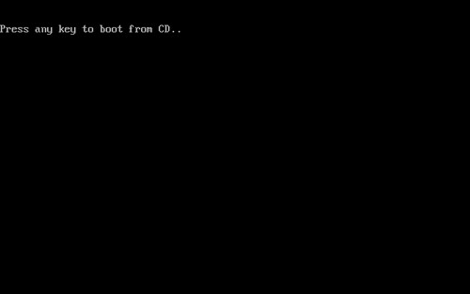
- Windows XP Setup begins. During this portion of setup, your mouse will not work, so you must use the keyboard. On the Welcome to Setup page, press ENTER.

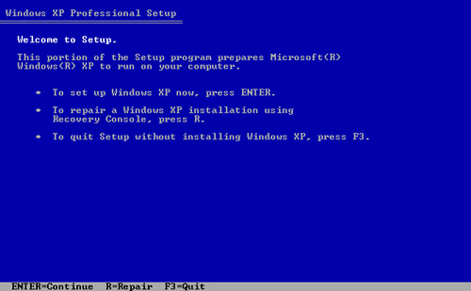
4. On the Windows XP Licensing Agreement page, read the licensing agreement. Press the PAGE DOWN key to scroll to the bottom of the agreement. Then press F8.
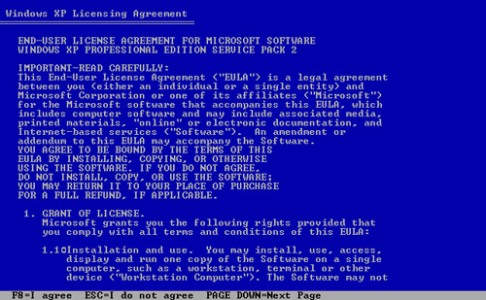
5. This page enables you to select the hard disk drive on which Windows XP will be installed. Once you complete this step, all data on your hard disk drive will be removed and cannot be recovered.
It is extremely important that you have a recent backup copy of your files before continuing. When you have a backup copy, press D, and then press L when prompted. This deletes your existing data.
6. Press ENTER to select Unpartitioned space, which appears by default.
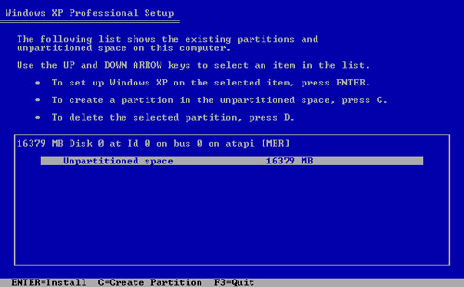
7. Press ENTER again to select Format the partition using the NTFS file system, which appears by default.
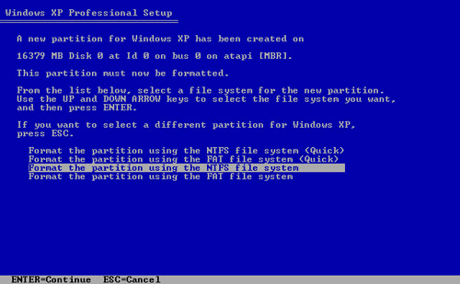
8. Windows XP erases your hard disk drive using a process called formatting and then copies the setup files. You can leave your computer and return in 20 to 30 minutes.
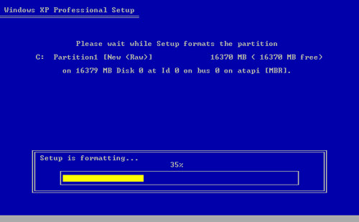
Part 2: Continue the installation
9. Windows XP restarts and then continues with the installation process. From this point forward, you can use your mouse. Eventually, the Regional and Language Options page appears. Click Next to accept the default settings. If you are multilingual or prefer a language other than English, you can change language settings after setup is complete.
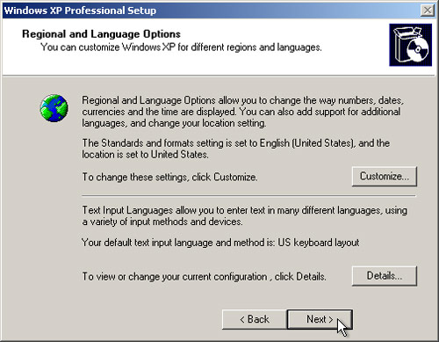
10. On the Personalize Your Software page, type your name and your organization name. Some programs use this information to automatically fill in your name when required. Then, click Next.
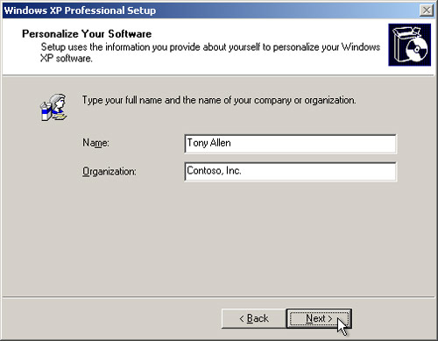
11. On the Your Product Key page, type your product key as it appears on your Windows XP CD case. The product key is unique for every Windows XP installation. Then, click Next.
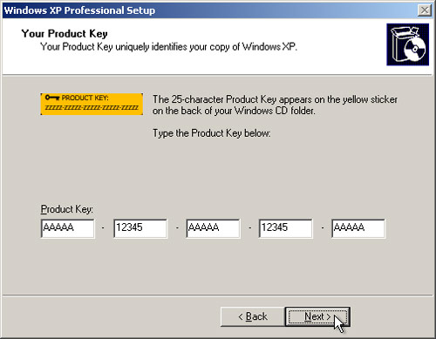
12. On the Computer Name and Administrator Password page, in the Computer name box, type a name that uniquely identifies your computer in your house, such as FAMILYROOM or TOMS. You cannot use spaces or punctuation. If you connect your computer to a network, you will use this computer name to find shared files and printers. Type a strong password that you can remember in the Administrator password box, and then retype it in the Confirm password box. Write the password down and store it in a secure place. Click Next.
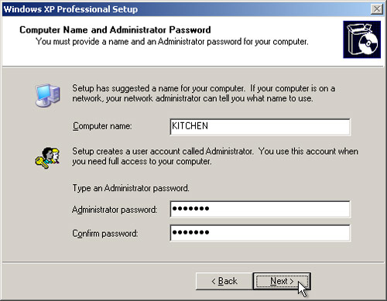
13. On the Date and Time Settings page, set your computer’s clock. Then, click the Time Zone down arrow, and select your time zone. Click Next.
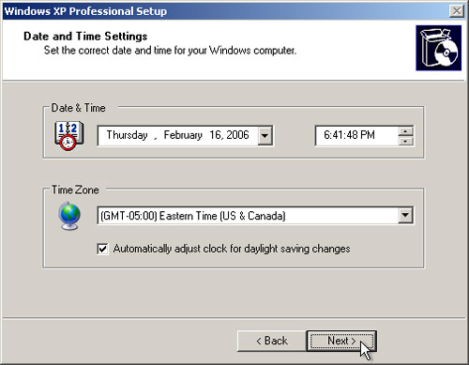
14. Windows XP will spend about a minute configuring your computer. On the Networking Settings page, click Next.
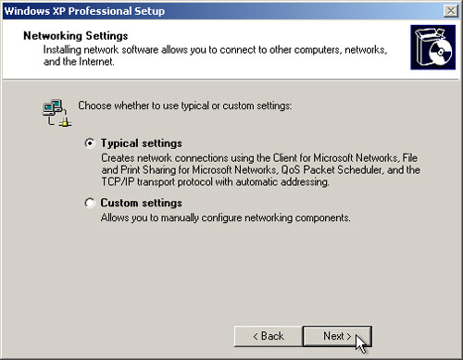
15. On the Workgroup or Computer Domain page, click Next.
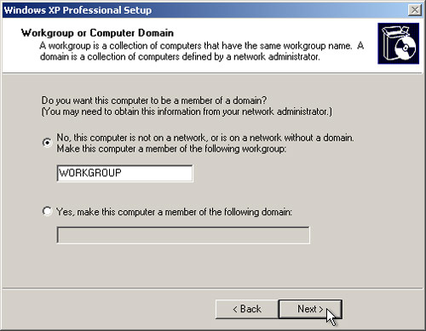
Part 3: Complete the installation
16. Windows XP will spend 20 or 30 minutes configuring your computer and will automatically restart when finished. When the Display Settings dialog appears, click OK.
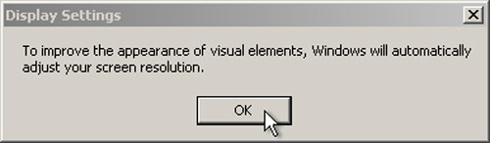
17. When the Monitor Settings dialog box appears, click OK.
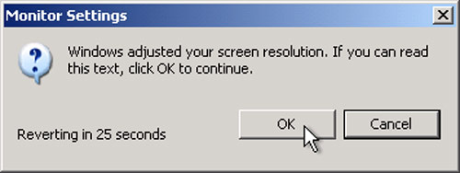
18. The final stage of setup begins. On the Welcome to Microsoft Windows page, click Next.
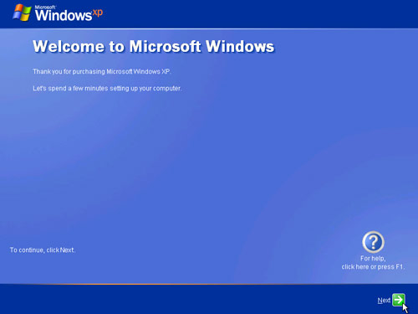
19. On the Help protect your PC page, click Help protect my PC by turning on Automatic Updates now. Then, click Next.
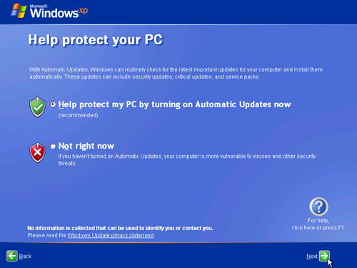
20. Windows XP will then check if you are connected to the Internet:
• If you are connected to the Internet, select the choice that describes your network connection on the Will this computer connect to the Internet directly, or through a network? page. If you’re not sure, accept the default selection, and click Next.
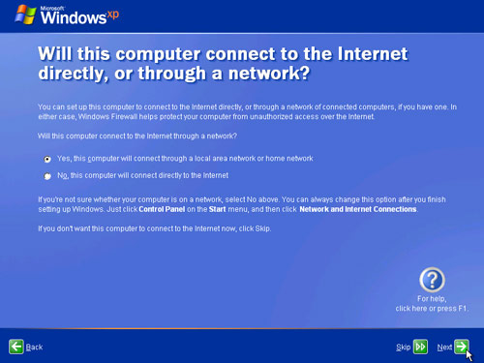
• If you use dial-up Internet access, or if Windows XP cannot connect to the Internet, you can connect to the Internet after setup is complete. On the How will this computer connect to the Internet? page, click Skip.
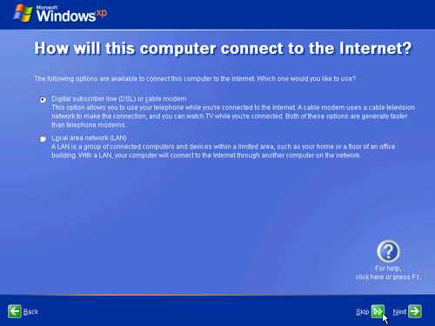

21. Windows XP Setup displays the Ready to activate Windows? page. If you are connected to the Internet, click Yes, and then click Next. If you are not yet connected to the Internet, click No, click Next, and then skip to step 24. After setup is complete, Windows XP will automatically remind you to activate and register your copy of Windows XP.
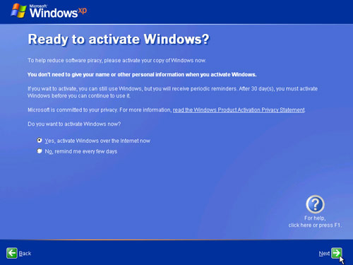

22. On the Ready to register with Microsoft? page, click Yes, and then click Next.
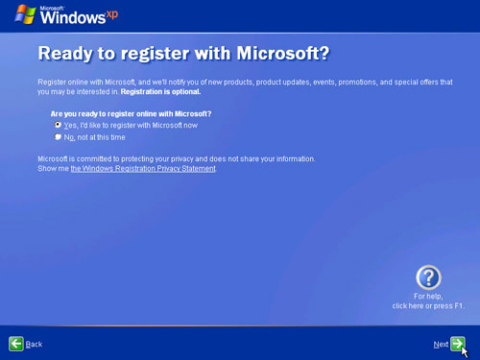
23. On the Collecting Registration Information page, complete the form. Then, click Next.
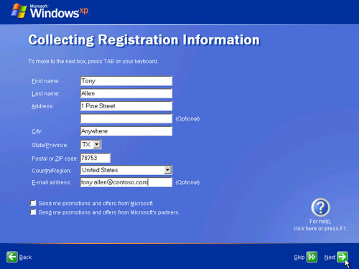
24. On the Who will use this computer? page, type the name of each person who will use the computer. You can use first names only, nicknames, or full names. Then click Next. To add users after setup is complete or to specify a password to keep your account private, read Create and customize user accounts.
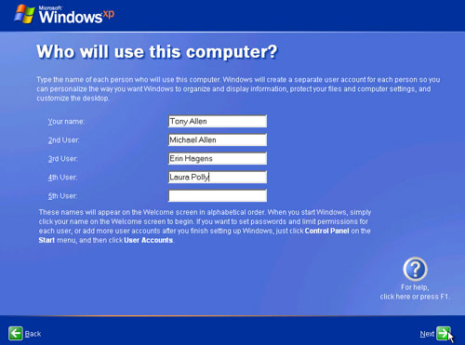
25. On the Thank you! page, click Finish.
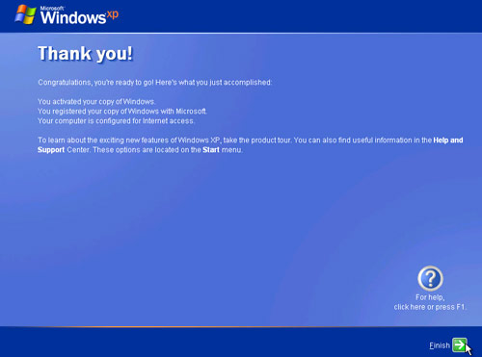

3.5 Creating user account in Windows XP/ 2000
Unlike older versions of Windows, Windows XP Professional doesn't allow you to skip logging in to the computer. You will need a Windows XP user account (a user name and password).
A Windows account will only work on the computer it is created on. If you want to use a different computer, you will have to set up a Windows account on that computer.
There are two types of Windows XP user accounts. Computer Administrators can change all computer settings (for example, installing software and creating new user accounts). Limited users can only modify the passwords for their own user accounts.
If you have a Windows XP computer in your office and you are the computer's primary user: UIS will create the Windows account on your computer before you get it. You will only need to create accounts if other people in your office want to use your computer.
If you want to use another person's Windows XP computer: Someone with a Computer Administrator account on the computer will have to create an account for you.
Setting Up a Windows XP User Account
- Click the Start button, and then click Control Panel.
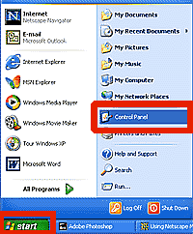
- Click User Accounts.
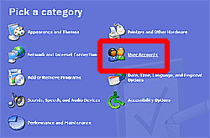
- Click Create a New Account.
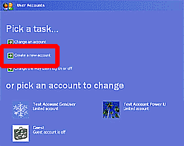

- To name your user account, type in your Novell user name. Click the Next button.
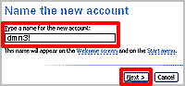
- There are two types of Windows XP user accounts:
  - Computer administrators can change all computer settings (for example, installing software and creating new user accounts).
  - Limited users can only modify the passwords for their own user accounts.
To pick an account type, click either Computer Administrator or Limited. Click the Create Account button.
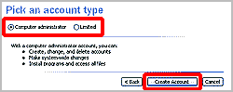
- You will be sent back to the User Accounts window where your new account will appear.
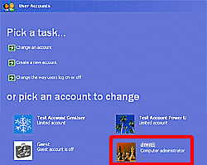

3.6 Assigning permission in Windows XP

Turning on and turning off Simple File Sharing
Note Windows XP Home Edition-based computers always have Simple File Sharing enabled.
By default, the Simple File Sharing UI is turned on in Windows XP Professional-based computers that are joined to a workgroup. Windows XP Professional-based computers that are joined to a domain use only the classic file sharing and security interface. When you use the Simple File Sharing UI (that is located in the folder's properties), both share and file
permissions are configured.
If you turn off Simple File Sharing, you have more control over the permissions to individual users. However, you must have advanced knowledge of NTFS and share permissions to help keep your folders and files more secure. If you turn off Simple File Sharing, the Shared Documents feature is not turned off.
To turn Simple File Sharing on or off in Windows XP Professional, follow these steps:
- Click Start, and then click My Computer on the desktop.
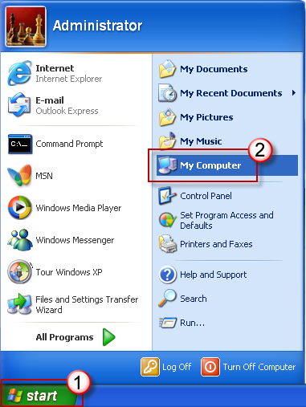

- On the Tools menu, click Folder Options.

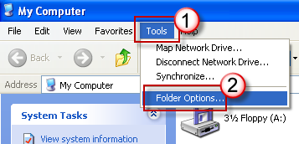
- Click the View tab, and then select the Use Simple File Sharing (Recommended) check box to turn on Simple File Sharing. (Clear this check box to turn off this feature.)
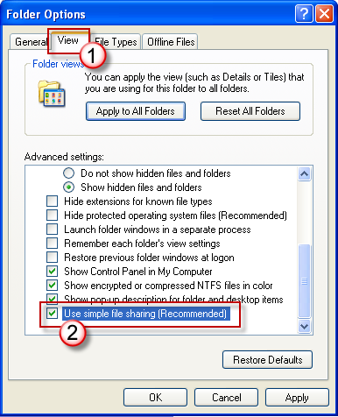

Sharing Files and Folders
In Windows XP Professional, members of the Administrators, Power Users, and Server Operators groups can share folders. Other users who have been granted the Create Permanent Shared Objects user right can also share folders. If a folder resides on an NTFS volume, you must have at least Read permission to share the folder.

When you share a folder, keep the following in mind:
- You can share only folders, not files.
- Shared folders are relevant only to users who need to access data over the network. Sharing a folder and assigning shared folder permissions has no effect on users who are locally logged on to a computer.
- When you copy a shared folder, the original shared folder is still shared, but the copy is not shared.
- When you move a shared folder, the folder is no longer shared.
- If you have a mixed environment, use 8.3 format share names so that older client operating systems can recognize them.

To share a folder
- Right-click the folder you want to share, and then click Properties.
- In the folder properties dialog box, click the Sharing tab.
- Click Share this folder, and then in Share name, type the name you want users to see when they browse for this folder on the network. If you append the name with the $ symbol, the folder is shared, but the folder does not appear when users browse for it across the network.
- In Comment, type a description for the shared folder. This description is visible to users who browse across the network.
- In User limit, make any changes you want. The default setting is Maximum allowed, which corresponds to the number of client access licenses you have purchased. You can also designate a user limit by clicking Allow, typing the number of users next to Users, and then clicking OK.
Warning By default, shared folder permissions are set so that the Full Control permission is assigned to the Everyone group. You can change the default shared folder permissions by clicking Permissions in the folder properties dialog box. Note that this behavior changed in Windows XP Service Pack 1 and later, where the default shared folder permissions are Read permission for the Everyone group.
This change does not apply, however, to sharing files using the net share command or using Simple File Sharing.

Configuring Shared Folder Permissions
Shared folder permissions determine who can gain access to resources on remote computers. When a folder is shared, users can connect to the folder over the network and gain access to its contents. Shared folder permissions allow you to control which users or groups can gain access to the contents of a shared folder.

Shared folders and NTFS permissions
Shared folder permissions are different from NTFS permissions. NTFS permissions use access control lists (ACLs) to limit access to resources and can be assigned only to resources on an NTFS volume. In addition, NTFS permissions can be assigned to both files and folders. Shared folder permissions do not use access control lists and can therefore be used on a volume that is formatted with any file system, including FAT, FAT32, or NTFS. In addition, shared folder permissions can be assigned only to folders.

Setting shared folder permissions
Shared folder permissions can be set only by members of the Administrators, Power Users, or Server Operators groups. Users who have been granted the Create Permanent Shared Objects user right can also assign shared folder permissions. If a folder resides on an NTFS volume, you must have at least Read permission to assign shared folder permissions.
There are three types of shared folder permissions: Read (the most restrictive), Change, and Full Control (the least restrictive). Table 6-3 describes each of these permissions.
Permission | Description
Read | Users can display folder and file names, display file data and attributes, run program files and scripts, and change folders within the shared folder.
Change | Users can create folders, add files to folders, change data in files, append data to files, change file attributes, delete folders and files, and perform all tasks permitted by the Read permission.
Full Control | Users can change file permissions (on NTFS volumes only), take ownership of files (on NTFS volumes only), and perform all tasks permitted by the Change permission that aren’t otherwise prohibited by the underlying NTFS file system permissions.
You can allow or deny shared folder permissions to individual users or groups. From an administrative standpoint, it is usually most efficient to assign permissions to a group rather than to individual users. Also, deny permissions only when it is necessary to override permissions that are otherwise applied. Denied permissions take precedence over any permission that you otherwise allow for user accounts and groups. For example, it might be necessary to deny permissions to a specific user who belongs to a group that has been granted permissions.

To configure shared folder permissions
- Right-click the folder for which you want to configure shared folder permissions, and then click Properties.
- In the folder properties dialog box, click the Sharing tab, and then click Permissions.
- In the Permissions for dialog box, click Add.
- In the Select Users, Computers, or Groups dialog box, click Object Types, click the Users check box, and then click OK.
- Under Enter the object names to select, type the name of the group or user for which you want to set shared folder permissions, and then click OK.
- In the Permissions for dialog box, in the Group or user names box, click the group or user for which you want to set shared folder permissions.
- In the Permissions for dialog box, allow or deny permissions, and then click OK.

3.7 Adding a printer on windows XP

When you add a printer, you tell your operating system such as Windows XP Professional that you have a certain kind of printer attached to your computer or available over a network that you would like to print to. Even if you've hooked up the printer correctly, you still need to add it in the operating system and install the drivers to use it properly including all of the printers features. These instructions walk you through on how to add a printer in Windows XP.
Step One: Click "Start" at the bottom right hand corner of your taskbar then Select "Printers and Faxes".

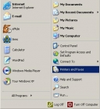

Step Two: Double click "Add Printer" then Click "Next" on the "Welcome to the Add Printer Wizard" screen.

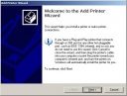

Step Three: On the Local or Network Printer screen select "Local Printer Attached to this computer" and check the box that says "Automatically detect and install my Plug and Play printer". After you have made your selections click "Next" to move on to the next step.

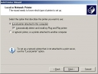
Step Four: On the next screen use the drop down menu to select the "port". Most times your computer will automatically detect the port so most users can just click "Next" to move on to the next step.

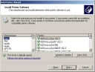
On the next screen use the drop down menu to select the "port". Most times your computer will automatically detect the port so most users can just click "Next" to move on to the next step.
Step Five: Choose the Manufacturer and the model of your printer. If your printer is not listed, click the "Have Disk" button. You'll need to locate the manufacturer-supplied drivers on your computer or disk. Click "Next".

Step Six: Type in a name for the printer. This is the name that will appear under the printer icon in the Printers and Faxes folder. Choose a name which you will be able to easily identify. Select "Yes" if you are asked to use the newly added printer as your "Default”. Click "Next".

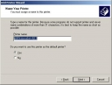

Step Seven: It is up to you to decide if you would like to print a test page. As a good rule of thumb you should always print a test page to ensure your printer is set up properly.

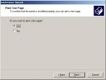

Step Eight: Finally you are done adding your new printer. Click "Finish" on the summary window. That’s it! You are done! Enjoy your new printer!

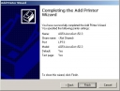

3.8 Using scandisk and defrag utilities

3.8.1 SCANDISK
For Windows 95/98/ME the easiest way to get to the Scandisk utility is to go to Start, then Run, type in scandisk and click OK. You will then see a window like the example below.
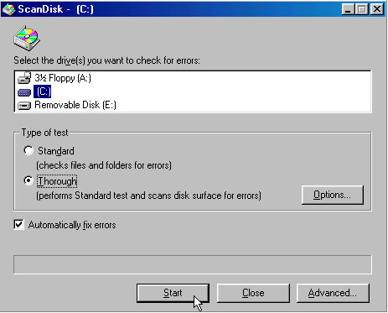
First you select the drive you want to scan, usually your C drive. Then select Standard or Thorough. For most cases you can go with Standard unless you are having more serious problems. The thorough option can take a very long time depending on the size of your drive. You should select the automatically fix errors box and let Windows take care of the repairs. Finally click on start to begin the process. Before running Scandisk make sure you close all open programs and don’t touch the computer until it is done or else it may tend to keep starting over. When its completed it will give you a summary telling if it found any errors and whether or not they were fixed.
The Windows 2000, 2003 & XP version is a more improved version and is accessed a little differently. There are a few ways to get to it you can open My Computer, select your C drive and right click it and then go to Properties. Then there will be a Tools tab with an Error Checking option. Click on Check Now and you will see the following screen.
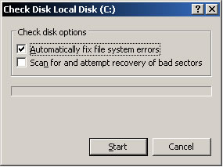
You should check the automatically fix file system errors box. If you check the Scan for and attempt recovery of bad sectors box then that is the same as the thorough option for the older version. After you click Start you will be presented with a dialog box that looks like the following:
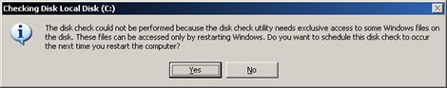
Then the next time you reboot you will see a black DOS type screen while it runs the Scandisk utility. Then when its complete it will go right into Windows. If you do not check the automatically fix file system errors box then it will scan within Windows but will not fix any errors.

3.8.2 Defrag utility
DEFRAG is a Microsoft utility that takes data on your hard drive and rearranges it into a chronological order so when it is access the hard drive doesn’t have to search all over the disk to find what its looking for. The more it has to search for data the longer it takes for your computer to do what it needs to do. Its good to run Defrag once a month or so and will actually increase performance.
To access defrag in Windows 95/98/ME go to My Computer, right click your C drive and select properties. Then you will see a Tools tab and within that a Defragment Now button. When you click the button you will be presented with a dialog box asking you which drive you want to defragment. Select your drive and click OK.
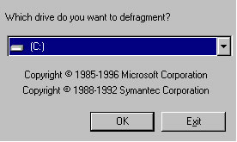
Windows will go through the process and let you know when its finished. Make sure you close all open programs and don’t touch the computer during the process. Its also a good idea to turn off your screensaver because any interruption may make the program start over again.
For 2000, 2003 and XP you can access Disk Defragmenter by right clicking My Computer and selecting Manage. There will be a Defrag option you can select which will bring you to the following screen.
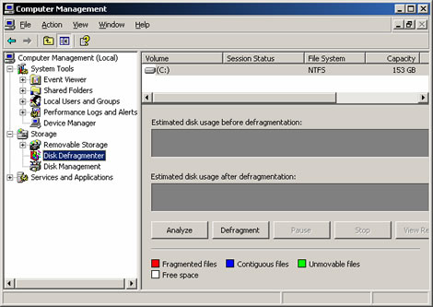

Select the disk you want to defragment or you can choose the Analyze button to have Windows check the disk to see if it even needs to be defragmented. This newer version of Defrag is not as touchy and you can actually use the computer while it’s running.
For newer operating systems like Windows 7 you can click on Start, All Programs, Accessories, System Tools and then Disk Defragmenter.

3.9 Booting windows operating system in safe mode
Booting windows in safe mode is performed when the computer is unable to boot into normal Windows mode or cannot troubleshoot because of errors in normal mode. Windows Safe Mode bypasses startup programs and drivers that are not required for Windows to load and permits to fix Windows problems. As an advice before booting in Safe Mode because you cannot get into Windows, it is recommended to first try loading the last known good configuration.

3.9.1 Booting Windows 2000 / XP/VISTA/WINDOWS 7 in safe mode
To get into the Windows 2000 / XP Safe mode, as the computer is booting press and hold "F8 Key" which should bring up the "Windows Advanced Options Menu" as shown below. Use your arrow keys to move to "Safe Mode" and press your Enter key.
Note: With some computers, if you press and hold a key as the computer is booting you will get a stuck key message. If this occurs, instead of pressing and holding the "F8 key", tap the "F8 key" continuously until you get the startup menu.
The following screen will appear when F8 key is pressed.
Windows Advanced Options Menu
Please select an option:
Safe Mode
Safe Mode with Networking
Safe Mode with Command Prompt
Enable Boot Logging
Enable VGA mode
Last Known Good Configuration (your most recent settings that worked)
Directory Services Restore Mode (Windows domain controllers only)
Debugging Mode
Start Windows Normally
Reboot
Return to OS Choices Menu
Use the up and down arrow keys to move the highlight to your choice.

3.9.2 Windows 95/ 98 / ME users
To get into Windows 98 / ME Safe Mode, as the computer is booting press and hold your "F8 key" on the top of your keyboard or press and hold the left or right Ctrl key as the computer is booting. If done properly “Windows 98 / ME Startup Menu" similar to the below screen example. In this menu choose option 3 by pressing the 3 key and press enter.
Note: With some computers if you press and hold a key as the computer is booting you will get a stuck key message. If this occurs, instead of pressing and holding the "F8 key", tap the "F8 key" continuously until you get the startup menu.
Microsoft Windows 98 Startup Menu
=============================
1. Normal
2. Logged (\BOOTLOG.TXT)
3. Safe mode
4. Step-by-step confirmation
5. Command prompt only
6. Safe mode command prompt only
Enter a choice: 1
F5=Safe Mode Shift+F5=Command prompt Shift+F8= Step-by-step confirmation [N]
Get out of Safe Mode
From Windows Safe Mode click Start / Shutdown and restart the computer. This will start the computer automatically back into Normal Mode.
Safe Mode with Networking
For users needing access to the Internet or the network they're connected to while in Safe Mode users may wish to choose this option. This mode is helpful for when you need to be in Safe Mode to troubleshoot but also need access to the Internet so you can get updates, drivers, or other files to help troubleshoot your issue.
Safe Mode with Command Prompt
This Safe Mode would also allow you to have access to the command line (MS-DOS prompt).

3.10 Using windows 2000/xp recovery console

In the Windows Recovery Console you can:
- Use, copy, rename or replace operating system files and folders.
- Enable or disable services or devices from starting when you next start your computer.
- Repair the file system boot sector or the Master Boot Record (MBR).
- Create and format partitions on drives.
Note that only an administrator can obtain access to the Windows Recovery Console so that unauthorized users cannot use any NTFS volume.

3.10.1 Starting the Windows Recovery Console
To start the Windows Recovery Console, use any of the following methods:
- Start your computer with the Windows Setup with the Windows CD-ROM. At the "Welcome to Setup" screen, press F10, or press R to repair, and then press C (Windows 2000/XP only) to start the Windows Recovery Console. Select the appropriate number for the Windows installation that you want to repair, and then type the administrator password. If the administrator password does not exist, just press ENTER.
- Add the Windows Recovery Console to the Windows Startup folder by using Winnt32.exe with the /cmdcons switch. This procedure requires approximately 7 MB of hard disk space on your system partition to hold the Cmdcons folder and files.

3.10.2 Using the Command Console
1: C:\WINNT
Which Windows installation would you like to logon to (enter to abort)?
After you enter the number for the appropriate Windows installation, enter the Administrator account password. Note that if you use an incorrect password three times, the Windows Recovery Console quits. After you enter your password and the Windows Recovery Console starts you can start to copy files from I386 FOLDER such as NTDETECT.COM and NTLDR.COM used to boot Windows 2000/XP.

REFERENCES

1. http://www.scribd.com/doc/30634201/215/Classification-of-Semiconductor-Memory
2. http://en.wikipedia.org/wiki/System_bus
3. http://www.pccomputernotes.com/system_bus/bus02.htm
4. CISCO IT Essential 1 notes (www.cisco.netacad.net)

